Construction - Wood Trades

Bench Joinery Diploma -Level 2 Full time

Course Code: RCON078F
Duration: Sept ’23 to June ‘24
Attendance: 15 Hours per week
Campus: Crawley, Workshops
Contact your Study Programme Leader - Trevor Francis
01293 442200
Ext: 2381 Workshop (WO17)
Ext: 2310 Office.
tfrancis@crawley.ac.uk

Welcome to Crawley College

Dear Student

Thank you for choosing to study Bench Joinery Level 2 Full time at Crawley College. I am the study programme leader and look forward to working with you over the next year.

Further to your starting information, which outlines your start date & time, below is a brief overview regarding coming to college and preparing to study your course.

Your course requires the purchase or hire of some resources you will find further information on these during induction and on your course acceptance letters. Please order as soon as possible to ensure you are ready to learn.

The first few days of the course will be for induction and enrolment. Timetables will not be available until this point. This will give you the opportunity to get to know the other students on the course, as well as your lecturers and your student tutor.

English and Maths
All students aged 16-18 years on a full-time course are required to update their English and Maths skills if they do not hold a GCSE grade A/9-C/4 in both subjects. So please be aware that if you do not have these qualifications, you will be required to undertake a GCSE resit (or equivalent qualification) alongside your main programme of study. This is compulsory and not optional. Please be aware that you cannot be awarded for one qualification without passing the other.

Work Experience
All students on a full-time course are required to research, arrange, and attend work experience as part of their course. This is compulsory and is part of your study programme.

Please ensure that on your first day you bring the following:

- A pen, paper & file. If you are a school leaver, Confirmation of your GCSE results – we cannot enrol you without a copy of results, so this is essential.
- PPE and other essential equipment as listed below.
- If applicable, payment for your course/evidence of benefits.

What you need to bring with you for all lessons:

The equipment below is a guide of the minimum standard required, please choose the most suitable equipment for you.

Equipment | Details | Price
Course Textbook  L2 Site Carpentry & Architectural Joinery | 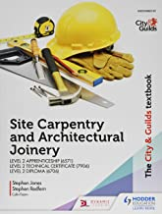 amazon.co.uk | £28.00
Suitable Work Trousers, Apron, Smock or Tool Belt. | ebay.co.uk | £10.00 - £ 50.00
Safety Boots  Safety Rating: S1 P SRA  200J Steel Toe Cap  Steel Penetration-Resistant Midsole | 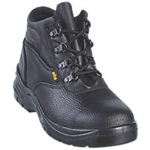 screwfix.co.uk | £16.99
Work Gloves  For General Handling  Knitted Cuffs for Comfort  Breathable Back | screwfix.co.uk | £2.99
Safety Glasses  Polycarbonate  Grade F Impact Lens  Optical Class: 1 | 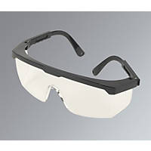 screwfix.co.uk | £2.08
Ear Defenders  27.6dB Standard Noise Reduction  ABS Plastic Construction  Surface Wipe Only | screwfix.co.uk | £2.98
Dust Mask  Class 2 efficiency  Fold Flat Design  Flexible Nose Piece  Modern Valve Design | screwfix.co.uk | £2.29
Hi Vis Waistcoat  50mm Reflective Tape on Body & Shoulders  Hook & Loop Fastening  Breathable Fabric | screwfix.co.uk | £3.59
A4 Lever Arch File | whsmith.co.uk | £3.99
A4 Refill Pad | 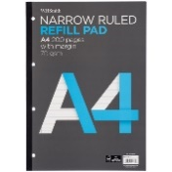 whsmith.co.uk | £2.49
Black Pens and 2H Pencils | 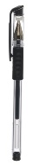 whsmith.co.uk | £3.00
Mathematical Drawing Set | 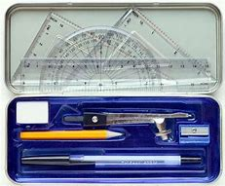 whsmith.co.uk | £6.00
Triangular Scale Rule | 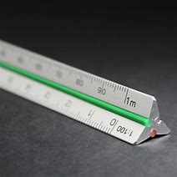 ebay.co.uk | £3.00
Corded Headphones  3.5mm Jack  for theory lessons | 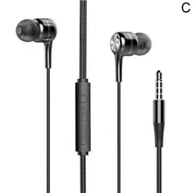 ebay.co.uk | £2.00

Please feel free to contact me with any questions you may have regarding the above and I will be happy to help.

Best wishes,

Trevor Francis.

Study Programme Leader

