

WOODTRADES COURSE
EQUIPMENT REQUIREMENTS

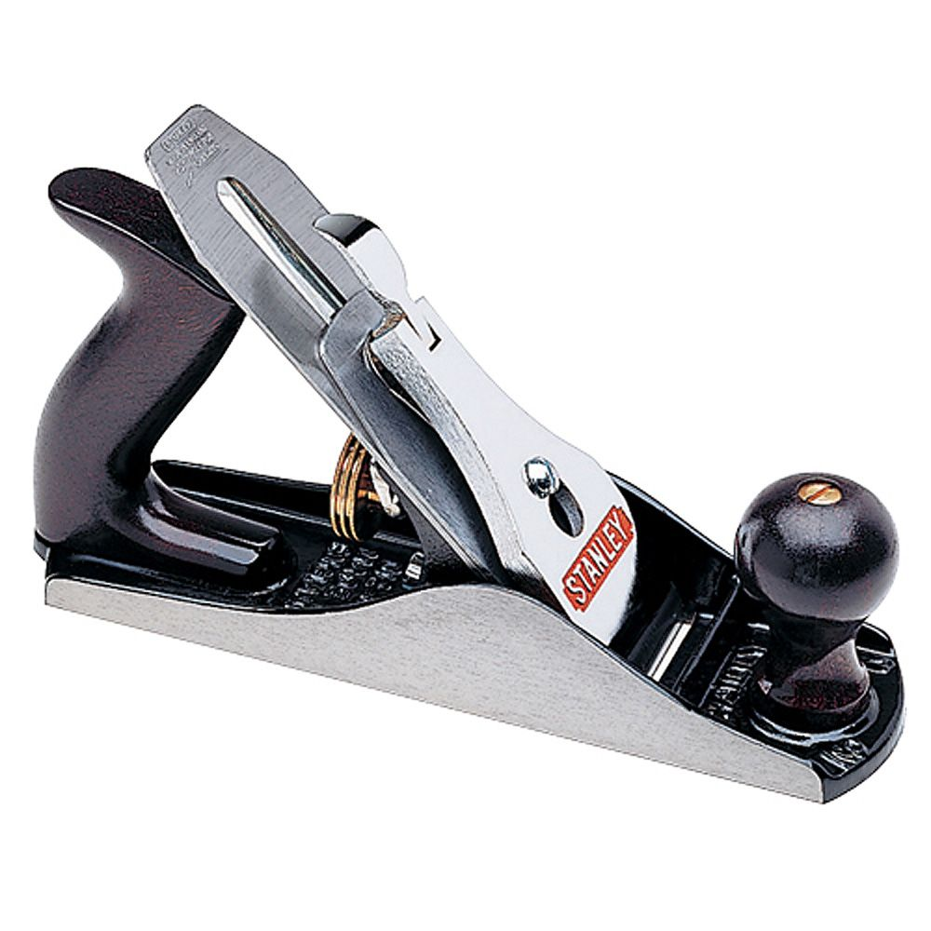
2025 - 2026



Student Name
_________________________________
Carpentry and Joinery

Crawley College
01293 442200
Email: info@crawley.ac.uk
Equipment Required for your
Carpentry and Joinery Course

Whilst attending the course you will need the following items:-

- Clothing – our trade often works in a dirty and dusty environment so wear items that you don't mind getting dirty. No shorts and no loose clothing.

- Personal Protective Equipment is personal to you; therefore it is used for your protection and shows basic Health and Safety awareness while conforming to Legislation.
This is essential equipment required to enter the workshops. Items shown below:

Equipment | Details
Safety Boots –  with steel toe caps  Safety Rating:  200J Steel Toe Cap  Steel Penetration-Resistant Midsole  Essential for any workshop. | 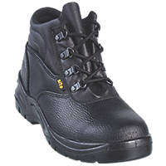 screwfix.co.uk
Work Gloves  For General Handling  Knitted Cuffs for Comfort  To protect the hands and fingers from splinters, cuts etc. |  screwfix.co.uk
Safety Glasses  Polycarbonate  Grade F Impact Lens  Essential for tasks that have flying debris, e.g. when chiselling, drilling, power tools |  screwfix.co.uk
Ear Defenders  Standard Noise Reduction  ABS Plastic Construction  Surface Wipe Only  When covering loud tasks such as Portable Power Tools. |   or  screwfix.co.uk
Dust Mask  JSP Flexinet Disposable Valved Mask P2  Flexible Cover Retains Mask Shape  No Metal Parts  Medium Efficiency: Minimum 94%  To be worn when covering items that generate dust. |  screwfix.co.uk
Hi Vis Waistcoat  Class 2 Hi-Vis Safety Rating  50mm Reflective Tape on Body & Shoulders  This can be used for any site visits. | screwfix.co.uk
Suitable Work Trousers and Tool Belt.  Being more prepared and professional in the workshops saves time and improves focus and work rate. This is not mandatory although essential requirements for an Employer. | 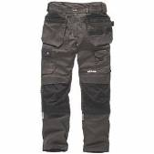    screwfix.co.uk / ebay.co.uk
2H Pencils  A MUST HAVE  and PENS | 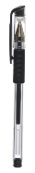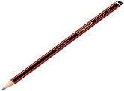 whsmith.co.uk
A4 Lever Arch File for THEORY |  whsmith.co.uk
Paper for THEORY | 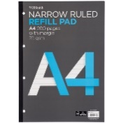 whsmith.co.uk
Pens and a MUST HAVE  2H Pencils  This is so important it is mentioned twice! | whsmith.co.uk
Mathematical Drawing Set incorporates items such as protractor, compass, rubber, pencil sharpener etc. | 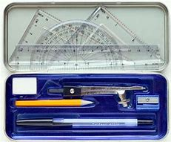 whsmith.co.uk
Triangular 300mm Metric Scale Ruler with low scales such as - 1:1, 1:5, 1:10, 1:20 | 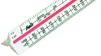 amazon.co.uk
Corded Headphones  Inexpensive ones are fine.  3.5mm Jack  For computers in theory lessons to be able to listen to various Modules. |  ebay.co.uk
Course Textbook  to suit your course  L1 Carpentry & Joinery  Essential for THEORY as we refer to this every week. | 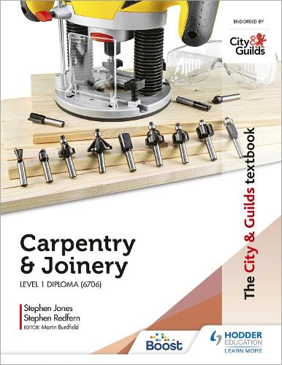  Amazon.co.uk / Waterstones /  WHSmiths
Tape Measure  Essential for ALL Apprentices |  screwfix.co.uk

Textbooks to Accompany the Course

There are a number of textbooks published for Carpentry and Joinery Level 1. This one is the most recently printed while also being the most readily available. Essential for THEORY as we refer to this every week.

L1 Carpentry & Joinery

Book Approx. £25.00 - £30.00

ISBN – 9781398319370

