Textbooks to Accompany the Course

There are a number of textbooks published for Carpentry and Joinery. Your Lecturer will advise you on this as it depends on your Study Programme as to what is required.

Equipment Required for the Course

Whilst attending the course you will need all of the following items:

Clothing – our trade often works in a dirty and dusty environment so wearing suitable work trousers that you don't mind getting dirty, no loose clothing.

- Personal Protective Equipment is personal to you. PPE is to be used for your protection and shows basic Health and Safety awareness while conforming to Legislation. This is essential equipment required to enter the workshops. Basic items shown below, you must have all of these items with you for all lessons when completing Architectural Joinery or Furniture Wood Machining.

Equipment | Details
Safety Boots  Safety Rating: S1 P SRA  200J Steel Toe Cap  Steel Penetration-Resistant Midsole | 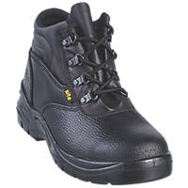 screwfix.co.uk
Work Gloves  For General Handling  Knitted Cuffs for Comfort  Breathable Back | screwfix.co.uk
Safety Glasses  Polycarbonate  Grade F Impact Lens  Optical Class: 1 | 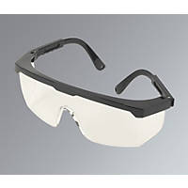 screwfix.co.uk
Ear Defenders  27.6dB Standard Noise Reduction  ABS Plastic Construction  Surface Wipe Only | or 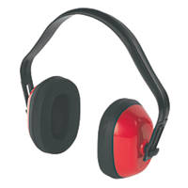 screwfix.co.uk
Dust Mask  Class 2 efficiency  Fold Flat Design  Flexible Nose Piece  Modern Valve Design | 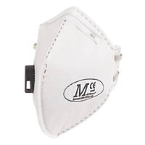 screwfix.co.uk
Suitable Work Trousers, Apron, Smock or Tool Belt.  Not mandatory, however being more prepared and professional in the workshops saves time and improves focus and work rate.  Essential requirements for an Employer | 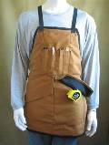  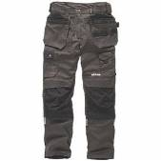  screwfix.co.uk / ebay.co.uk
A4 Lever Arch File | whsmith.co.uk
A4 Refill Pad | 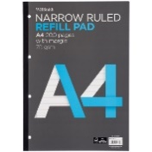 whsmith.co.uk
Black Pens and 2H Pencils | 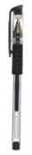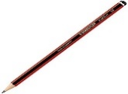 whsmith.co.uk
Mathematical Drawing Set | 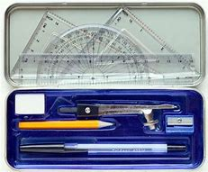 whsmith.co.uk
Triangular Scale Rule | 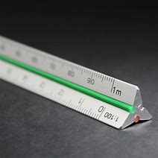 ebay.co.uk
Corded Headphones  Inexpensive ones are fine.  3.5mm Jack  for theory lessons to connect to computers | 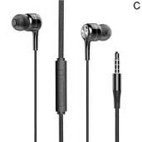 ebay.co.uk
Course Textbook  to suit your course  L1 Carpentry & Joinery  or  L2 Site Carpentry & Architectural Joinery  or  L3 Site Carpentry & Architectural Joinery | 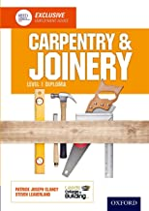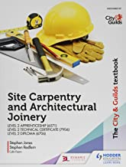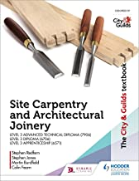  amazon.co.uk
Tape Measure  Essential for ALL Apprentices | 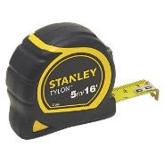 screwfix.co.uk

