Welcome to Chichester College
Course details
Course Code: CPUB001F1A Duration: Sept ‘23 to June ‘24
Campus: Chichester
Contact your Study Programme Leader
 01243 786321 ext. 2362
steve.woolcombe@chichester.ac.uk

Your induction will take place in the first week of your course, please do not be alarmed if you are disappointed with your exam results.

You can join our “YES” Day on Tuesday 29th August.
Please go to the college website; www.chichester.ac.uk to book your place.

Dear Student

Thank you for choosing to study the NCFE L3 Diploma for Entry into the Uniformed Services at Chichester College. This course will provide you with invaluable insight into a career within any of the Uniformed Public Services. The course is 9 months in length and students will be assessed using a multitude of methods from practical, portfolio work, group tasks, and presentations.
During the course, you will experience many visits to various industries such as Middle Wallop (Army Air Corp), overnight residential (Outdoor Pursuits), Defence School of Police & Guarding (DSPG), and weekly visits to the British Army Air Defence Regiment at Baker Barracks (leadership training). You will learn many skills on the course such as Confidence, Leadership, Communication, and many of our students go onto highly successful careers in Public Service.
Further to your starting information, which outlines your start date & time, below is a brief overview regarding coming to college and preparing to study for your course.

The first few days of the course will be for induction and enrolment, this will allow you to get to know the other students on the course, as well as your lecturers and your student tutor. (You must bring evidence of your GCSE grades on the first day).

Please feel free to contact me with any questions you may have regarding your course, such as trips, kits, or coursework and fees, I will be happy to help.

Best wishes,
Steve Woolcombe
Steve Woolcombe
Study Programme Leader

Important information about your Course
Timetables
The first few days of the course will be for induction and enrolment, all students MUST attend BOTH to start your course. The induction week will allow you to get to know the other students on the course, as well as your lecturers and your student tutor.
Timetables for your course will not be available until you attend your induction.

Your first week at college
For your first day, you will be required to meet the course team at the college sports centre for 1000 hrs. on Monday 4th Sept.
In the first few days, you will be guided around the college campus and become familiar with all the facilities, clubs, and extra curriculum activities available to you through the student union.
The days of your induction week are Mon 4th Sept – Fri 8th, 0915 to 1530 daily. (Less Mon, 10am start)
Your week will include a course introduction, all enrolment requirements, team-building exercises, sports activities, and a campus tour with informative presentations. All are designed to settle students as quickly as possible before the commencement of formal instruction.

You will need a sports kit every day of your induction week.

Your Enrolment

Further to your starting information and an invitation to register your “Pre-enrolment” with the College; you should now have the following information ready for September:
- Your Student Number
- Your invitation to attend your Induction Date which outlines your start date & time in September.

Should you not have either of these, please contact enrolments@chichester.ac.uk for further details.

Please ensure that when attending your enrolment, you bring the following:

- Copy/Photo-shot of your Certificate(s) with your grades.
- Please bring a pen, paper & file
- Please bring a presentable sports kit. We will be doing exercises on Induction Day.
- Please produce/ bring a printed Microsoft Word document containing your ‘Short-, Medium- & Long-term’ ‘SMART goals’ for course intentions/ career aspirations.

If you are unsure of what this entails, please email admissions@chichester.ac.uk for further details.

English and Math's
NB: All students aged 16-18 years on a full-time course are required to update their English and Math's skills if they do not hold a GCSE grade of A/9-C/4 in both subjects. So please be aware that if you do not have these qualifications, you will be required to undertake a GCSE re-sit (or equivalent qualification) alongside your main programme of study. This is compulsory and not optional. Please be aware that you cannot be awarded for one qualification without passing the other.

Work Experience
Students will have to undertake a one-week block of work experience during the course, this should be related to Uniformed Public Service, and you will receive assistance from the course team to facilitate this.

KIT and other costs

There are some small fees attached to this course for offsite trips throughout the year, however, you will be told in advance when the money will be required and the amount. Some personal kit for residential trips is desirable, such as a Sleeping bag, Rucksack, and a Water- Proof Jacket.

To prepare you for the costs and to allow you to save for these expenditures, I have listed below examples of the biggest costs. There are some charges attached to this course which would have been explained at your interview:

- Course clothing including boots (September) £150
- Residential overnight Induction camp (September) £50
- Brecon Beacons, Wales 1 week Residential – Easter £150

Students who feel that they may struggle with some of the inherent costs of approx. £350 spread over the year are actively encouraged to discuss their circumstances with the finance team to see if, following a means test, financial support can be provided to students.
If you would like to ask for financial support to pay for these costs, please contact our Student Financial Support Team via the Chichester College website and read the information below.
Getting Support at College
The Learning Support Grant & Bursary
We understand that financial matters are an important consideration for our students and that everyone’s circumstances are different.
We believe financial constraints alone should never be enough to prevent a student from studying and so we will work with you to find out what support you may be entitled to and help you to access any funding available. You can apply online (via online portal) for the Learning Support Grant. We have tried
to make the application as simple as possible, but it will involve filling in online forms, providing evidence and telling us about your financial situation. We will then make an assessment based on your personal circumstances.

Contact
If you have any questions regarding student finance, please email studentfinance@chigroup.ac.uk and one of our team will be in touch to help.

MAP
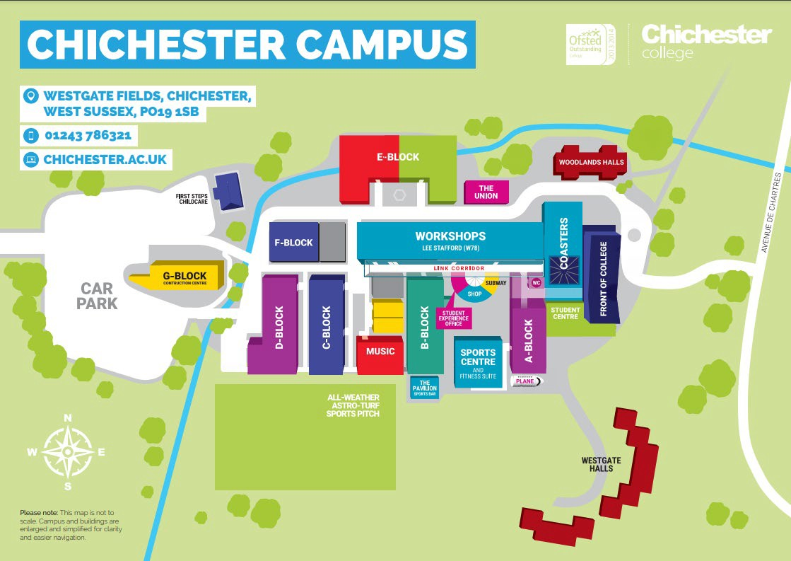

College Life

At Chichester College, you will find plenty of ways to enrich your learning experience.

All the information that you need about College Life, including term dates and travel is available on the website: College Life | Chichester College

To complement your course, we have excellent sports and fitness facilities on-site, as well as our Lee Stafford Hair Salon and Oasis Beauty Spa. There is also a well-stocked library and learning resource centre.
The campus is set in the heart of the city, with stunning views of the cathedral. Though relatively small, Chichester has everything you could expect from a larger city – bustling shops, including high street stores and independent retailers, cinemas, leisure/sports centre, bowling alley, museums, trampoline parks, restaurants, and bars.

