Welcome to Chichester College
Course details
Course Code: CPUB003F1A Duration: Sept ‘23 to June ‘24
Campus: Chichester
Contact your Study Programme Leader
 01243 786321 ext. 2362
wayne.hodkinson@chichester.ac.uk

Your induction will take place in the first week of your course, please do not be alarmed if you are disappointed with your exam results.

You can join our “YES” Day on Tuesday 29th August.
Please go to the college website; www.chichester.ac.uk to book your place.

Welcome to Chichester College

Dear Student

Thank you for choosing to study Level 1 Introduction to Sport and Uniformed Services at Chichester College.
I am the study programme leader and look forward to working with you over the next year.
I am really excited about the course this year, as I feel we have been able to build the best programme we have run!
The course will enable you to be challenged to develop towards your future goals, all whilst having fun and meeting new people!
Please take time to read all the information about your course and your first week at college below this letter as it will help you get ready for college.
Do feel free to contact me with any questions you may have regarding the information regarding your course, such as trips, kits or course work and I will be happy to help.
Best wishes,

Wayne Hodkinson
Study Programme Leader

Important information about your Course
Timetables

The first few days of the course will be for induction and enrolment.
Timetables will not be available until this point.
This will give you the opportunity to get to know the other students on the course, as well as your lecturers and your student tutor so it is very important that you are available for college in you your induction week: Monday 7th to Friday11th September. If you are unable to attend, please contact Admissions and your course leader at your nearest opportunity.

Your first week at College

Your Induction

Please ensure that on your first day you bring the following:

- A pen, paper & file
- If applicable, payment for your course/your loan letter/evidence of benefits
- Personal protective equipment that will help you access your course
- Practical kit as a separate change of clothes.

If there are any trips associated with your course, you will be required to complete any attached consent forms and submit to your course leader during induction week.

Your Enrolment

Further to your starting information and an invitation to register your “Pre-enrolment” with the College.
You should now have the following information ready for September:
- Your Student Number
- Your invitation to join your Induction Date which outlines your start date & time in September.

Should you not have either of these, please contact enrolments@chichester.ac.uk for further details.

Please ensure that when attending your enrolment you bring the following:

- Copy/Photo-shot of your Certificate(s) with your grades.
- If applicable, payment for your course/your loan letter/evidence of benefits
- Any documentation you need the college to complete at enrolment, e.g., Child Tax/Council Tax

If you are unsure of what this entails, please email admissions@chichester.ac.uk for further details.

English and Maths
NB: All students aged 16-18 years on a full-time course are required to update their English and Maths skills if they do not hold a GCSE grade of A/9-C/4 in both subjects. So please be aware that if you do not have these qualifications, you will be required to undertake a GCSE re-sit (or equivalent qualification) alongside your main programme of study. This is compulsory and not optional. Please be aware that you cannot be awarded for one qualification without passing the other.

KIT and other costs

There will be small charges for trips and activities across the year. Financial assistance is available if necessary. Sports kit including a pair of trainers appropriate for multi activities including running will be required.
There will be the possibility to purchase course and college branded practical kit if people wish to do so, however this will be completely optional, and kit packages will be released at a later date.
If you would like to ask for financial support to pay for these costs, please contact our Student Financial Support Team via the Chichester College website and read the information below.

Getting Support at College
The Learning Support Grant & Bursary
We understand that financial matters are an important consideration for our students and that everyone’s circumstances are different.
We believe financial constraints alone should never be enough to prevent a student from studying and so we will work with you to find out what support you may be entitled to and help you to access any funding available. You can apply online (via online portal) for the Learning Support Grant. We have tried
to make applying as simple as possible, but it will involve filling in online forms, providing evidence and telling us about your financial situation. We will then make an assessment based on your personal circumstances.

Contact
If you have any questions regarding student finance, please email studentfinance@chigroup.ac.uk and one of our team will be in touch to help.

MAP
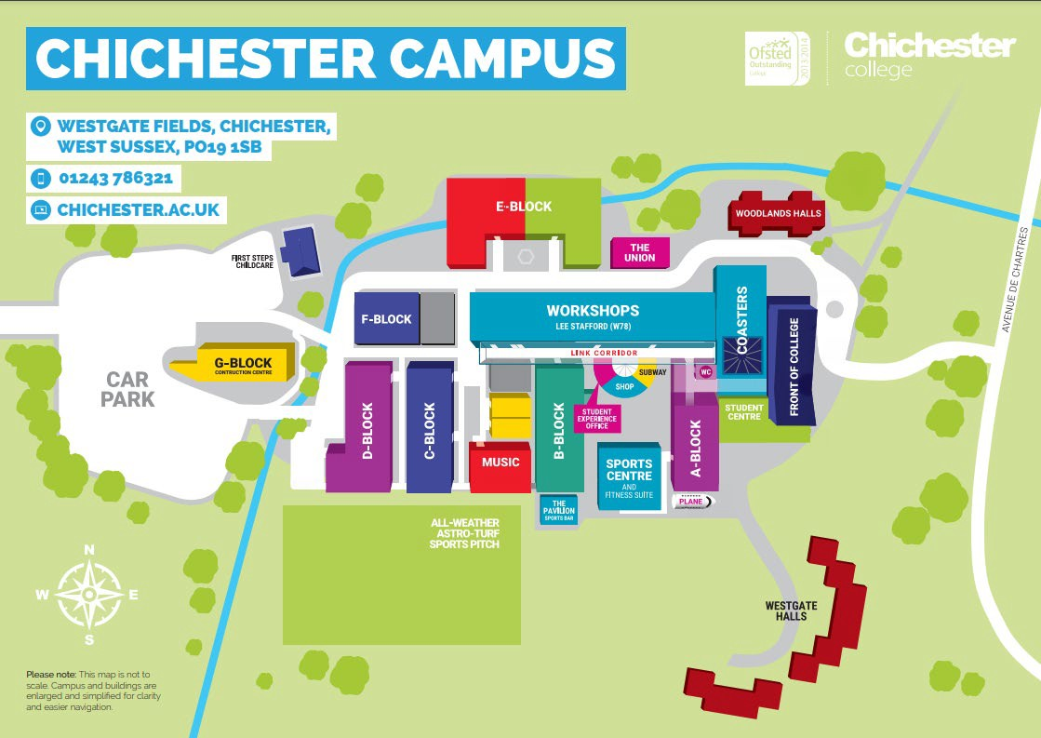

College Life

At Chichester College, you will find plenty of ways to enrich your learning experience.

All the information that you need about College Life, including term dates and travel is available on the website: College Life | Chichester College

