Course details

Course Code: CPUB017F1A
BTEC Level 3 NED in the Uniformed Protective Services
Duration: Sept ’23 to June ‘25
Campus: Chichester
Contact your Study Programme Leader
 01243 786321 ext. 2362
chris.waller@chichester.ac.uk
Welcome to Chichester College

Your induction will take place in the first week of your course, please do not be alarmed if you are disappointed with your exam results.

You can join our “YES” Day on Tuesday 29th August.
Please go to the college website; www.chichester.ac.uk to book your place.

Dear Student

Thank you for choosing to study here at Chichester College.

Congratulations on receiving the offer of a place on the National Extended Diploma in the Uniformed Protective Services.
I am your study programme leader, and I am looking forward to working with you over the next two years.

This letter is just a short communication to wish you every success in your forth coming GCSE results, plus to give you a brief overview on what will be happening in your first week, which is called Induction Week.

You will arrive in College on Monday 4th September, with your GCSE results, pen, and paper/laptop. You will also need sports kit, water, and food. There is a shop, café, and canteen on site. I would suggest bringing a padlock so you can have your own locker to store what you need. They are situated in the corridor next to your main classrooms in B-Block, on the top floor.
I will then photocopy your results and return them to you before the end of the day. You will also receive a programme for the week ahead.

Finally, you and your new class will be taking part in a Team Building Day during the week. It will incorporate aspects of adventurous activities. The aim is to put you out of your comfort zone and develop your teamwork, confidence etc with your peers and highlight future leaders. These are all very crucial skills to the uniformed services. This will incur a fee. It is usually around £50 but exact costs and details will be finalised very soon. Don’t forget, you can apply for a Learner Support Grant. You may be eligible, so please contact Student Finance to get more details.

You will receive further enrolment instructions from our Admissions Team during the Summer.
Please feel free to contact me with any questions you may have regarding the information regarding your course, such as trips, or course work and I will be happy to help.
Best wishes,
Chris Waller
C. Waller
Study Programme Leader

Important information about your Course

Timetables
The first few days of the course will be for induction and enrolment.
You will be invited to attend an enrolment and an induction, and you MUST attend BOTH to start your course.
Timetables for your course will not be available until you attend your induction.
This will give you the opportunity to get to know the other students on the course, as well as your lecturers and your student tutor.

Other Trips

There is a four-day residential trip to Wales at the end of April/early May to take part in Unit specific Outdoor Activities e.g., rock climbing, and gorge walking etc. This will be approx. £180.
Again, this will all be finalised nearer the time when we know student numbers.

Your Enrolment

Further to your starting information and an invitation to register your “Pre-enrolment” with the College; you should now have the following information ready for September:
- Your Student Number
- Your invitation to join your Induction Date which outlines your start date & time in September.

Should you not have either of these, please contact enrolments@chichester.ac.uk for further details.

Please ensure that when attending your enrolment you bring the following:

- Copy/Photo-shot of your Certificate(s) with your grades.
- Please bring a pen, paper & file
- Please bring presentable sports kit. We will be doing exercise on Induction day.
- Please produce/ bring a printed Microsoft Word document containing your ‘Short-, Medium- & Long-term’ ‘SMART goals’ for course intentions/ career aspirations.

If you are unsure of what this entails, please email admissions@chichester.ac.uk for further details.

English and Maths
NB: All students aged 16-18 years on a full-time course are required to update their English and Maths skills if they do not hold a GCSE grade A/9-C/4 in both subjects. So please be aware that if you do not have these qualifications, you will be required to undertake a GCSE re-sit (or equivalent qualification) alongside your main programme of study. This is compulsory and not optional. Please be aware that you cannot be awarded for one qualification without passing the oth
If you would like to ask for financial support to pay for these costs, please contact our Student Financial Support Team via the Chichester College website and read the information below.

Getting Support at College
The Learning Support Grant & Bursary
We understand that financial matters are an important consideration for our students and that everyone’s circumstances are different.
We believe financial constraints alone should never be enough to prevent a student from studying and so we will work with you to find out what support you may be entitled to and help you to access any funding available. You can apply online (via online portal) for the Learning Support Grant. We have tried
to make applying as simple as possible, but it will involve filling in online forms, providing evidence and telling us about your financial situation. We will then make an assessment based on your personal circumstances.

Contact
If you have any questions regarding student finance, please email studentfinance@chigroup.ac.uk and one of our team will be in touch to help.

MAP
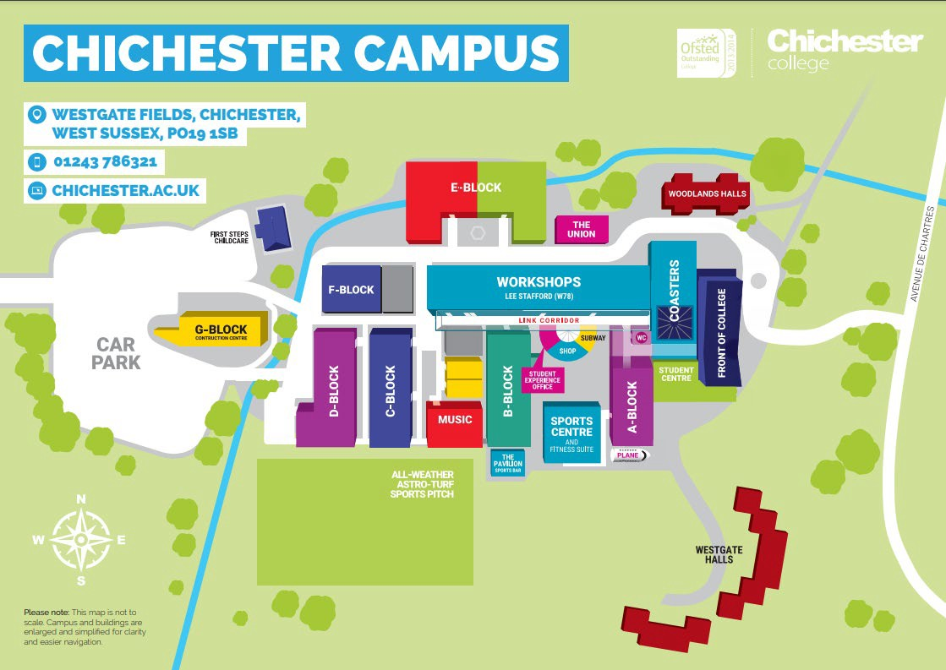

College Life

At Chichester College, you will find plenty of ways to enrich your learning experience.

All the information that you need about College Life, including term dates and travel is available on the website: College Life | Chichester College

