Welcome to Chichester College
Course details
Course Code: CSPO017CF1A
Duration: Sept ’23 to June ‘24
Campus: Chichester
Contact your Study Programme Leader
 01243 786321 ext. 2249
blakeye@chichester.ac.uk

Your induction will take place in the first week of your course, please do not be alarmed if you are disappointed with your exam results.

You can join our “YES” Day on Tuesday 29th August.
Please go to the college website; www.chichester.ac.uk to book your place.

Dear Student

Thank you for choosing to study Sport at Chichester College.
This will be your first year of a two-year diploma in Sport and Coaching; Level 3 National Extended Certificate in Sport.
I am the study programme leader; the sports team and I look forward to working with you over the next year.

Throughout this year you will study a variety of topics within the sporting industry.
You will experience both practical and theoretical methods of teaching and learning.
We also have exciting trips planned this year which include FTY Football Gym, Disability Awareness Day and many more!

Please feel free to contact me with any questions you may have regarding the information regarding your course, such as trips, kits or course work and I will be happy to help.

Best wishes,
Emma Blakely
Emma Blakely
Study Programme Leader

Important information about your Course

Timetables
The first few days of the course will be for induction and enrolment.
You will be invited to attend an enrolment and an induction, and you MUST attend BOTH to start your course.
Timetables for your course will not be available until you attend your induction.
This will give you the opportunity to get to know the other students on the course, as well as your lecturers and your student tutor.

Your Induction

Your induction will take place on campus. You will be taking part in a variety of theory and practical activities.
Please ensure that you bring:
- Please bring a pen, paper & a laptop**
- Please bring presentable sports kit. We will be doing exercise during your induction.
- Please produce/ bring a printed/saved Microsoft Word document containing your ‘Short-, Medium- & Long-term’ ‘SMART goals’ for course intentions/ career aspirations.

** We have long-term loan scheme of laptops if you are unable to afford a laptop/tablet.
If you are unsure of what this entails, please email admissions@chichester.ac.uk for further details.

Your Enrolment

Further to your starting information and an invitation to register your “Pre-enrolment” with the College; you should now have the following information ready for September:
- Your Student Number
- Your invitation to join your Induction Date which outlines your start date & time in September.

Should you not have either of these, please contact enrolments@chichester.ac.uk for further details.

Please ensure that when attending your enrolment you bring the following:

- Copy/Photo-shot of your Certificate(s) with your grades.

English and Maths
NB: All students aged 16-18 years on a full-time course are required to update their English and Maths skills if they do not hold a GCSE grade A/9-C/4 in both subjects. So please be aware that if you do not have these qualifications, you will be required to undertake a GCSE re-sit (or equivalent qualification) alongside your main programme of study. This is compulsory and not optional. Please be aware that you cannot be awarded for one qualification without passing the other.

Work Experience
As part of your course, you will complete work experience in the college’s sports Centre. You will undertake the role of recreation assistant and develop your skills required for the workplace.

KIT and other costs
Each student will pay £120 per year to cover the costs of course trips, visits, kit, and equipment.
This will be payable via the online shop. Details on how to do this will be given in induction week.
If you would like to ask for financial support to pay for these costs, please contact our Student Financial Support Team via the Chichester College website and read the information below.

Clubs and Fitness Suite
The College has a fitness suite, and sports academies which you can join in September, please speak to your Student Union representative or visit the College’s Sports Centre for more details on how to join and any costs. During your induction, there will be a Fresher’s Fair where you can find out more.
Getting Support at College
The Learning Support Grant & Bursary
We understand that financial matters are an important consideration for our students and that everyone’s circumstances are different.
We believe financial constraints alone should never be enough to prevent a student from studying and so we will work with you to find out what support you may be entitled to and help you to access any funding available. You can apply online (via online portal) for the Learning Support Grant. We have tried to make applying as simple as possible, but it will involve filling in online forms, providing evidence and telling us about your financial situation. We will then make an assessment based on your personal circumstances.

Contact
If you have any questions regarding student finance, please email studentfinance@chigroup.ac.uk and one of our team will be in touch to help.

MAP
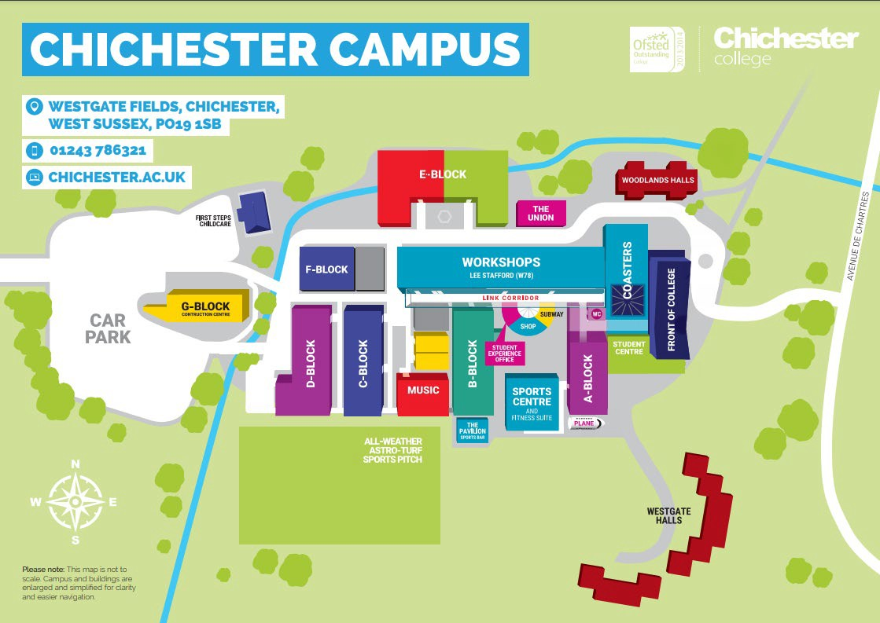

College Life

At Chichester College, you will find plenty of ways to enrich your learning experience.

All the information that you need about College Life, including term dates and travel is available on the website: College Life | Chichester College

To compliment your course, we have excellent sports and fitness facilities on site, as well as our Lee Stafford Hair Salon and Oasis Beauty Spa. There is also a well-stocked library and learning resource centre.
The campus is set in the heart of the city, with stunning views of the cathedral. Though relatively small, Chichester has everything you could expect from a larger city – bustling shops, including high street stores and independent retailers, cinemas, leisure/sports centre, bowling alley, museums, trampoline parks, restaurants, bars.

