Welcome to Chichester College
Course details
Course Code: CSPO037F1A Duration: Sept ’23 to June ‘24
Campus: Chichester
Contact your Study Programme Leader
 01243 786321 ext. 2321??
Hootonm@chichester.ac.uk

Your induction will take place in the first week of your course, please do not be alarmed if you are disappointed with your exam results.

You can join our “YES” Day on Tuesday 29th August.
Please go to the college website; www.chichester.ac.uk to book your place.

Dear Student

Thank you for choosing to study Extended Diploma in Personal Training at Chichester College. I am the study programme leader and look forward to working with you over the next year.

We are thrilled to have you join our community of aspiring personal trainers. Get ready for an exciting journey filled with knowledge, growth, and countless opportunities to make a positive impact in the lives of others.

As you embark on this course, here are some things to expect:

You will be learning from experienced trainers and industry professionals who are passionate about sharing their knowledge and helping you succeed. Expect insightful lectures, practical demonstrations, and hands on training that will equip you with the skills needed to excel in your personal training career.

Our course is designed to provide you with real world experience from day one. You can expect to apply your knowledge through practical exercises, client sessions, and case studies. This hands-on approach will enhance your understanding and prepare you for the challenges and demands of the personal training industry.

Prepare to be part of a supportive and collaborative learning environment. You will have the opportunity to interact and collaborate with fellow students, exchanging ideas, sharing experiences, and building a network of likeminded individuals who will support you throughout your journey.

Please feel free to contact me with any questions you may have regarding the information regarding your course, such as trips, kits or course work and I will be happy to help.

Best wishes,

Matt Hooton
Matt Hooton
Study Programme Leader

Important information about your Course

Timetables
The first few days of the course will be for induction and enrolment.
You will be invited to attend an enrolment and an induction, and you MUST attend BOTH to start your course.
Timetables for your course will not be available until you attend your induction.
This will give you the opportunity to get to know the other students on the course, as well as your lecturers and your student tutor.

Your Induction
Please ensure you bring sports kit for doing practical (with appropriate footwear for exercise).
Most of the day will be dedicated to spending time in the gym.
There is a compulsory expense that is required to be paid that day, as your books and learner portfolios need to be ordered in advance.

Your Enrolment

Further to your starting information and an invitation to register your “Pre-enrolment” with the College; you should now have the following information ready for September:
- Your Student Number
- Your invitation to join your Induction Date which outlines your start date & time in September.

Should you not have either of these, please contact enrolments@chichester.ac.uk for further details.

Please ensure that when attending your enrolment you bring the following:

- Copy/Photo-shot of your Certificate(s) with your grades.
- Please bring a pen, paper & file
- Please bring presentable sports kit. We will be doing exercise on Induction Day.
- Please bring £150 for your course material/compulsory supplement.

If you are unsure of what this entails, please email admissions@chichester.ac.uk for further details.

English and Maths
NB: All students aged 16-18 years on a full-time course are required to update their English and Maths skills if they do not hold a GCSE grade A/9-C/4 in both subjects. So please be aware that if you do not have these qualifications, you will be required to undertake a GCSE re-sit (or equivalent qualification) alongside your main programme of study. This is compulsory and not optional. Please be aware that you cannot be awarded for one qualification without passing the other.

Work Experience
During your time on the course, you will be required to undergo 60 hours of work experience within the health and fitness industry. Doing so will develop your knowledge within the industry and help improve your career-based skills. You are allowed to find your own work experience, but all worked hours and details of your employer must be documented. In the event you cannot find work experience, communicate with your lecturer and they will find you an employer.
Getting Support at College
The Learning Support Grant & Bursary
We understand that financial matters are an important consideration for our students and that everyone’s circumstances are different.
We believe financial constraints alone should never be enough to prevent a student from studying and so we will work with you to find out what support you may be entitled to and help you to access any funding available. You can apply online (via online portal) for the Learning Support Grant. We have tried
to make applying as simple as possible, but it will involve filling in online forms, providing evidence and telling us about your financial situation. We will then make an assessment based on your personal circumstances.

If you would like to ask for financial support to pay for these costs, please contact our Student Financial support Team via the Chichester College website and read the information below.

Contact
If you have any questions regarding student finance, please email studentfinance@chigroup.ac.uk and one of our team will be in touch to help.

MAP
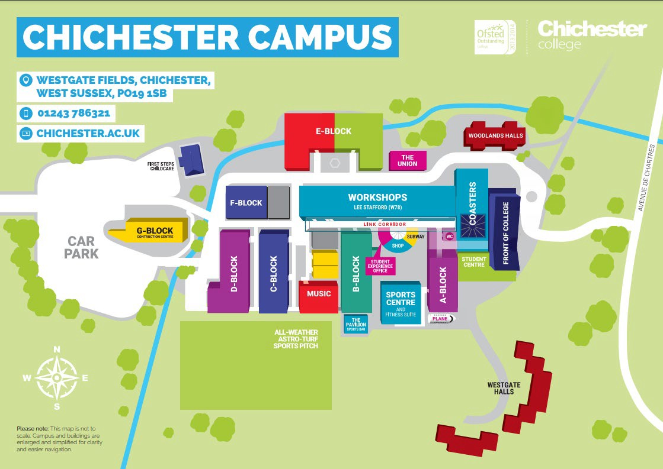

College Life

At Chichester College, you will find plenty of ways to enrich your learning experience.

All the information that you need about College Life, including term dates and travel is available on the website: College Life | Chichester College

To compliment your course, we have excellent sports and fitness facilities on site, as well as our Lee Stafford Hair Salon and Oasis Beauty Spa. There is also a well-stocked library and learning resource centre.
The campus is set in the heart of the city, with stunning views of the cathedral. Though relatively small, Chichester has everything you could expect from a larger city – bustling shops, including high street stores and independent retailers, cinemas, leisure/sports centre, bowling alley, museums, trampoline parks, restaurants, bars.

