Business & Management

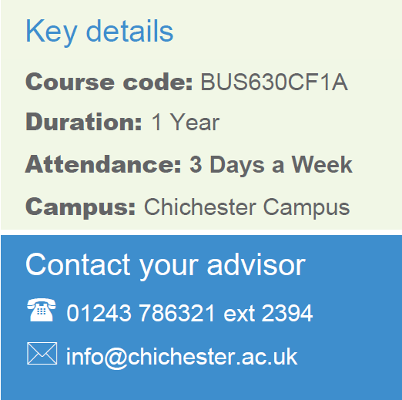
T Level in Accounting
CACC037F1A
2 Years
Chichester
Full Time
Contact your Study Programme Leader

2219
naomi.craig@chichester.ac.uk

Welcome to Chichester College

Dear Student

Thank you for choosing to study the T Level in Finance at Chichester College. I am the Study Programme Leader and look forward to working with you over the next year.

Below is a brief overview regarding coming to college and preparing to study your course.

Your first day is 4th September 2023, you should arrive at 9.15 am and come to the top floor of C Block. The first few days of the course will be for induction and enrolment. Timetables will not be available until this point. This will give you the opportunity to get to know the other students on the course, as well as your lecturers and your student tutor.

Please ensure that on your first day you bring the following:

- Confirmation of your GCSE results – You will not be enrolled on the course without this.
- A pen, paper & file
- Identification

If there are any trips associated with your course, you will be required to complete any attached consent forms
and submit to your course leader during induction week.

English and Maths
NB: It is a requirement of this course that you have gained 5 GCSEs at grade 5 or above to include Maths and English Language. If you do not gain these qualifications you will not be allowed to start this course.

Please feel free to contact me with any questions you may have regarding the above.

Best wishes,

Naomi Craig
Accounting Lecturer

Where will I be studying?
The course will take place at our Chichester campus. In C Block room C114
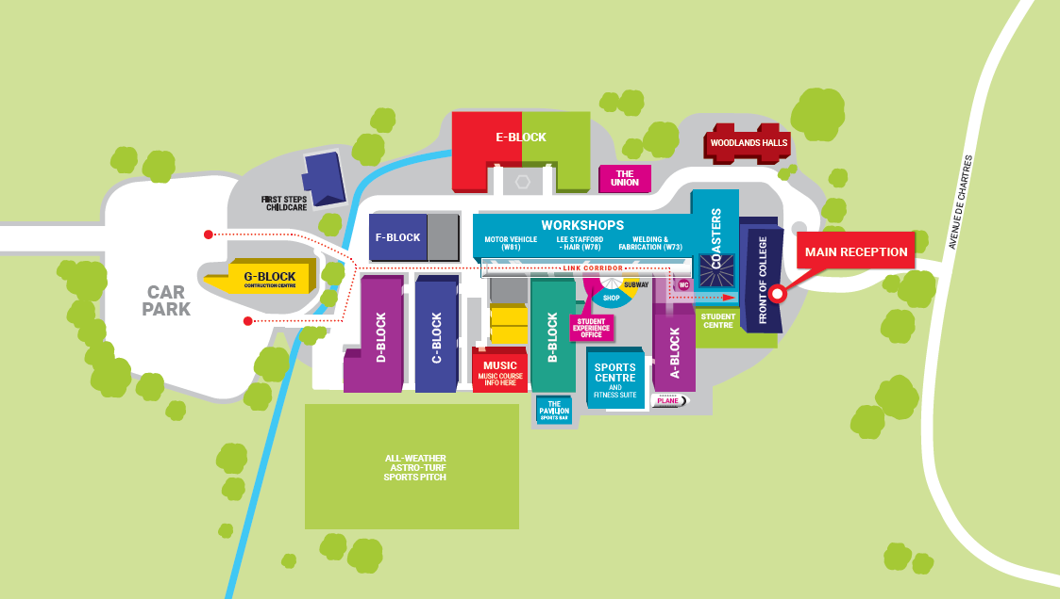

Summer Assignment

Summer Assignment

Activity 1: My Income and Expenditure

Using a spreadsheet, keep a record of all outgoings (spending) and incomings (saving/income) for a full week over the summer.

Activity 2: Accounting Terms

This is your first Flipped Learning Task. Please prepare definitions with examples for the following terms. These will form part of a test in your first week:

- Income Statement
- Statement of financial position
- Assets
- Liabilities
- Income
- Expenditure
- Capital
- Drawings
- Source Document
- Purchase invoice
- Sales invoice
- Bank paying in slip
- Bank statement

Activity 3: The Accounting Equation
- What is the accounting equation?
- Explain the Dual Effect principle.
- Research the dual effect on the accounting equation from different transactions.

Complete the gaps in the following table:

Assets £ | Liabilities £ | Capital £
20,000 | 0
15,000 | 5,000
16,400 |  | 8,850
 | 3,850 | 10,250
25,380 |  | 6,950
 | 7,910 | 13,250

- Complete the following table, using the dual effect principle:

Transaction | Effect on equation
Business buys a computer for use in the office | Increase in asset (computer)  Decrease in asset  (bank)
The owner invests new capital into a business bank account
Business buys a van on loan
Business pays a payable by cheque

Activity 4: Double – Entry Bookkeeping.

- In a few short sentences, describe double-entry bookkeeping.

Activity 5: Differences between the bookkeeper and accountant.

Nicola is setting up her own small business, as Nicola does not feel confident dealing with the money side of things, she is thinking of hiring someone to help her.

Explain the difference between the role of a bookkeeper and the role of the accountant. Make a recommendation to Nicola and justify your answer. (500 words).

Activity 6: The purpose of accounting

Explain what is meant by each purpose:
- Record the transactions of a business
- Prepare financial statements
- Monitor performance
- Assist in decision making

Can you add any other purposes to this list?

