Business, Learning and Development

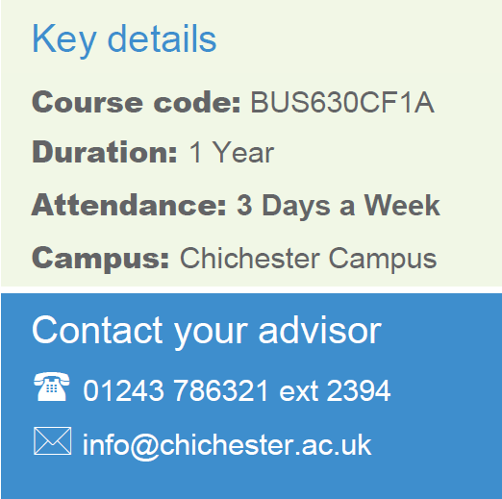
AAT Level 2 Certificate in Accounting
CACC043
1 Year
Chichester
Part Time
Contact your Study Programme Leader

2219
terryj@chichester.ac.uk

Welcome to Chichester College

Dear Student

Thank you for choosing to study your AAT Level 2 Certificate in Accounting at Chichester College. I am the Study Programme Leader and look forward to working with you over the next year.

Below is a brief overview regarding coming to college and preparing to study your course.

If you are studying in the evening, your first day in college will be Wednesday 13th September at 6pm, If you are studying during the day your first day in college will be Friday 15th September at 9:15am. Your first day/evening in college will concentrate on induction. This will give you the opportunity to get to know the other students on the course, as well as your lecturers and your student tutor.

Please ensure that on your first day you bring the following:

- Confirmation of your GCSE results for Maths and English – see below
- A pen, paper & file
- If applicable, payment for your course/evidence of benefits
- You will also need to purchase an AAT membership for £175 directly from the AAT
.

English and Maths
Students are expected to have a GCSE in Maths and English Language to enrol on this course. If you do not have these qualifications, you must enrol on the L2 functional skills English and/or Maths to sit alongside this course.

Please feel free to contact me with any questions you may have regarding the above.

Best wishes,

Jon Terry

Accounting Lecturers

Where will I be studying?
The course will take place at our Chichester campus. Please come to C Block room C118
