AAT L3 Diploma in Accounting
Contact your Study Programme Leader
01243 786321 ext. 2219
Dennett.Arlott@chichester.ac.uk
Course details
Course Code: CACC044D1B
Duration: Feb 2024 – May 2025
Attendance: 6 Hours per week
Campus: Chichester
BUSINESS, LEARNING & DEVELOPMENT

Welcome to Chichester College
Welcome to the AAT Diploma in Accounting Level 3.
The first day of your course is Tuesday 20th February 2024, starting at 9.15am and the course will take place in room C118 (C Block - First Floor - Room 18).
During this session we will introduce you to your new AAT course and ask you to complete an assessment based on your Level 2 knowledge. You will be given a schedule for your course. You will be required to attend the course every Tuesday from 9.15am to 4.15pm.
This level 3 course runs over 4 terms with and covers 5 units. Assessments may fall outside regular term dates. Due to this, it is important that you do not book any holidays during the scheduled period, or you may miss one of your exams.

Your enrolment schedule will be confirmed in the first lesson but you will need:
- Photographic identification
- Means of payment / bank details if setting up a Direct Debit
- Employer sponsorship form if employer is to be invoiced
- Evidence of the advanced learner loan having been set up
If you are applying for an advance learner loan please follow this link https://www.gov.uk/advanced-learner-loan/overview All the information you need to complete the application has been sent from the college, if you have not received your loan letter please contact Paula.Power@chichester.ac.uk
If you are new to Chichester college please bring your Level 2 AAT and maths and English GCSE certificates with you to your first session.
All offers for the level 3 are provisional and will be finalised at induction.
Please bring paper, pens and a calculator to your first session.
I look forward to meeting you soon
Dennett Arlott
Lecturer in Accounting
For more information phone 01243786321 extension 2219 or email Dennett.Arlott@chichester.ac.uk

Where will I be studying?
Chichester Campus
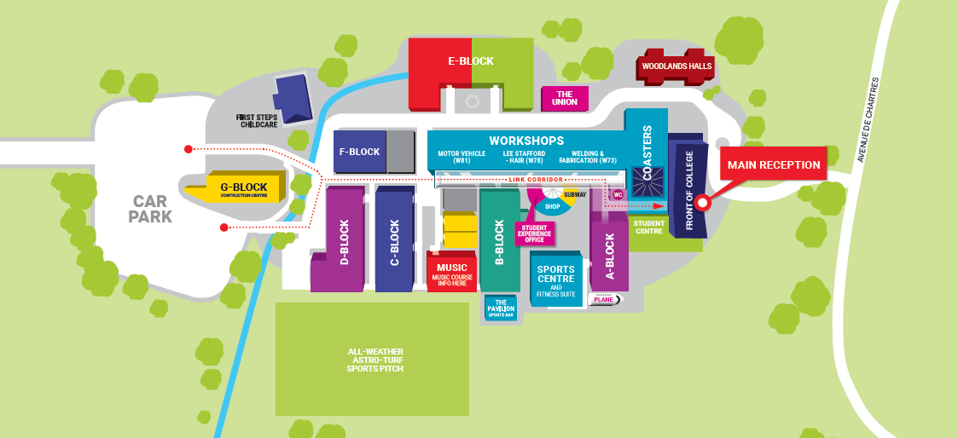

Additional Costs
You will be expected to purchase a copy of the course books, at a cost of around £15 to £18 each, details of which will be supplied during the first week of the course.
It will also be necessary for you to sign up with the AAT as a student member, the membership fee for the Level 3 course is £228.00 and this is to be paid directly to the AAT.

