Business & Management

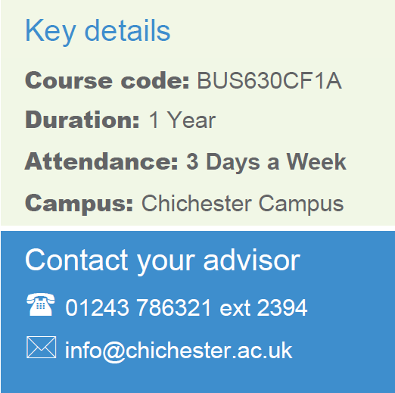
AAT Level 4 Diploma in Professional Accounting
CACC045
4 Terms
Chichester
Part Time
Contact your Study Programme Leader

2219
Anastasia.khomenker@chichester.ac.uk

Welcome to Chichester College

Dear Student

Thank you for choosing to study your AAT Level 4 Diploma in Professional Accounting at Chichester College. I am the Study Programme Leader and look forward to working with you over the next year.

Below is a brief overview regarding coming to college and preparing to study your course.

Your first day in college will be Tuesday 20th February 2023 at 9:15am. Your first day in college will concentrate on induction and include an entrance assessment based on your Level 3 knowledge. This will give you the opportunity to get to know the other students on the course, as well as your lecturer.

Please ensure that on your first day you bring the following:

- Confirmation of your GCSE results for Maths and English – see below
- Confirmation of your AAT Level 3 achievement
- A pen, paper & file
- If applicable, payment for your course/evidence of benefits/evidence of advanced learner loan.
- You will need to pay for an AAT student membership, the cost of this is £245.

If you are applying for an advance learner loan please follow this link https://www.gov.uk/advanced-learner-loan/overview All the information you need to complete the application has been sent from the college, if you have not received your loan letter please contact Paula.Power@chichester.ac.uk
.
English and Maths
Students have a GCSE in Maths and English Language to enrol on this course. If you do not have these qualifications, you must enrol on the L2 functional skills English and/or Maths and differ your enrolment to this course until these have been achieved.

Please feel free to contact me with any questions you may have regarding the above.

Best wishes,

Anastasia Khomenker

Where will I be studying?
The course will take place at our Chichester campus. Please come to C Block room C116
