Business, Learning and Development

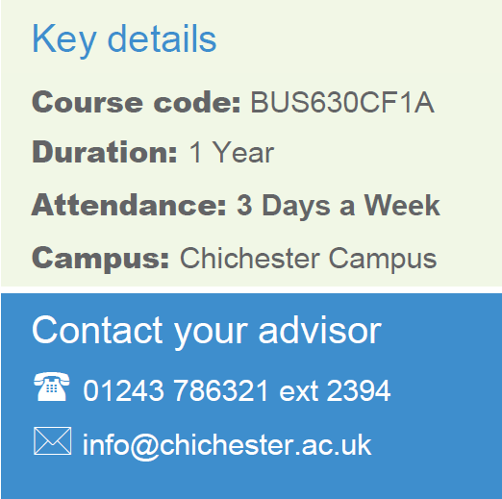
AAT Level 1 Award in Bookkeeping
CACC048D1A
16 Weeks
Chichester
Part Time
Contact your Study Programme Leader

2219
terryj@chichester.ac.uk

Welcome to Chichester College

Dear Student

Thank you for choosing to study your AAT Level 1 Award in Bookkeeping at Chichester College. I am the Study Programme Leader and look forward to working with you over the next year.

Below is a brief overview regarding coming to college and preparing to study your course.

You are studying in the daytime, your first day in college will be Monday 29th January at 13:00pm. You should go to C322. Your first day in college will concentrate on induction. This will give you the opportunity to get to know the other students on the course, as well as your lecturers and your student tutor.

Please ensure that on your first day you bring the following:

- A pen, paper & file
- If applicable, payment for your course/evidence of benefits
- You will need to purchase an AAT student membership for £48 directly from the AAT
.

Please feel free to contact me with any questions you may have regarding the above.

Best wishes,

Jon Terry

Accounting Lecturer

Where will I be studying?
The course will take place at our Chichester campus. Please come to C Block room C322
