Business & Management

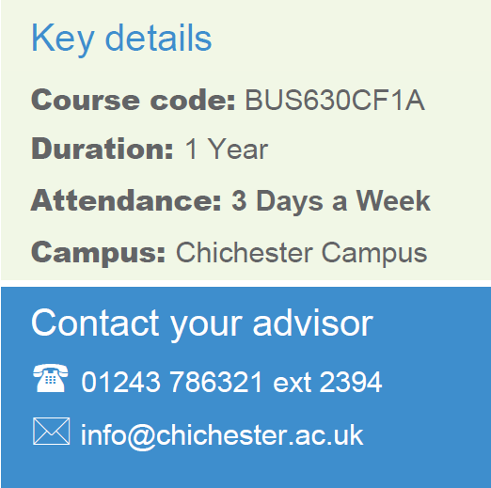
BTEC LEVEL TWO FIRST EXTENDED CERTIFICATE IN BUSINESS
CBUS004F1A

1 Year
Chichester
Full time
Contact your Study Programme Leader

2258
smithv@chichester.ac.uk

Welcome to Chichester College

Dear Student

Thank you for choosing to study on the Level Two Business BTEC course at Chichester College. I am the Study Programme Leader and look forward to working with you over the next year.

Below is a brief overview regarding coming to college and preparing to study your course. These are the key dates that you need to attend

Your first day of induction: Tuesday 5th September, arrive at 9am to finish at 3.30pm
Normal timetable starts: Monday 11th September 2023 at 9.15am

The first few days of the course will be induction and enrolment. Timetables will not be available until this point. This will give you the opportunity to get to know the other students on the course, as well as your lecturers and your student tutor.

Please ensure that on your first day you bring the following:
- YOUR GCSE RESULTS - we must see the original results slip from your school; you will not be enrolled without it.
- A pen, paper & folder
- Completed consent forms attached – some will need a parent or guardian’s signature.
- Your summer assignment work – see page 3 of this letter for assignment brief.

English and Maths
NB: All students aged 16-18 years on a full-time course are required to achieve their English and Maths skills if they do not hold a GCSE grade A/9-C/4 in both subjects. So please be aware that if you do not have these qualifications, you will be required to undertake a GCSE resit alongside your main programme of study. This is compulsory.

Please feel free to contact me with any questions you may have.

Best wishes,

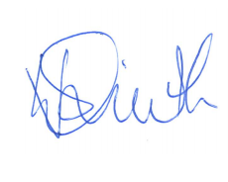
Vicki Smith
Study programme leader

Where will I be studying?

Business and Management courses in C Block
The course will take place at our Chichester campus.
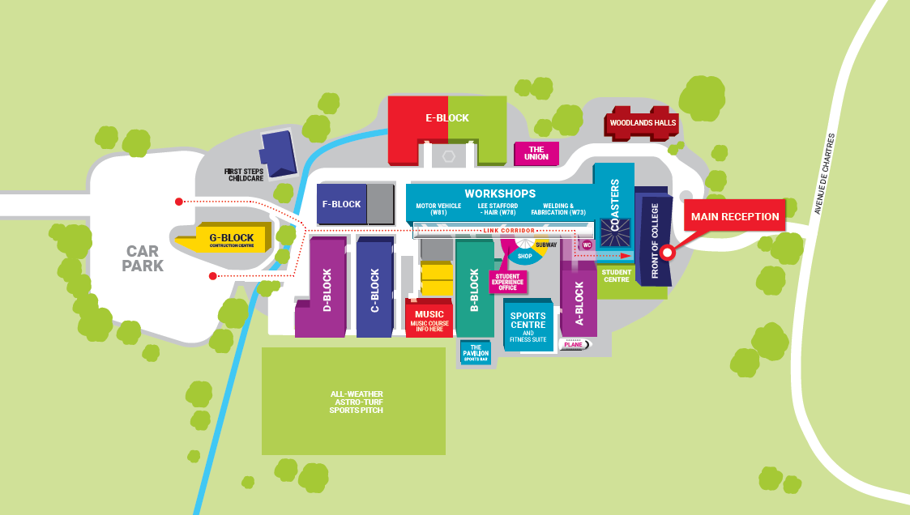

SUMMER ASSIGNMENT – PROGRESSION WORK

To be completed and brought with you to induction
TASK 1 – Work placement task
When you begin your studies here at the college you will be enrolled on a study programme. The study programme consists of your main course (Business), Maths and English resits and work experience.

The work experience you carry out will be at our student run retail shop ‘The shop around the corner’ where you will be assisting in the planning and running of the shop. Currently the shop sells stationery and books, with seasonal promotions throughout the year.

To prepare you for your placement you have been asked to think about an event we could run at the shop to help boost our sales. The event could take place at any time during the year, and you are free to be as creative as you wish.

There is no word count for Task 1

TASK 2 – Course related task
One of the units you will study is ‘Enterprise in the Business world’. To help prepare you for your studies you have been asked to answer the following questions.

1. Choose 1 business that you have an interest in and describe how it has been affected by the current economic situation.
2. What makes a business successful?
3. Describe 3 successful businesses that you know and explain the features that make them successful

Your task 2 report should be at least 500 words.

SUGGESTED BOOKS – not mandatory

The course main textbook is - BTEC First Business, Pearson ISBN 978–1-4469-0136-6.

Revision book for Finance and Marketing exams – Revise BTEC First Business- Unit 2 & 9

https://www.amazon.co.uk/BTEC-First-Business-Revision-Workbook/dp/1446906698/ref=pd_lpo_1?pd_rd_i=1446906698&psc=1

CONSENT FORMS – MUST BE SIGNED AND BROUGHT WITH YOU ON YOUR FIRST INDUCTION DAY

Forms can be found on the following pages, please complete all of them and bring them with you on induction day.

If you have a part time job, please fill out a work experience for that job as well as the college shop.

If you are under 18, the work experience and trips forms need to be signed by a parent or guardian.

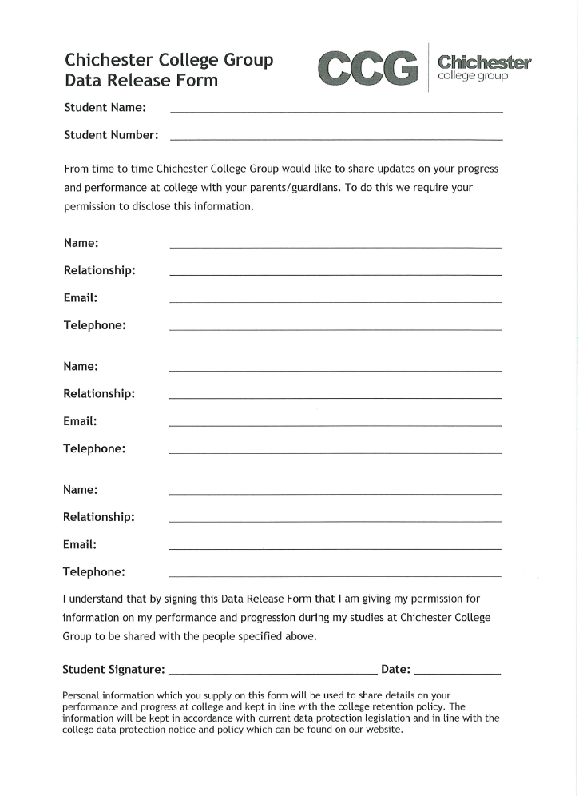
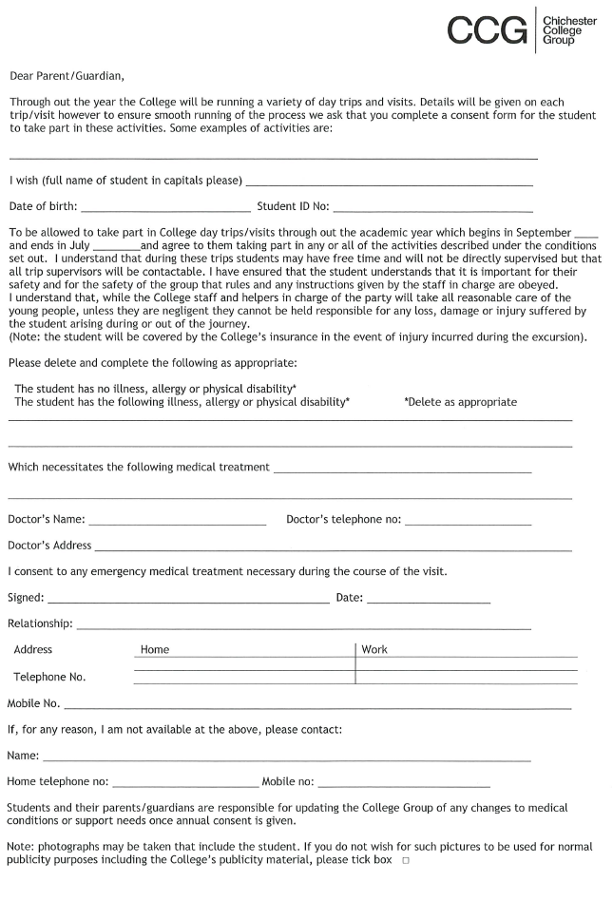
UNDER 18s – MUST BE SIGNED BY PARENT OR GUARDIAN

UNDER 18s – MUST BE SIGNED BY PARENT OR GUARDIAN – for part time job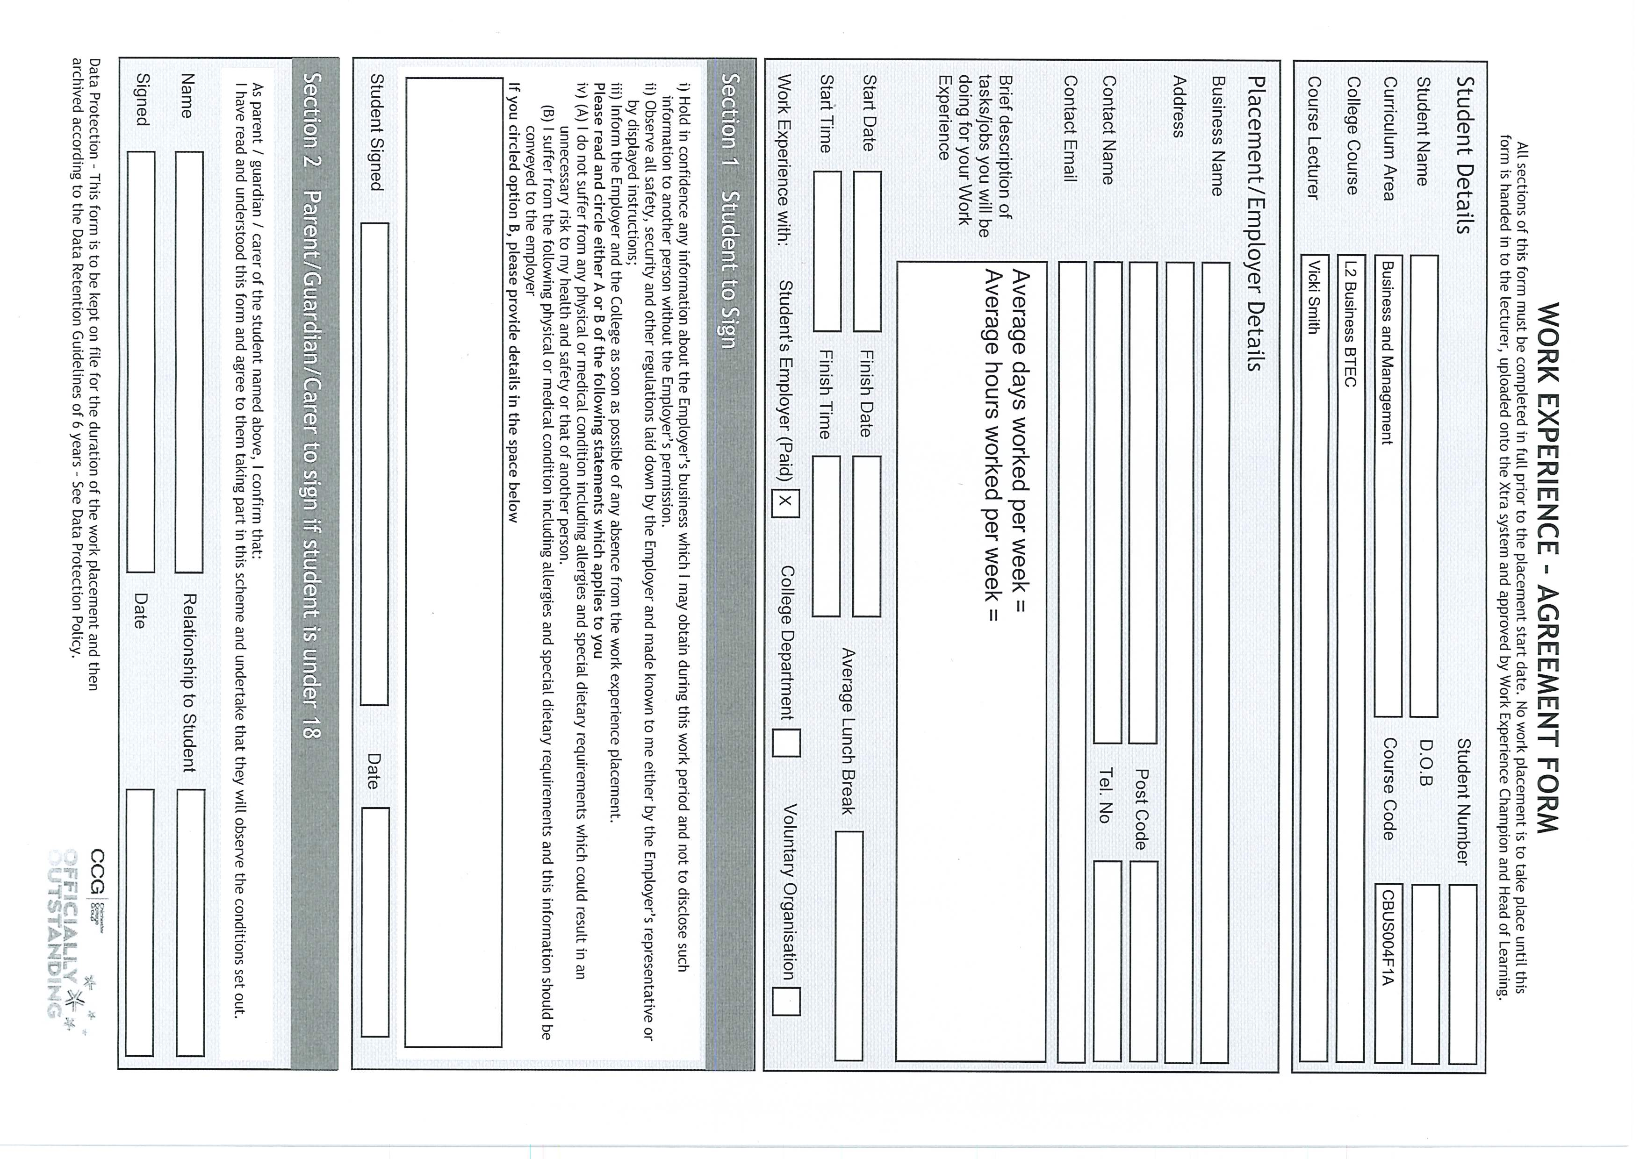

UNDER 18s – MUST BE SIGNED BY PARENT OR GUARDIAN – for working in college shop
