Business & Management

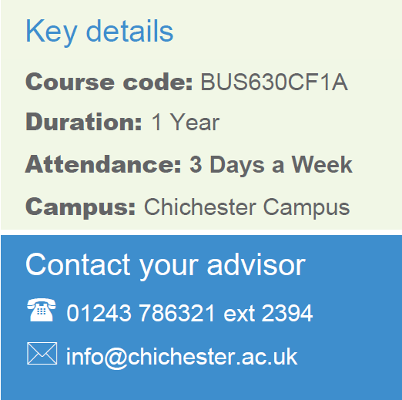
Level 3 T Level in Legal Services
< CLAW022F1A>
<2 years>
<Chichester>
<Full Time>
Contact your Study Programme Leader

2379>
stuart.cuthbert@chichester.ac.uk>

Welcome to Chichester College

Dear Student

Thank you for choosing to study at Chichester College. I am the Study Programme Leader and look forward to working with you over the next year.

Further to your starting letter, which outlines your start date & time, below is a brief overview regarding coming to college and preparing to study your course.

If your course requires the purchase of uniform or kit, you will find attached order forms to complete. Please order as soon as possible to guarantee delivery in time for start date.

The first few days of the course will be for induction and enrolment. Timetables will not be available until this point. This will give you the opportunity to get to know the other students on the course, as well as your lecturers and your student tutor.

Please ensure that on your first day you bring the following:

- Confirmation of your GCSE results – we cannot enrol you without a copy of results so this is essential
- A pen, paper & file
- If applicable, payment for your course/evidence of benefits
- Your Summer assignment

If there are any trips associated with your course, you will be required to complete any attached consent forms
and submit to your course leader during induction week.

English and Maths
NB: All students aged 16-18 years on a full time course are required to update their English and Maths skills if they do not hold a GCSE grade A/9-C/4 in both subjects. So please be aware that if you do not have these qualifications, you will be required to undertake a GCSE resit (or equivalent qualification) alongside your main programme of study. This is compulsory and not optional. Please be aware that you cannot be awarded for one qualification without passing the other.

Please feel free to contact me with any questions you may have regarding the above.

Best wishes,
Stuart Cuthbert, Lecturer in Law & Criminology

Where will I be studying?
The course will take place at our Chichester campus.
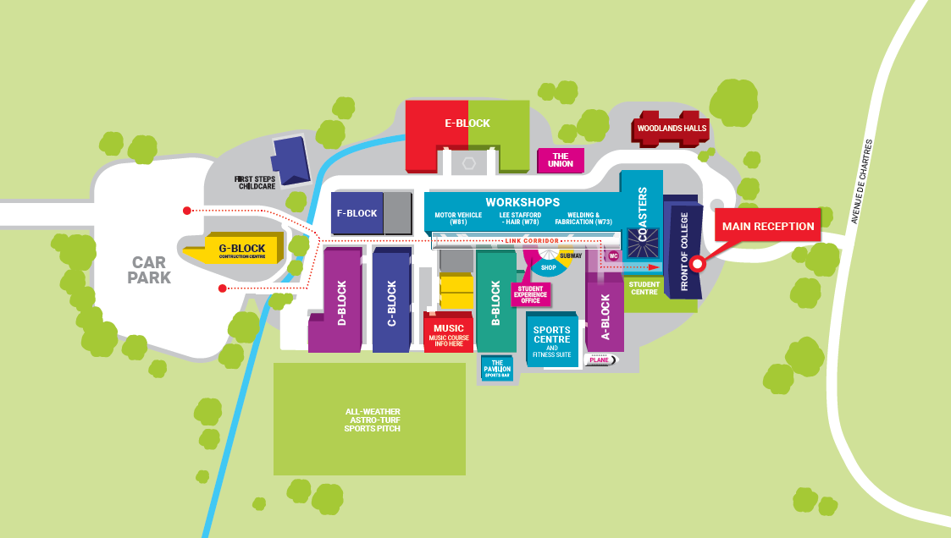

Summer Assignment

Research how a person can seek advice if they have a legal dispute with another person. Consider the following:
- The job titles of legal professionals and what do they do
- Any alternative ways to seek advice instead of using a legal professional
- How a problem can be resolved either in and out of court

Trips
Trips (If applicable)

Reading List

Reading List (if applicable)

Kit List

Kit List (If applicable)

