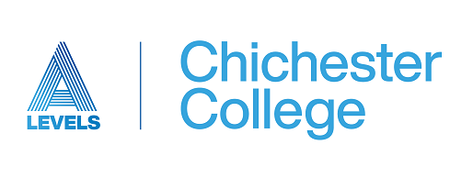

If you are applying for any of our Art courses (Fine Art, Graphic Communication, or Photography) we would like to see some of your creative work before we offer you a place. We have separate tasks for each subject but, if you are applying for more than 1 art based subject, you only need to produce 1 sample of work.

Please bring your work with you to your Interview. If you have a phone interview, please submit your creative work to [alevelinterviews@chichester.ac.uk](mailto:alevelinterviews@chichester.ac.uk) 7 days before your interview.

***We are really interested in seeing work that you are proud of and that shows a true picture of your ability and potential.***

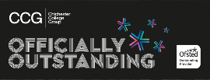  

**A-Level Fine Art**

We would like to see the best of your work. To ensure that you are suited to this course we ask you to construct a portfolio of your best pieces of artwork. You should have between 4-6 pages. This ideally will be submitted digitally to [alevelinterviews@chichester.ac.uk](mailto:alevelinterviews@chichester.ac.uk). The A-Level Art Lecturers will look at this prior to your interview, this will allow us to raise any questions around the suitability for the course.

For the portfolio please include:

* A collection of artworks (4-6 pages) that are of the same theme (*potentially from a GCSE project*) this could be sketchbook pages, boards or single artworks that are related with a brief description of each.
* To show diversity, artworks using
  + *(two or more of the following different media Paint/ Collage / Sculpture / Printmaking) produced*
  + This can be anything that you are proud of!

**A-Level Photography Portfolio**

We would like to see the best of your work. You may be thinking about joining A-Level Photography having done a GCSE or just as a keen amateur, both are valid pathways. To ensure that you are suited to this course we ask you to construct a portfolio of your best images. You should have between 10-15 images. This ideally will be submitted digitally to [alevelinterviews@chichester.ac.uk](mailto:alevelinterviews@chichester.ac.uk). The A-Level Photography Lecturers will look at this prior to your interview, this will allow us to raise any questions around the suitability for the course.

For the portfolio please include:

* A collection of images (4-6) that are off the same theme (*potentially from a GCSE project*) with a brief description of the purpose of the images.
* To show diversity, images displaying different genres
  + *(two or more of the following Portrait / Landscape / Still Life / Documentary)*
* A few of your best images that you have taken
  + This can be anything that you are proud of!

**A-Level Graphics Portfolio**

We would like to see the best of your work. You may be thinking about joining A-Level Graphics having done a GCSE in Graphics or Art and Design or just as a keen amateur, both are valid pathways. To ensure that you are suited to this course we ask you to construct a portfolio of your best images/artwork. You should have between 10-15 pieces of work. This ideally will be submitted digitally [alevelinterviews@chichester.ac.uk](mailto:alevelinterviews@chichester.ac.uk). The A-Level Graphics Lecturers will look at this prior to your interview, this will allow us to raise any questions around the suitability for the course.

For the portfolio please include:

* Artwork
  + A demonstration of your artistic abilities
    - This could be digital artwork or traditional painting/drawing/collage/etc
* Photographs
  + Demonstrate your eye for a great image
    - Show us the best photographs that you have taken, this can be of any subject matter (*Portrait / Landscape / Still Life / Documentary/Action/etc)*
* Anything Other
  + Anything that doesn’t fit the boxes above that you are proud of
    - *For Example: This may be work from Product/3D Design*

Please send the images of your work in an email to Alevels@chichester.ac.uk. You can upload images of your work into a PowerPoint, google slides or another presentation format such as Word or Indesign. If you want to send individual images, please be aware that these might be too large to send in a single email so consider putting them in a folder and zipping it or sending via a file transfer service such as WeTransfer.

We wish you good luck in your interview.

