Preparing for your

A Level Interview

Name: College Number: 500

Thank you for applying for A-levels at Chichester College.

Please complete these questions in as much detail as you can.

Please email this to ALevelinterviews@chichester.ac.uk.

1. Whatever educational path you choose for your next step, the most important thing is that it is the right path for you. You could choose A-levels, a vocational course such as a BTEC Level 3 Extended Diploma, T-Levels or an Apprenticeship. What is the difference?

2. Why have you chosen A-levels and why do you think this is the best path for you?

3. Do you perform better in coursework elements or do you perform better with examinations? Why do you think this is?
4. What is your future goal? What do you want to do after A-levels? What qualifications do you need to achieve that future goal? (e.g. Have you looked up the entry requirements on the UCAS website for a degree you might have identified?) If you are unsure of your future goal, it is fine just to write that.

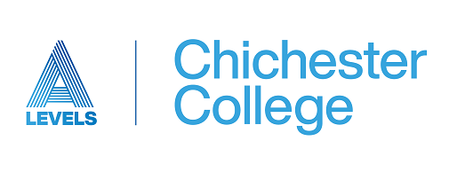

5. Successful A-level students need to be resilient, well organised, able to study independently and work well under pressure. Describe a situation where you have demonstrated one or more of these skills. Which of these skills do you feel you need to work on?

6. What subjects have you chosen and why? Briefly outline what you know about each subject and why you have chosen it.

Subject 1:

Subject 2:

Subject 3:

Subject 4: (available for students who achieve six GCSEs grade 9-7 (A*-A) and needs 4th subject for University, e.g. Medicine, Dentistry etc).

7. Do you have any specific questions or queries that you would like to ask at your interview?

Please email this to ALevelinterviews@chichester.ac.uk.

