GCSE to A LEVEL
Summer Project
Name:
Subject: A Level Business

The purpose of this A Level Summer project is to introduce you to studying this subject at A Level standard. You will need to complete 10 hours of study on each subject every week, 4½ in class with your teacher and the rest as independent learning. Therefore, it is important that you enjoy this subject and that you start to practice your study skills as early as possible. Some subjects have significant maths content (for example business, psychology, economics); others require strong essay writing skills (for example history, English). Think about the study skills and underpinning knowledge you will require in this subject – not just the title.

If after completing this project you think this may not be your ideal choice, you can ask to transfer to another subject at the start of term, as long as you have the entry requirements and it fits alongside your other choices on the A Level Matrix (timetable). If you do decide to change subject, you will be required to complete the Summer project for your new choice too.

This is also your first taste of Flipped Learning and elements will be used within your first week of lessons.

Please ensure your name, student number and subject are clearly noted on each page and bring it with you to hand in at Enrolment.

We hope you enjoy this project as you start your A Level journey.

Have a good summer and we look forward to seeing you in September.

HOW TO SUBMIT:
Please print your completed project and bring a copy with you to Induction in a clearly labelled plastic wallet.
If you don’t have access to a printer, electronic copies can be emailed as a Word or PDF attachment to ALevel_Business@chichester.ac.uk with the email clearly labelled ‘Business Summer Project’ prior to Induction.

GCSE to A Level Business
Summer Project
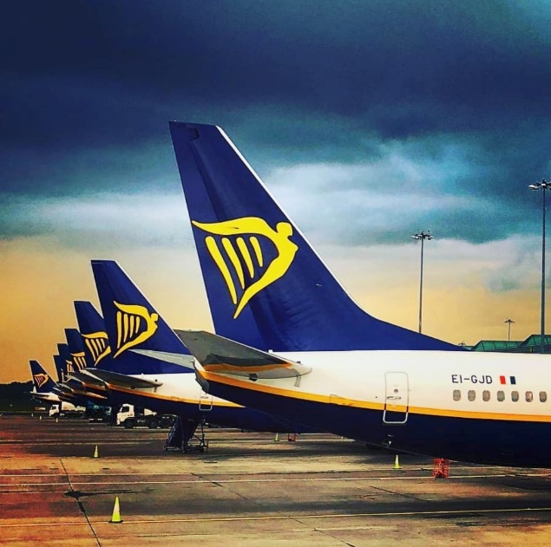
Task 1 – Business essay

Task 2 – Business numeracy skills check

Task 1 – Using your own knowledge and research around pricing strategies, you are required to write an essay of 1000 words (as a minimum).
Your answer should include:
Definition of pricing strategies, along with a few examples of what strategies businesses may use.
You are to analyse the benefits and drawbacks of Ryanair's current pricing policy and provide evidence from the case study that backs these points. You need to consider the question - what impact does the pricing strategy have on Ryanair's finances?
Finally, you need to write a conclusion that includes a clear judgement - is Ryanair's pricing strategy correct? If so, justify why, if not, why not and how they should change their pricing. What impact will this have on their finances? Is the pricing strategy correct in the short-term but needs to be changed in the long-term?
You may use a word processor or hand write your answer to this question. Please ensure you name is on every page you submit.

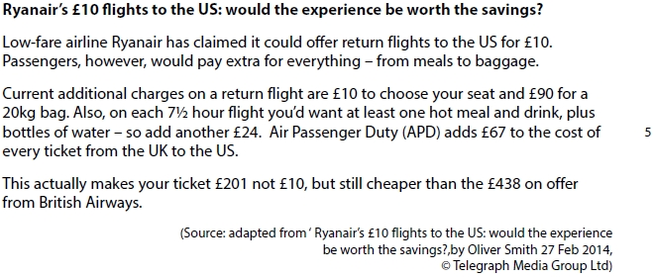

Evaluate the likely impact on the finances of a business of using a pricing strategy such as that used by Ryanair.

Task 2 – Please answer all of the following questions. Remember to show your workings.

Q1 | Balti Towers is an Indian takeaway that also offer a delivery service. Last year, the business delivered 1,400 curries. This year, the owner estimates that they will deliver 1,512 curries.  Calculate the estimated percentage increase in curry deliveries.
Your workings:

Q2 | School of Choc is a confectionary manufacturer located in County Durham. The business employs 120 staff. The ratio of male to female staff is 2:3.  Calculate how many female staff School of Choc employs.
Your workings:

Q3 | Jimmy Chews is a sweet shop located in Wetherby. This year, the owner estimates that the business, which also sells soft drinks, will sell 3,360 cans of coca cola, 5% more than last year.  Calculate how many cans of coca-cola Jimmy Chews sold last year.
Your workings:

Q4 | Bubblicious is a hot tub manufacturer located in Chester. Their hot tubs retail for £4,500. The manufacturing cost per hot tub is 2/5 of the selling price.  Calculate the cost of manufacturing one hot tub.
Your workings:

Q5 | The chart below shows the number of hot tubs Bubblicious sold between 2014 and 2017. The owner estimates that in 2018, hot tub sales will be 5% lower than in 2017.  Calculate the average annual sales of hot tubs between 2014 and 2018.
Your workings:

Q6 | Melchester Rovers Football Club can seat 42,000 spectators. Last week, when they played Harrogate Town, there were 36,960 spectators.  Calculate the percentage of empty seats.
Your workings:

Q7 | A family of four, on holiday in the UK from Spain, visited the ‘Whale of a Time’ sea life centre in London. The total entrance cost for the family was £90.  Assuming an exchange rate of £1: €1.08, calculate the total entrance cost in Euros.
Your workings:

Q8 | Loft in Space, a manufacturer of loft insulation, took 80 of its employees on a two-day team-building trip to an outdoor activity centre in the Lake District. The total cost of the trip was £9,600. The accommodation cost per employee was 3/5 of the total cost per employee.  Calculate the accommodation cost per employee.
Your workings:

Q9 | Tea-Total is a café in Cumbria. Below is a pie chart showing the percentage of drinks purchased for a group of 200 customers.  (A) Calculate how many customers purchased a coffee  (B) Calculate how many customers did not purchase a tea  (C) Calculate the fraction of customers that purchased a Latte
Your workings:

Q10 | Graham Riley is an employee of Father Treads, a business that specialises in car tyres. Graham attends a meeting at Head Office, travelling 60 kilometres each way. Graham is entitled to claim travel expenses at 45p per mile.  Based on the assumption that 10 kilometres is equivalent to 6 miles (approximately), calculate how much Graham is entitled to claim.
Your workings:

Q11 | Car-tastrophe is a car showroom based in Stanhope. The business consists of one manager and 3 salespersons, Jim, Jon and Joseph. Each month, a sum of money is paid as a bonus and is divided in the ratio of the number of cars each salesperson has sold. Jim sold 7 cars, Jon sold 8 cars and Joseph sold 9 cars. Joseph received £1,125  Calculate how much money Jim and Jon received.
Your workings:

Q12 | Barber Streisand is a hair-dressing salon located in Sunderland. The owner, Barbara, recently introduced a new system of rewarding her staff. At the end of the week, Barbara puts the following in a bag:  5 x £10 notes  4 x £20 notes  3 x £50 notes  At the end of the week, the hairdresser who has provided the best service can select a note from the bag as a reward.  Calculate the probability of not selecting a £10 note.
Your workings:

Q13 | Frame, Set and Match is a picture framing business with several shops across the North East of England. The business has 90 employees, of which 54 are female.  Calculate, in the lowest possible terms, what fraction of the total employees are male.
Your workings:

Q14 | Wooden it be Lovely is a small manufacturer of wooden children’s toys. Last week, the business produced 32,000 toys, of which 40% were checked for quality. Of the 40% checked, 1/5 had a defect.  Calculate how many wooden toys were found to not have a defect.
Your workings:

Q15 | Sparked Out is a retailer of electrical products located in County Durham. The owner, Joseph Sparks, is analysing the sales figures of two product lines, the Lavazza coffee machine and the Breville toaster.  In 2017, the total value of Lavazza coffee machine sales was £12,100 whilst the total value of Breville toaster sales was £5,292. Joseph noticed that the sales of Lavazza coffee machines have been increasing by 10% per year, whilst sales of Breville toasters have been increasing by 5% per year, over the last two years.  Calculate the total sales value of Lavazza coffee machine sales and Breville toasters in 2015.
Your workings:

