GCSE to A LEVEL
Summer Project
Name:
Subject: A Level English Language & Literature

The purpose of this A Level Summer project is to introduce you to studying this subject at A Level standard. You will need to complete 10 hours of study on each subject every week, 4½ in class with your teacher and the rest as independent learning. Therefore, it is important that you enjoy this subject and that you start to practice your study skills as early as possible. Some subjects have significant maths content (for example business, psychology, economics); others require strong essay writing skills (for example history, English). Think about the study skills and underpinning knowledge you will require in this subject – not just the title.

If after completing this project you think this may not be your ideal choice, you can ask to transfer to another subject at the start of term, as long as you have the entry requirements and it fits alongside your other choices on the A Level Matrix (timetable). If you do decide to change subject, you will be required to complete the Summer project for your new choice too.

This is also your first taste of Flipped Learning and elements will be used within your first week of lessons.

Please ensure your name, student number and subject are clearly noted on each page and bring it with you to hand in at Enrolment.

We hope you enjoy this project as you start your A Level journey.

Have a good summer and we look forward to seeing you in September.

HOW TO SUBMIT:
Please print your completed project and bring a copy with you to Induction in a clearly labelled plastic wallet.
If you don’t have access to a printer, electronic copies can be emailed as a Word or PDF attachment to ALevel_EnglishLangandLit@chichester.ac.uk with the email clearly labelled ‘English Language & Literature Summer Project’ prior to Induction.

English Language and Literature

GCSE to A-Level Summer Work

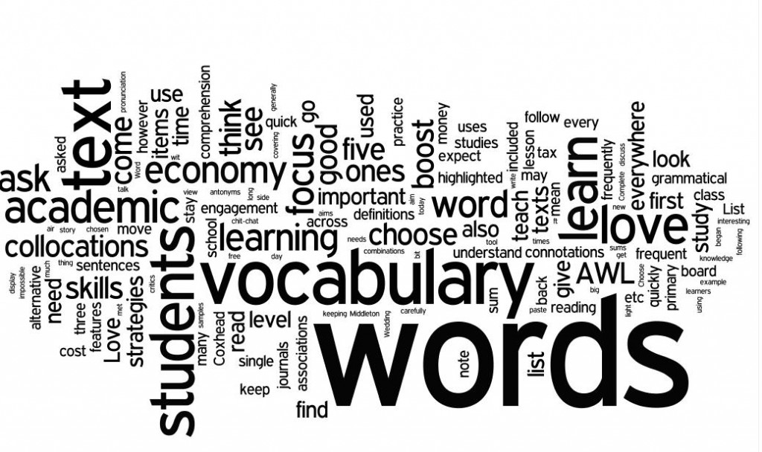
The key skills needed are:

- The ability to read and analysis texts with a focus on the integration of language and literature.
- Students will see how linguistic and literary methods are related, and to explore these links in their studies.
- A range of writing skills will be developed, such as re-creative writing, commentary writing, discursive essays and research-based investigative writing, which allows students to develop a wide range of skills. These include the ability to read critically, analyse, evaluate and undertake independent research.

Welcome to English Language and Literature

In the first unit, in English Language and Literature we study a piece of prose text ‘The Handmaid’s Tale,’ by Margaret Atwood to be able to understand and analyse this text in detail, it is recommended that students read the text several times.

In order to be able to develop different perspectives on the text this will need to be read over the summer break and notes made about the plot of the text.

Activity 1: To write a book review of ‘The Handmaid’s Tale’ by Margaret Atwood.

Students will need to research what a book review entails, by obtaining several examples to aid their understanding; these should be kept in a scrap book to help the re-creative tasks that we will be undertaking later in the course. Students should then write a detailed book review of ‘The Handmaid’s Tale,’ giving a brief overview of the text, their opinion of the text and a rating. The book review should be about 800 words in length.

Activity 2: To complete a research project on the city Paris.

Students will complete a study of the AQA Anthology: Paris. The anthology includes a wider range of texts types with a particular emphasis on non-fiction and non literary material. In this part of the subject content, students explore speech and other genres. They study a wide range of linguistic and generic features, as well as related issues around questions of representation of viewpoint in texts, which are taken from a range of time periods. The texts follow the representation of narratives and how these are constructed through the sense of the writers’ personal journeys and the influences of contextual factors such as time period, race, social class and gender.
In order to be able to develop an understanding of these texts a detailed research task needs to be undertaken to understand the background of the city of Paris. Using the following headings ‘History’, ‘Politics’, ‘Social’ and ‘Culture’ identify key information to aid your understanding of the city of Paris. The research should take the form of an essay, writing approximately 1000 words.

Students will also need to provide a bibliography of where research has been taken from, website addresses, text book names etc.

This will need to be submitted at the beginning of term.

I hope you enjoy your first taste of exploring English Language and Literature and I look forward to seeing you in September.

Kind regards

Kerrin Adamson

