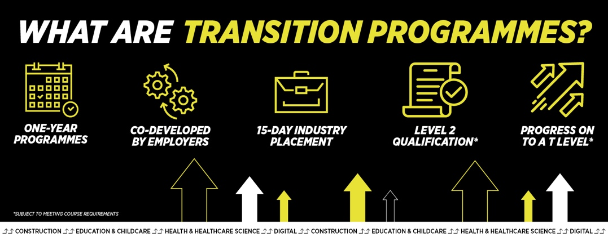
Course details
Duration: Sept ’23 to June ‘24
Attendance: 15 Hours per week
Campus: Crawley, ATC
Engineering Transition Level 2
Course Area – Engineering
Welcome to Crawley College
Contact your Study Programme Leader
01293 442200 ext. 2312
skerr@crawley.ac.uk

Dear Student

Thank you for choosing to study Engineering Transition Level 2 at Crawley College. I am the study programme leader and look forward to working with you over the next year. The T Level Transition Programme is a new type of 16 to 19 study programme, specifically designed to develop the skills, experience, knowledge and behaviours to support progression on to and success on a T Level. It is targeted at students who are not ready to start a T Level but have the potential to progress onto one following a tailored preparation programme.

Further to your starting information, which outlines your start date & time, below is a brief overview regarding coming to college and preparing to study your course.

Your course requires the purchase of uniform or kit.

The first few days of the course will be for induction and enrolment. Timetables will not be available until this point. This will give you the opportunity to get to know the other students on the course, as well as your lecturers and your student tutor.

Please ensure that on your first day you bring the following:

- Confirmation of your GCSE results – we cannot enrol you without a copy of results so this is essential
- A pen, paper & file
- If applicable, payment for your course/evidence of benefits

If there are any trips associated with your course, you will be required to complete any attached consent forms and submit to your course leader during induction week.

English and Maths
NB: All students aged 16-18 years on a full time course are required to update their English and Maths skills if they do not hold a GCSE grade A/9-C/4 in both subjects. So please be aware that if you do not have these qualifications, you will be required to undertake a GCSE resit (or equivalent qualification) alongside your main programme of study. This is compulsory and not optional. Please be aware that you cannot be awarded for one qualification without passing the other.

PTO

What you need to bring with you:

Please bring with you a pen, pencil, ruler, eraser, calculator, A4 lined notepad. A large A4 lever arch folder should be considered.

Other equipment needed may include:
45 º Set Square
30 º /60 º Set Square
Architects scale rule
Pair of compasses
Protractor

All PPE will be available for purchase when you come in for induction. If you would like to buy prior to starting college you will require:

A pair of steel-toe boots
A boiler suit

Please feel free to contact me with any questions you may have regarding the above and I will be happy to help.

Best wishes,

Stuart Kerr
Study Programme Leader

