Summer Project
Name:
Subject: Level 3 Core Maths

The purpose of this Summer project is to introduce you to studying this subject at Level 3 standard. You will need to complete 10 hours of study on each subject every week, 4½ in class with your teacher and the rest as independent learning. Therefore, it is important that you enjoy this subject and that you start to practice your study skills as early as possible. Some subjects have significant maths content (for example business, psychology, economics); others require strong essay writing skills (for example history, English). Think about the study skills and underpinning knowledge you will require in this subject – not just the title.

If after completing this project you think this may not be your ideal choice, you can ask to transfer to another subject at the start of term, as long as you have the entry requirements and it fits alongside your other choices on the Matrix (timetable). If you do decide to change subject, you will be required to complete the Summer project for your new choice too.

This is also your first taste of Flipped Learning and elements will be used within your first week of lessons.

Please ensure your name, student number and subject are clearly noted on each page and bring it with you to hand in at Induction.

Have a good summer and we look forward to seeing you in September.

HOW TO SUBMIT:
Please print your completed project and bring a copy with you to Induction.
If you don’t have access to a printer, electronic copies can be emailed as an attachment to L3_CoreMaths@chichester.ac.uk with the email clearly labelled ‘Level 3 Core Maths Summer Project’ prior to Induction.

Assumed knowledge

It is expected that students will be competent in all topics which appear in standard type in the GCSE curriculum (see AQA specification 8300). Competence in the following topics, which are underlined in the GCSE curriculum, is also expected:
• surface area and volume of spheres, pyramids, cones and composite solids
• arc lengths, angles and areas of sectors of circles
• similar shapes
• Pythagoras’ Theorem in 2-D shapes Competence in the following topic, which is bold in the GCSE curriculum, is also expected:
• Pythagoras’ Theorem in 3-D shapes Students are expected to understand the use and notation of spreadsheets, including:
• “= A1 + A2 + A3” to sum values in cells
• “= 2*B3” to multiply a value given in a cell
• “= SUM(A1:A10)” to sum values in cells

Command words
We aim to use simplified language as much as possible to make papers accessible to all students. However, students are expected to be familiar with mathematical terms. As Mathematical Studies uses real-life contexts, we will endeavour to introduce unfamiliar contexts on the Preliminary Material so that students are familiar with the contexts prior to the examination. However, this may not always be possible depending on the nature of the context or the content of the question
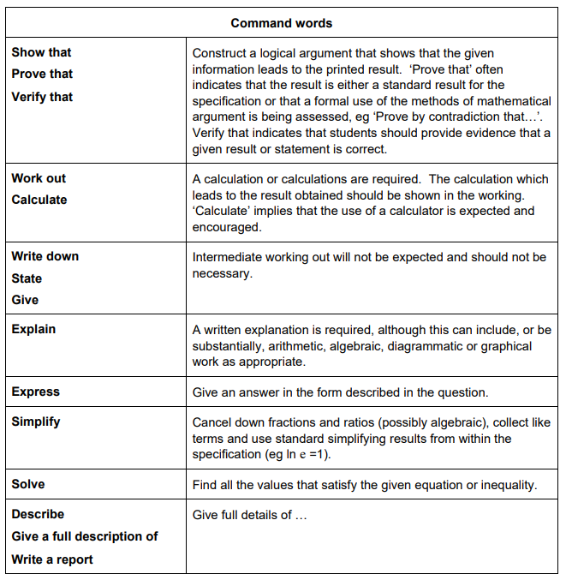

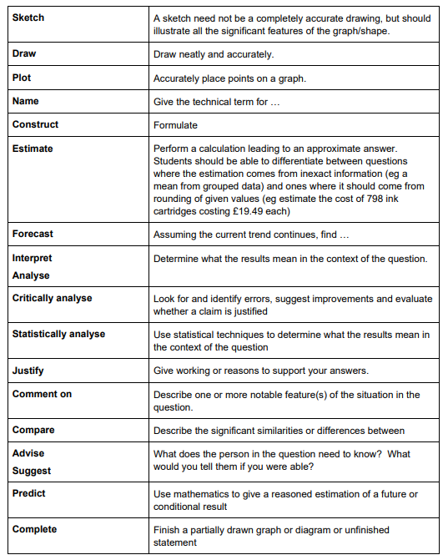

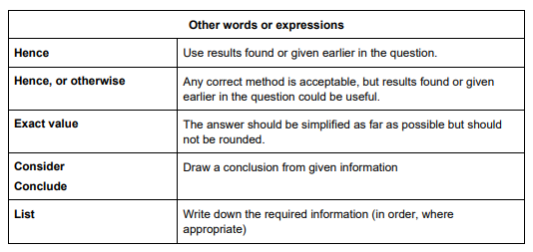

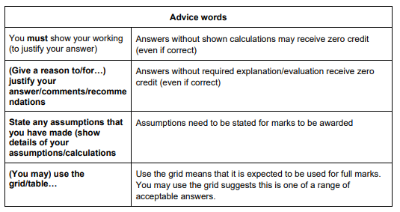

- Analysis of Data

Appreciating the difference between qualitative and quantitative data, including the difference between discrete and continuous quantitative data
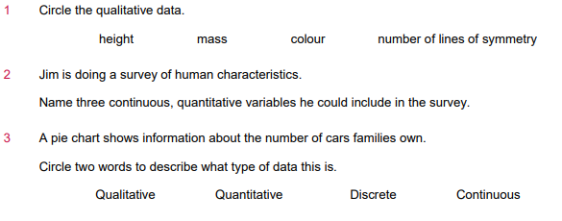

Appreciating the difference between primary and secondary data, including the use of secondary data that have been processed

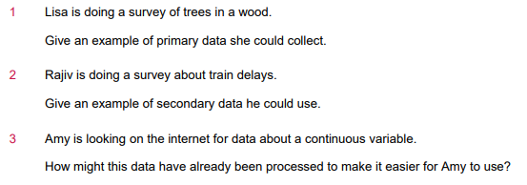

Calculating/identifying mean, median, mode, quartiles, percentiles, range, interquartile range, standard deviation

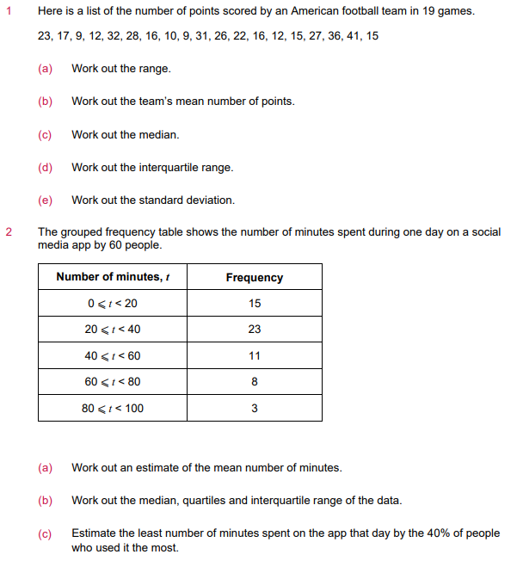

- Maths for personal Finance

Financial expression

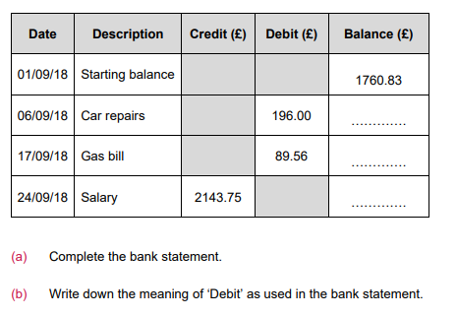

Using conventional notation for priority of operations, including brackets, powers, roots and reciprocals

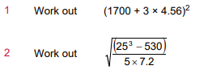

Applying and interpreting limits of accuracy, specifying simple error intervals due to truncation or rounding

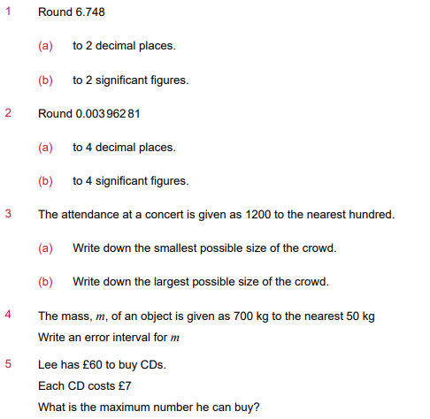

Finding approximate solutions to problems in financial contexts

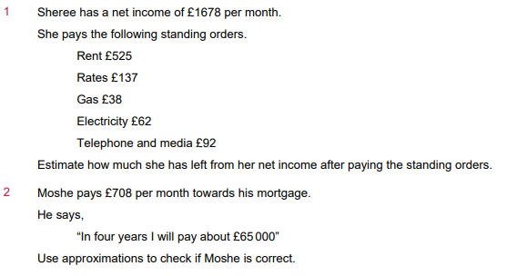

Interpreting percentages and percentage changes as a fraction or a decimal and interpreting these multiplicatively

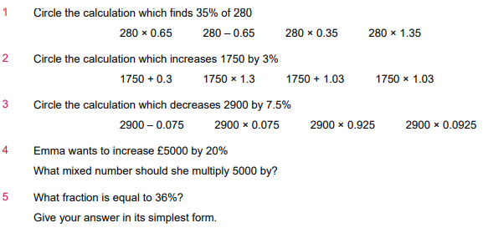

Currency exchange rates including commission

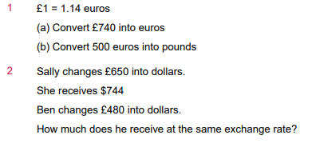

Percentages section test

Four reductions in a sale are shown below. Questions 1 is about these reductions.
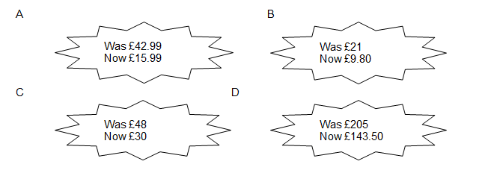

- Which is the biggest percentage reduction? A,B,C or D

- The population of a town grows from 47 300 to 50 500.

What is the percentage increase? Give your answer to one decimal place.

…….%

- What is the multiplier for a 2.1% increase?

- What is the multiplier for a 1.6% decrease?

- Mrs Smith pays £11.61 for a return rail ticket to the nearest city. She makes this journey a couple of times a week. She hears on the news that prices will rise by 3.4%.
What should she expect her train ticket to cost after the rise?

- Mrs Smith goes on a rail journey with a friend. The friend has a rail card which gives her 20% off the cost of her ticket. Mrs Smith pays full price. The cost of both tickets together is £71.19.
How much is Mrs Smith’s ticket?

- A newspaper report says that a group of workers who are on strike already earn 65% more than the median wage. The workers are asking for a 5% increase. What percentage above the median wage would they earn if they got the increase?
- 68.28%
- 70%
- 73.25%
- 147.5%

- The average inflation rate in the UK from 1980 to 2017 was 3.9% a year. John started work in 1980 earning £6000 a year.

What annual salary would buy the same amount of goods in 2017?

Give your answer to the nearest thousand pounds.

32% increase in robberies in a year.

Assume the figure in the headline above has been rounded to the nearest 1%

There were 430 robberies after the increase.
Use the headline figure to find how many robberies there were before the increase.

- What does this headline mean?
Number of cars in city increase by 180%

Select one:
- It can’t be true because it’s not possible to have more than 100% increase.
- The number of cars in the city has nearly doubled.
- The number of cars in the city has nearly trebled.
- There are 18 times as many cars in the city

