GCSE to A LEVEL

Summer Project

|  |
| --- |
| Name: |
| Subject: A Level Further Maths |

The purpose of this A Level Summer project is to introduce you to studying this subject at A Level standard. You will need to complete 10 hours of study on each subject every week, 4½ in class with your teacher and the rest as independent learning. Therefore, it is important that you enjoy this subject and that you start to practice your study skills as early as possible. Some subjects have significant maths content (for example business, psychology, economics); others require strong essay writing skills (for example history, English). Think about the study skills and underpinning knowledge you will require in this subject – not just the title.

If after completing this project you think this may not be your ideal choice, you can ask to transfer to another subject at the start of term, as long as you have the entry requirements and it fits alongside your other choices on the A Level Matrix (timetable). If you do decide to change subject, you will be required to complete the Summer project for your new choice too.

This is also your first taste of Flipped Learning and elements will be used within your first week of lessons.

Please ensure your name, student number and subject are clearly noted on each page and bring it with you to hand in at Induction.

We hope you enjoy this project as you start your A Level journey.

Have a good summer and we look forward to seeing you in September.

**HOW TO SUBMIT:**

Please print your completed project and bring a copy with you to Induction in a clearly labelled plastic wallet.

If you don’t have access to a printer, electronic copies can be emailed as a Word or PDF attachment to [ALevel_FurtherMaths@chichester.ac.uk](mailto:ALevel_FurtherMaths@chichester.ac.uk) with the email clearly labelled ‘Further Maths Summer Project’ prior to Induction.

**STARTING WITH CONFIDENCE**

This booklet has been designed to help you to bridge the gap between GCSE Maths and A level Maths and Further Maths.

[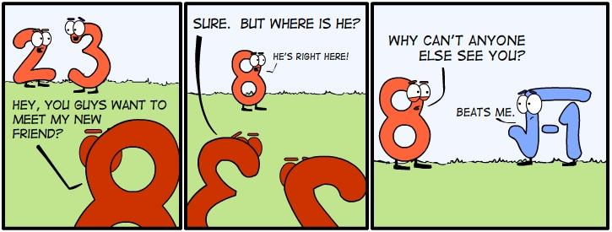](https://www.google.co.uk/url?sa=i&rct=j&q=&esrc=s&frm=1&source=images&cd=&docid=pI5adScCF5bPbM&tbnid=0aYCDmPy6w5aVM:&ved=0CAUQjRw&url=https://classroom.peoriaud.k12.az.us/sites/librown/Site%20Image%20Library/Forms/AllItems.aspx&ei=3MN5U-aJMKyy7AaVjoE4&bvm=bv.66917471,d.ZGU&psig=AFQjCNFskKV8gn0vq1B8imYNHasA9Je15A&ust=1400575217385222)

**You will not be able to take A Level Maths and Further Maths** at Chichester College unless you have attempted each problem in this booklet (as well as completing the Maths booklet) and handed it in at Induction. **You should tackle the work in the Maths booklet first since this booklet builds upon it.**

# Further Maths …..

As well as covering a wider range of Maths, Further Maths at A level involves becoming more skilled at problem-solving. Think for a while about each of the following problems by yourself first; if you cannot see how to progress, turn to the tips at the end. If you cannot answer the problem fully, make a comment about any progress you have made, explaining your reasoning.

**There should be some evidence of work on each question**

Problem 1.

Five numbers are arranged in order from least to greatest:

$$x, x^{3}, x^{4}, x^{2}, x^{0}$$

Where does $-x^{-1}$ belong in the list above?

Space for working and answer or comment on progress.

Problem 2.

Find the area of the equilateral triangle shown 

Space for working and answer or comment on progress.

Problem 3.

Solve ${{(x}^{2}-5x+5)}^{(x^{2}-36)}=1$

Space for working and answer or comment on progress.

Problem 4.

What is the value of the following expression?

$$\frac{\left(1+\frac{1}{2}\right)\left(1+\frac{1}{4}\right)\left(1+\frac{1}{6}\right)\left(1+\frac{1}{8}\right)…..(1+\frac{1}{100})}{\left(1-\frac{1}{2}\right)\left(1-\frac{1}{4}\right)\left(1-\frac{1}{6}\right)\left(1-\frac{1}{8}\right)…..(1-\frac{1}{100})}$$

**For**

Space for working and answer or comment on progress.

Problem 5.

*p* and *q* are both positive numbers.

$$\sqrt{p^{2}+5q}=8$$

$$\sqrt{p^{2}-3q}=6$$

Find the values of *p* and *q*.

Space for working and answer or comment on progress.

**Hints and tips.**

1. One of the numbers in the list doesn’t depend on the value of x. Which one? What does that tell you about x?

What happens when you square a number between 0 and 1?

What happens when you cube a negative number?

If stuck, try a possible number for x and see if it works.

1. Draw in a line which represents the vertical height of the triangle.

Can you use one of the triangles formed to help you? Do you know the length of two of the sides?

1. There are 5 solutions.

Can you think of any value for *b* for which $a^{b}$ always equals 1 (whatever *a* is)?

Also, can you think of any value for *a* for which $a^{b}$ always equals 1

Can you use part of the equation to form a quadratic equation that has to be true?

1. Write each addition and each subtraction as a top heavy fraction.

Does anything cancel out?

1. Check your answer/s when you have them by trying them out in each equation.

Try to write your answer exactly, as a “surd” rather than as an approximate decimal.

What do we usually do when we have 2 equations and we have 2 variables (letters) that we don’t know the value of?

What part of the problem is the most difficult? Is there a way to get rid of that problem?

(Note: remember that $\sqrt{a}-\sqrt{b}$ does **not** equal $\sqrt{a-b}$, and $\sqrt{a+b}$ does **not** equal $\sqrt{a}+\sqrt{b}$)