JOB PROFILE

JOB Profile SUMMARY

Job Title: Environmental Protection Technician
Reports to: Senior Environmental Health Officer
Division: Environmental Health
Service: Environmental Protection
Date: October 2022
Grade: C

Organisation Chart

Environmental Protection Officer Grade D - 0.8FTE

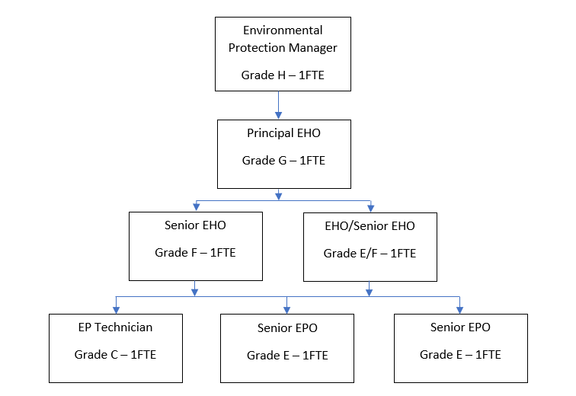

MAIN PURPOSE OF JOB

Why the job exists
This post exists to assists officers in the delivery of the council’s statutory obligations in relation to environmental protection service requests including pollution, nuisance, fly-tipping, private water supplies’ sampling, animal welfare and dog control, so to protect, human health and well being, and maintain and improve the local environment.

What it has to achieve
Directed and supported by EHOs the post will undertake air, water and noise sampling and assist in the investigation of nuisance and animal control complaints. The post holder will be required to attend a four year BSc hons Environmental Health Practitioner course as an apprentice.

KEY DUTIES/ACCOUNTABILITIES

All tasks are undertaken under the direction of a Senior Environmental Health Officer:

- Undertake coordination of the harbour sampling and publication of bathing water information.

- Investigate general pollution complaints, statutory nuisance, fly-tips and accumulations from initial contact with complainants, undertaking initial site visits/investigations and reporting back to the Environmental Health Officers.

- To assist in the stray dogs service, be the lead officer for the transportation of stray dogs and the enforcement of the Public Space Protection Order.

- To undertake the bi-monthly calibration checks of the air quality monitoring stations, be the main officer for remedying faults at the air quality monitoring stations and the monthy exposure of NOx (air quality) monitoring tubes.

- Preparing water samples (harbour / swimming pool), necessary paperwork and to submit the samples to the laboratory for analysis.

- To study for a BSc hons Environmental Health Practitioner as an apprenticeship.

- To install and collect noise monitoring equipment in complainants homes

ADDITIONAL DUTIES & ACCOUNTABILITIES

- Undertake the main responsibilities of the role under supervision or in liaison with Senior Environmental Health Officers.

- Answering queries and providing information to members of the public, employees and employers on environmental protection issues where they relate to key duties and responsibilities.

- Be responsible for an individual workload, maintaining records, including electronic records, sampling logs, case files, related correspondence.

- Arranging the maintenance and calibration of relevant technical equipment, in line with specified timescales, and maintain calibration records.

- Be fully compliant with Councils policies and procedures in relation to enforcement action, data protection and corporate IT security policies.

- To give, as directed by the Duty Officer in control at the time, any support to the Council and the Community that may be needed in response to a civil emergency whether-or-not the tasks are related to the normal functions of the post or the Service

- Assisting in the preparation and implementation of education programmes for the guidance of specific groups of the community.

- Undertaking such other tasks as may from time to time be directed by the post holder’s supervisor.

- Give, as directed, any support to the council and the community that may be needed in response to a civil emergency whether or not the tasks are related to the normal function of the post or service.

KNOWLEDGE, SKILLS & EXPERIENCE

Business Knowledge
- An understanding of the Private Water Supply regime, statutory nuisance and Local Air Quality Management legislation and regimes to demonstrate the ability to carry out carry out initial inspections.

- To have a working knowledge of relevant environmental legislation and able to demonstrate the ability of appraising regulatory information to assess risks and resolve environmental issues.

- To have a working knowledge of the relevant legislation in relation to stray dogs and other dog related law.

- Demonstrate an understanding and ability to interpret legislation, regulatory policies and procedures and applying the range of regulatory options available.

- Understand business sectors that the team regulate, with the ability to communicate accurately and clearly in a style appropriate to the audience.

- An awareness of the political context in local government.

- Demonstrate ability to monitor/evaluation/prioritise your work according to the team’s objectives.

Essential Functional / Technical Skills
- Experience of working in a team based, collaborative, environment demonstrating an ability to follow instruction.

- Demonstrate understanding and ability to work with relevant legislation, regulatory policies and procedures, ensure promotion of good health and quality of life.

- Knowledge and understanding of dog behaviour, dog handling and matters related to resonsible dog ownership.

- Ability to convey information in a clear manner, with the ability to handle occasional challenging cirumstances, both face-to-face, by telephone and by email and letter.

- To be aware of the Council’s Enforcement Policy.

- Experience in using Microsoft products such as; Word, Excel and PowerPoint and other IT systems.

- Be prepared to work outside of normal office hours (by exception).

- Full drivers licence and access to a vehicle for work.

Qualifications
- 3 Grade C or above A levels or equivalent level qualification(s) (essential)

- Desirable: Degree in relevant environmental or science based subject (desirable)

- The applicant will be required to study for a BSc Environmental Health Practitioner degree as an apprenticeship

Personal Attributes / Competencies
- Demonstrates high standards of communication and appropriate behaviour that upholds the reputation of the service.

- Self-motivated with a ‘can do’ approach.

- Ability to use initiative, progress work in a timely manner to work independently and remotely, but confident to seek support when needed.

- Ability to manage/cope with occasional difficult situations.

- Ability to plan and prioritise workloads with competing deadlines and install a clear sense of direction, priority and pace.

- Resilient, flexible and reliable.

- To work collaboratively as part of the team ensuring effective information sharing, support for colleagues and a desire to make a difference.

- You will be required to handle dogs and undertake investigation of properties and working outside in all weathers and including crossing rough ground. Some light lifting.

- Demonstrate a commitment to customer care at all times.

- DBS check.

- Pass CDC vehicle driving tests

This Job Profile is a description of the job as it is currently comprised. The Council reserves the right to review and amend this Job Profile from time to time, if required to enable it to effectively carry out its functions. Any changes that are made would be done so in consultation with the post holder and would be commensurate with the grade or salary of the post.

