GCSE to A LEVEL
Summer Project
Name:
Subject: A Level Biology

The purpose of this A Level summer project is to introduce you to studying this subject at A Level standard. You will need to complete 10 hours of study on each subject every week, 4½ in class with your teacher and the rest as independent learning. Therefore, it is important that you enjoy this subject and that you start to practice your study skills as early as possible. Some subjects have significant maths content (for example business, psychology, economics); others require strong essay writing skills (for example history, English). Think about the study skills and underpinning knowledge you will require in this subject – not just the title.

If after completing this project you think this may not be your ideal choice, you can ask to transfer to another subject at the start of term, as long as you have the entry requirements and it fits alongside your other choices on the A Level Matrix (timetable). If you do decide to change subject, you will be required to complete the transition project for your new choice too.

This is also your first taste of Flipped Learning and elements will be used within your first week of lessons.

Please ensure your name, student number and subject are clearly noted on each page and bring it with you to hand in at Induction.

We hope you enjoy this project as you start your A Level journey.

Have a good summer and we look forward to seeing you in September.

HOW TO SUBMIT:
Instructions on submission are given at the end.

Welcome to A Level Biology – (Edexcel Biology B).
At the start of the course you will need to purchase the following

text book Pearson Edexcel A Level Biology Student Book (Year 1 and Year 2)
Publisher: Hodder Education
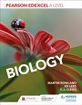
ISBN: 9781510469938 Currently £38.99 on the Pearson website

- Core practical lab book
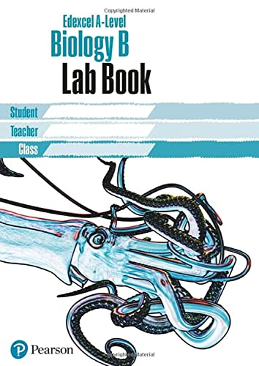
ISBN:1292200251 Currently £2.50 from Amazon

- A lab coat to carry out laboratory work. This can be purchased in college in September and there are some repurposed lab coats available at a cheaper price.

To every biology lesson you are also expected to bring:
- an A4 ring-binder folder,
- lined paper
- pens, pencils, ruler and scientific calculator

You will be provided with some workbooks and worksheets throughout the course, but you will be expected to print off some key material e.g. exam questions and flipped learning pre-work.

The getting ready work below is your first chance to see the level you will be studying at in Biology. All work must be in your own words and not copied.

Task 1: You will be producing a poster presentation on an endangered species. Below is an example of what a scientific poster looks like.
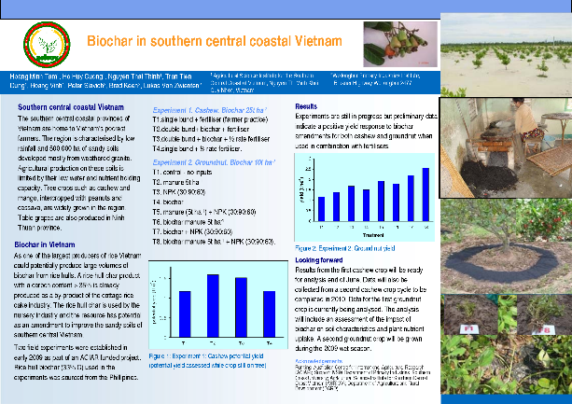
1: To choose your endangered species (animal or plant)
- visit the IUCN Red List of threatened species https://www.iucnredlist.org/en
- click on advanced search
- On the left hand side click onred list category to bring up a drop down menu
- Now check the boxes for either Critically Endangered (Cr) or Endangered (En)
- Now you can just scroll through the species until you find one that interests you.
- You can put additional filters on to narrow your search or you can simply search a species by its common name if you already have one in mind. It must however be in one of these two red list catagories.
2: You should then produce a poster presentation including the following sections.
- The name of the species. This should include the common name (if there is one) and its binomial Latin name. This will appear at the top of the page in italics and will consist of two parts: A genus name and a species name. e.g. If you were producing a poster on the Red Panda, this would be its common name whereas Ailurus fulgens would be the binomial name. Ailurus is the genus name and fulgens the species name.
- Include a photograph of the species.
- Additional information on this species including: The regions of the world it can be found in (geographic range); what habitat it is found in; current estimates of population size;
- Details of its red list status; is it endangered or critically endangered;
- Details of the threats it faces (reasons for being endangered);
- Details of any conservation actions in place;
- Include a reference. Whenever you use a source of information, whether it is a book, journal or online resource, you must always reference where you have gotten the information from. In this case the reference can be found near the top of the first page and is in this format

  - Glatston, A., Wei, F., Than Zaw & Sherpa, A. 2015. Ailurus fulgens (errata version published in 2017). The IUCN Red List of Threatened Species 2015: e.T714A110023718. https://dx.doi.org/10.2305/IUCN.UK.2015-4.RLTS.T714A45195924.en. Accessed on 11 May 2023.
How to design your poster
This should be A3. You can use one slide of a PowerPoint and set it to A3; in Word set to A3 (using small font to fit all the words and sections on). Alternatively, you can use an A3 piece of paper and stick everything on. In this case, all writing should be either a cut out from your research paper or produced on word and printed out to be stuck on. Be as creative as you like. Your name should be clearly displayed on the poster.
If you search for ‘how to produce a poster presentation in PowerPoint’ there are several videos that can help with this.
Please submit your completed poster to: Alevel_Biology@chichester.ac.uk before the start of term.

Task 2: Using the knowledge you have gained from completing your poster, follow this link to complete a multiple choice quiz:
https://forms.office.com/e/SQp5VsJCta
If you have any problems accessing this link, please email on the above email and you will be sent an electronic link.

