GCSE to A LEVEL
Summer Project
Name:

Subject: A Level Environmental Science

The purpose of this A Level Summer project is to introduce you to studying this subject at A Level standard. You will need to complete 10 hours of study on each subject every week, 4½ in class with your teacher and the rest as independent learning. Therefore, it is important that you enjoy this subject and that you start to practice your study skills as early as possible. Some subjects have significant maths content (for example business, psychology, economics); others require strong essay writing skills (for example history, English). Think about the study skills and underpinning knowledge you will require in this subject – not just the title.

If after completing this project you think this may not be your ideal choice, you can ask to transfer to another subject at the start of term, as long as you have the entry requirements and it fits alongside your other choices on the A Level Matrix (timetable). If you do decide to change subject, you will be required to complete the Summer project for your new choice too.

This is also your first taste of Flipped Learning and elements will be used within your first week of lessons.

Please ensure your name, student number and subject are clearly noted on each page and bring it with you to hand in at Induction.

We hope you enjoy this project as you start your A Level journey.

Have a good summer and we look forward to seeing you in September.

HOW TO SUBMIT:
Please print your completed project and bring a copy with you to Induction.
If you don’t have access to a printer, electronic copies can be emailed as an attachment to ALevel_EnvironmentalScience@chichester.ac.uk with the email clearly labelled ‘Environmental Science Summer Project’ prior to Induction.

At A-level you will be following the AQA Specification and will study the following topics:
- The Living Environment
- The Physical Environment
- Energy and Pollution
- Biological Resources
- Sustainability
- Scientific Methods
The text book will be issued on loan to you from College, or can be purchased from the publisher, Amazon or sometimes eBay.
Publisher: Insight & Perspective
ISBN: 9781912190072

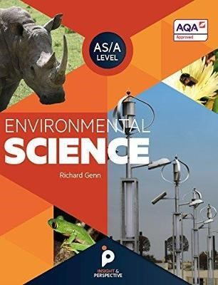

Summer project tasks -print these pages off and complete the activities for submission at enrolment. Alternatively, you can complete electronically and send to the email provided above.
Activity 1 Scientific vocabulary: Designing an investigation
Link each term on the left to the correct definition on the right.

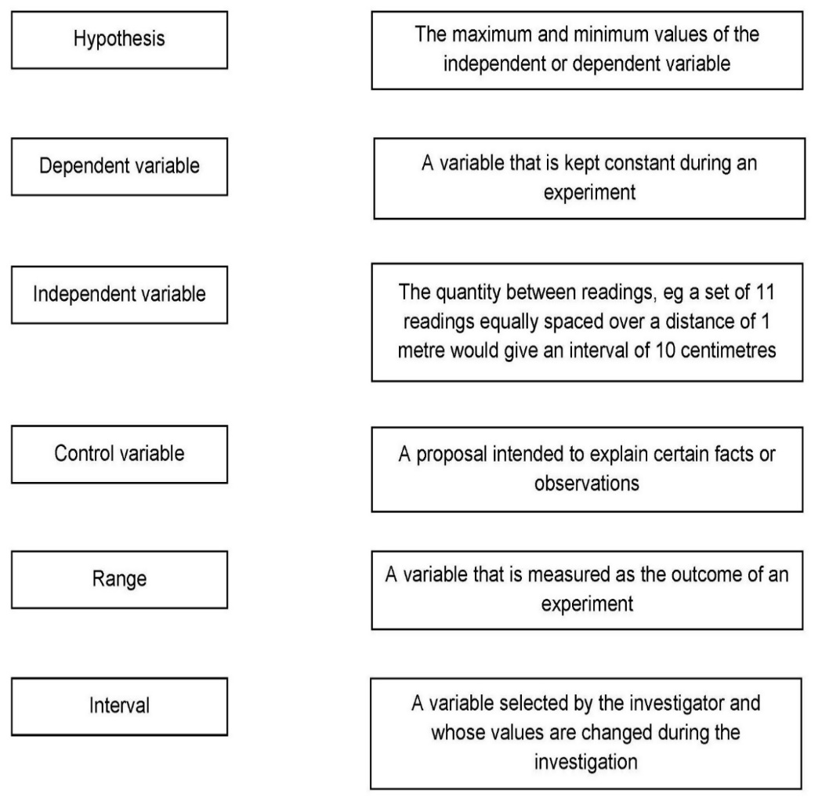

Activity 2 Scientific vocabulary: Making measurements
Link each term on the left to the correct definition on the right.

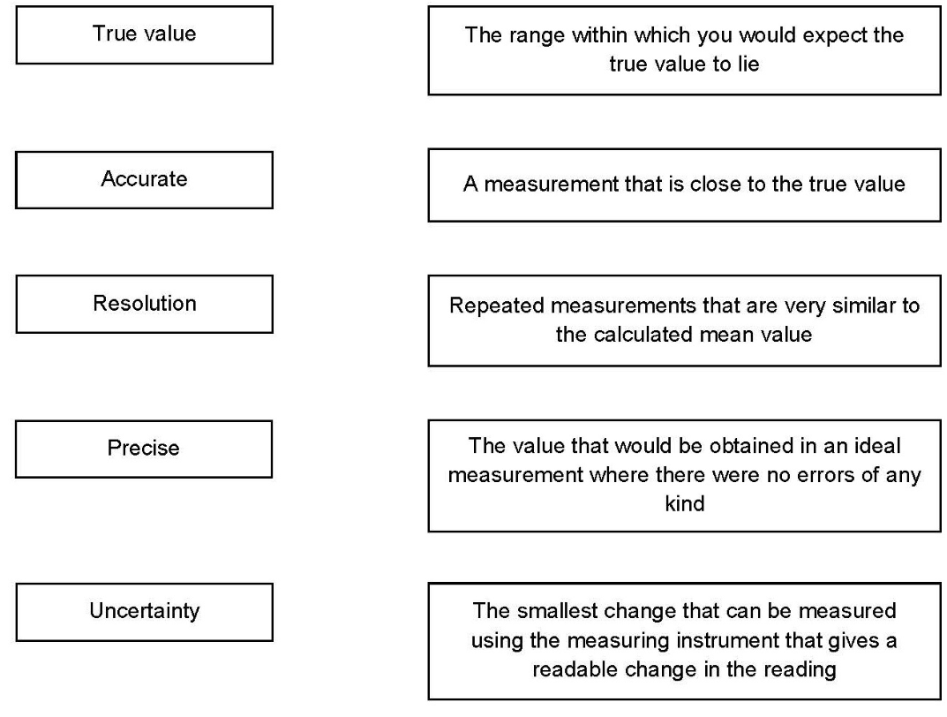

Activity 3 Scientific vocabulary: Errors
Link each term on the left to the correct definition on the right.

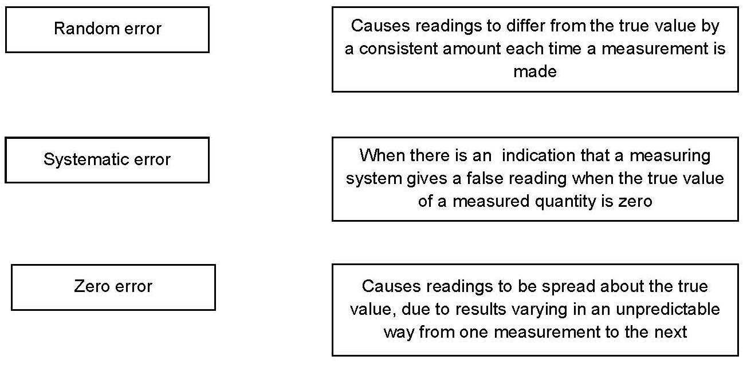

Understanding and using SI units

Every measurement has a size (eg 2.7) and a unit (eg metres or kilograms). Sometimes, there are different units available for the same type of measurement. For example, milligram, gram, kilogram and tonne are all units used for mass.
There is a standard system of units, called the SI units, which are used for most scientific purposes.
These units have all been defined by experiment so that the size of, say, a metre in the UK is the same as a metre in China.
There are seven SI base units, which are given in the table.

Physical quantity | Unit | Abbreviation
Mass | kilogram | kg
Length | metre | m
Time | second | s
Electric current | ampere | A
Temperature | kelvin | K
Amount of substance | mole | mol
luminous intensity | candela | cd

All other units can be derived from the SI base units. For example, area is measured in metres square (written as m²) and speed is measured in metres per second (written as m s^{–1}). This is a change from GCSE, where it would be written as m/s.

Using prefixes and powers of ten

Very large and very small numbers can be complicated to work with if written out in full with their SI unit. For example, measuring the width of a hair or the distance from Manchester to London in metres (the SI unit for length) would give numbers with a lot of zeros before or after the decimal point, which would be difficult to work with.
So, we use prefixes that multiply or divide the numbers by different powers of ten to give numbers that are easier to work with. You will be familiar with the prefixes milli (meaning 1/1000), centi (1/100), and kilo (1 × 1000) from millimetres, centimetres, and kilometres.
There is a wide range of prefixes. Most of the quantities in scientific contexts will be quoted using the prefixes that are multiples of 1000. For example, we would quote a distance of 33 000 m as 33 km.
The most common prefixes you will encounter are given in the table.

Prefix | Symbol | Power of 10 | Multiplication factor
Tera | T | 10¹² | 1 000 000 000 000
Giga | G | 10⁹ | 1 000 000 000
Mega | M | 10⁶ | 1 000 000
kilo | k | 10³ | 1000
deci | d | 10⁻¹ | 0.1 | 1/10
centi | c | 10⁻² | 0.01 | 1/100
milli | m | 10⁻³ | 0.001 | 1/1000
micro | μ | 10⁻⁶ | 0.000 001 | 1/1 000 000
nano | n | 10⁻⁹ | 0.000 000 001 | 1/1 000 000 000
pico | p | 10⁻¹² | 0.000 000 000 001 | 1/1 000 000 000 000
femto | f | 10^{–15} | 0.000 000 000 000 001 | 1/1 000 000 000 000 000

Activity 4 SI units and prefixes
What would be the most appropriate unit to use for the following measurements?

- The length of a leaf

- The distance that a migratory bird travels each year

- The diameter of a smoke particle

- The mass of a woodlouse

- The volume of the trunk of a large tree

- The flow volume of a river

Activity 5 Converting data
- Re-write the following.

- 0.00122 metres in millimetres

- 1 042 000 micrograms in grams

- 1120.2 metres in kilometres

- 0.7 decilitres in millilitres

- 70 decilitres in litres

- It is estimated that 33 000 000 000 tonnes of CO₂ was released globally in 2019 from energy-related sources. Circle the correct conversion. Use the prefix table above to help you.

33 Tt | 33 Gt | 33 Mt

- The distance between the Sun and the Earth is 149.6 Gm. In this case, Gm is not a common unit, so we can convert it to km and express it in standard form. Circle the correct conversion. Use the prefix table above to help you.

1.496 ×10⁶ km | 1.496 × 10⁸ km | 1.496 × 10¹² km

- The estimated volume of ice stored in the Antarctic ice sheet is 0.027 billion km³. Circle the correct conversion. Use the prefix table above to help you.

27 million km³ | 2.7 million km³ | 270 million km³

Practical skills

The practical skills you learnt at GCSE will be further developed through the fieldwork and practicals you undertake at A-level. Your teacher will explain in more detail the requirements for fieldwork, practical work, and the research methods.

There is a practical handbook for Environmental Science, which has lots of very useful information to support you in developing these important skills. You can download a copy here:

Activity 6 Investigating woodlice behaviour
Organisms have adaptations that enable them to survive in the conditions in which they normally live.

Students wanted to investigate if the distribution of invertebrates in a habitat depends on the intensity of light.

Equipment:
- 20 Woodlice
- Choice chamber with four sectors and a transparent lid
- Bench lamp
- Translucent material, eg tracing paper (to vary light intensity)
- Stop clock

Method:
- Place the choice chamber on the bench.
- Cover the sectors with different numbers of layers of translucent material. Leave one sector with no cover.
- Turn on the bench lamp so that it shines from directly above the choice chamber.
- Put 20 woodlice into the centre of the choice chamber.
- Immediately start a stop clock.
- Leave the apparatus for 2 minutes.
- Record the number of woodlice in each sector of the chamber.

- Write a hypothesis for this investigation.

- What do you predict will be the result of this investigation?

- What are the independent, dependent and control variables in this investigation?

- What is the difference between a repeatable measurement and a reproducible
- measurement?

The students’ results are shown below.

 | No cover | 1 layer | 2 layers | 3 layers
Number of woodlice after 2 minutes | 1 | 3 | 4 | 12

- Write a conclusion to explain what the results show.

- Suggest how you could improve this investigation to get more valid results.

Sampling techniques

Activities 7, 8 and 9 are based on GCSE questions. They cover a range of sampling techniques. Complete the questions to check you remember the key points.

Activity 7 Investigating dandelion abundance
Some students investigated the size of a population of dandelion plants in a field.

The diagram below shows the field.
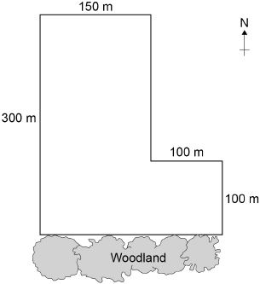

The students:
- placed a 1m × 1m square quadrat at 10 random positions in the field
- counted the number of dandelion plants in each quadrat.

The table below shows the students’ results.

Quadrat number | Number of dandelion plants
1 | 6
2 | 9
3 | 5
4 | 8
5 | 0
6 | 10
7 | 2
8 | 1
9 | 8
10 | 11

- Why did the students place the quadrats at random positions?

- Estimate the total number of dandelion plants in the field. Use the information in the diagram and the table to help you answer the question.
Give your answer in standard form.

Quadrats 5, 7 and 8 were each placed less than 10 m from the woodland. These quadrats contained low numbers of dandelion plants.

The students questioned if light intensity affected the abundance of dandelions, since the woodland created shade on the field.

They made the following hypothesis:

‘The number of dandelions will increase with distance from the woodland as
light intensity increases.’

- Write a method the students could use to test this hypothesis.

- Light is an abiotic factor that affects the growth of dandelion plants.

State two biotic factors that affect the growth of dandelion plants.

Activity 8 Investigating weed killer
Students investigated the effect of a weed killer on the weeds growing in a field.

They used 0.5 m × 0.5 m quadrats.

They sprayed half the field with liquid weed killer and half with water.

- Explain why the students used water on one side of the field instead of weed killer.

The table below shows the students’ results.

 | Number of weeds per quadrat
 | At start |  | After 2 weeks
 | Side A  (Weed killer) | Side B (Water) | Side A  (Weed killer) | Side B (Water)
 | 8 | 14 | 3 | 8
 | 2 | 9 | 4 | 15
 | 12 | 3 | 0 | 7
 | 15 | 16 | 2 | 12
 | 13 | 3 | 1 | 13
Mean

- Calculate the mean values in the table.

- Calculate the percentage decrease in the mean number of weeds on side A

after 2 weeks.

- One student thought the results were not valid.

Suggest one improvement the students could have made to the method to
make the results more valid.

Give the reason for your answer.

Activity 9 Investigating moths
Students were studying the ecology of their playing field. They wanted to count the population of ruby tiger moths.

Figure 1 shows the cross-section of the moth trap they used.

Figure 1
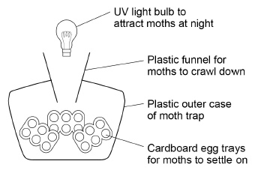

This is the method used.
- Set up the moth trap on the playing field.
- Leave the trap overnight with the light on.
- Remove the egg trays and count the number of ruby tiger moths.
- Release the moths on the playing field.

The students wanted to compare their results with another school.

- Suggest two ways that both schools could standardise the method to
make sure their results were reproducible.

Give reasons for your suggestions.

- Suggest two reasons why moths are important to other species.

Describing and explaining observations

Activity 10 is based on a GCSE question. Complete the questions to ensure you understand about describing and explaining trends in data.
Activity 10 Climate change
The graph below shows changes in global air temperature and changes in the concentration of carbon dioxide in the atmosphere.

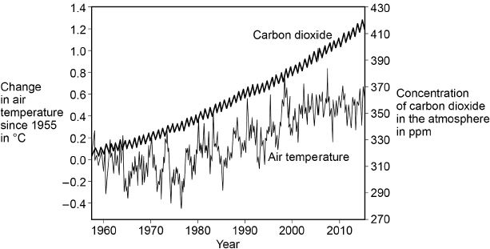

- Use the graph to describe two trends in carbon dioxide from 1955 to 2015.

- Many scientists think that an increase in carbon dioxide concentration in the atmosphere causes an increase in air temperature.
How would an increase in the concentration of carbon dioxide in the atmosphere cause an increase in air temperature?

In each year, the concentration of carbon dioxide in the atmosphere is higher in the winter than in the summer.

- Give one human activity that could cause the higher concentration of carbon dioxide in the winter.

- Give one biological process that could cause the lower concentration of carbon dioxide in the summer.

- Give the name of one other greenhouse gas that contains carbon.

Analysing graphs
Environmental Science is about collecting, analysing, and interpreting data on how our environment is changing. A wide range of different types of graphs are used in Environmental science and you will continue to develop the graph skills you gained at GCSE throughout the A-level course.
When you look at a graph remember to pay attention to the axes, units, key and trends before attempting any questions. At A-level the graphs become more complex than you will have seen at GCSE and may have two axes that you need to consider. You can see an example of this in Question 5 below.

Activity 11 Analysing graphs
Wildlife in rivers is affected by changes in conditions. The graph below shows how the oxygen content of water changes with temperature.

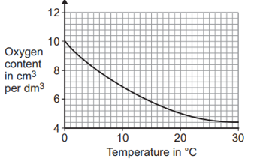

- Describe the relationship between the oxygen content and temperature.

- Does the data show a positive or negative correlation?

- Calculate the change in oxygen content when the temperature of water is increased from 0 ºC to 14ºC.

- The table below shows how the density of liquid water changes with temperature.
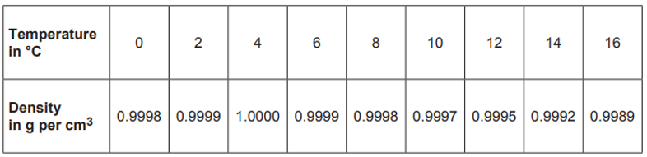

Which of the graphs below A, B, C or D, shows how the density of water changes with temperature?

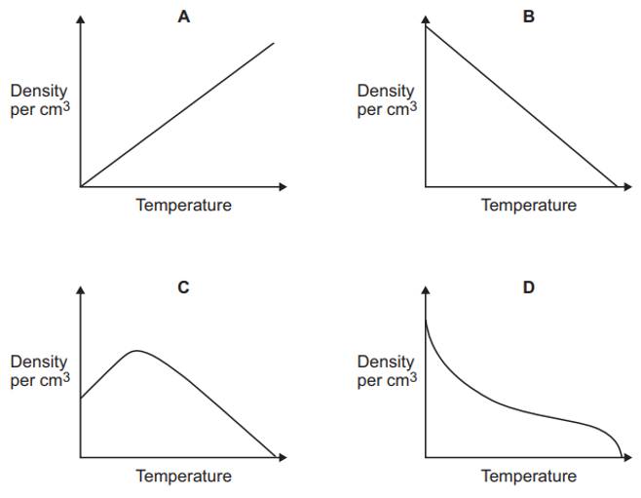

- The graph below shows how the stock and catch of one species of Artic fish have changed since 1960.

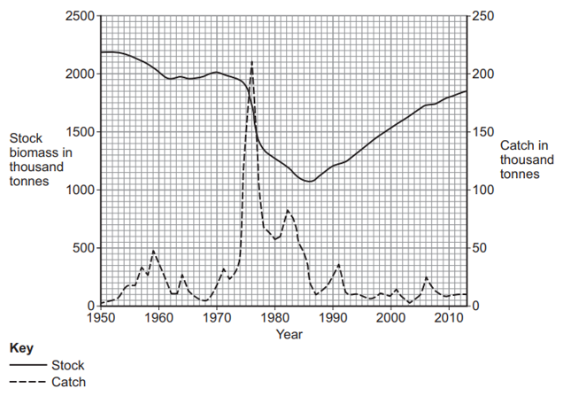

Describe how the catch of fish changed between 1973 and 1980.

Using maths skills

Throughout your A-level Environmental Science course you will need to be able to select relevant data and use the correct calculations to produce information that can then be used to inform how to manage environmental issues.

Activity 12 Maths skills
- In East Anglia, the average annual rainfall is 0.55 m.

A house in East Anglia has a flat roof with an area of 120 m².

If 75% of the rain falling on the roof is collected, what volume of rainwater would be collected in one year?

- The diagram shows the amount of water typically used in the home, in the UK, in one day.

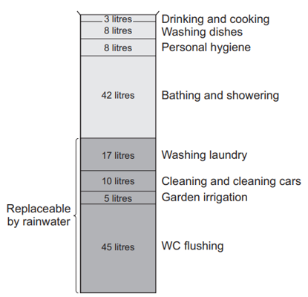

Calculate the percentage (%) of water use that is potentially replaceable by using rainwater.

- The table below shows how local authorities dealt with household waste they collected in 2009 and 2010.

 | January 2009 –  December 2009 |  | January 2010 –  December 2010
Local authority collected waste | 000 tonnes | % | 000 tonnes | %
Recycled, composted or reused | 10 275 | 38.7 |  | 39.7
Not recycled, composted or reused | 16 266 | 61.3 | 15 628 | 60.3

Calculate the mass of waste that was recycled, composted, or reused in 2010.

- A water company estimates that the 1.9 million people living in the area produce approximately
500 000 tonnes of sewage sludge a year.

Estimate the mass of sewage sludge produced by the UK in 1 year if it has a population of 67 million.

Give your answer in standard form.

- In 2017, the city of Manchester began a ‘City of Trees’ project. The project plans to plant 3 million trees
over the next 25 years.

It was suggested that the council plant 3.6 × 10⁵ trees in the first year. The rest of the trees would be planted
in equal numbers over the remaining years.

Calculate how many trees would need to be planted in each of the remaining years.

Give your answer in standard form.

- A sample of river water contains 125 mg per dm³ of dissolved solids.

Calculate the mass of dissolved solids in grams in 250 cm³ of this sample of river water.
(Remember about your unit conversions dm³ to cm³.)

Give your answer in grams to 2 significant figures.

Extended writing

The ability to write coherently in a logical, well-structured way is an essential skill to develop. At GCSE the 6-mark extended response questions are used so students can demonstrate this skill. At A-level you need to develop this skill further, and you will be expected to write longer extended response questions. In each Environmental Science exam paper there are questions worth 9 marks and an essay worth 25 marks. You will practice this skill over the next 2 years.
The command word in a question, like at GCSE, is important as it gives you an indication of what to include in your answers. For example, ‘explain’ means you must give reasons why things are happening, not just give a description. A comparison needs advantages and disadvantages or points for and against. Your teacher will work with you on this skill during the course.

Activity 13 Extended writing
In this activity there are two questions and model student answers. The first question is taken from a GCSE Combined Science Biology paper and the second is the type of 9-mark question you might find on this topic on an A-level Environmental Science paper.

Look at the two questions and see how the demand has increased from GCSE to A-level.

Question 1: GCSE Combined Science Biology (6 marks)

Plants take in carbon dioxide from the atmosphere as part of the carbon cycle.

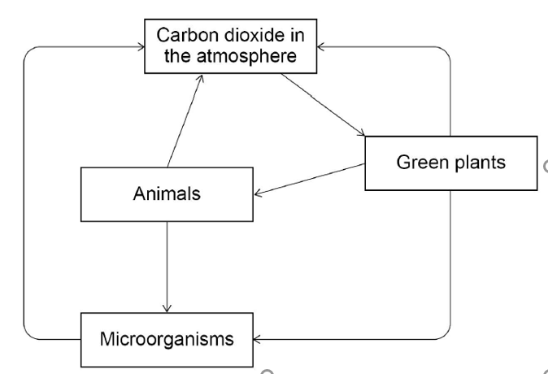

Explain how carbon from the atmosphere is cycled through living organisms.

Question 2: A-level Environmental Science question (9 marks)

Explain how an understanding of the carbon cycle can help us manage climate change.

How the demand progresses

At GCSE you have a question on the carbon cycle that requires you to know how the process works. There is a diagram to help support you and act as a stimulus.

In the A-level question you have to a make the link between the carbon cycle and the environment and apply what you know about the cycle to how it affects a real-life situation. There is no diagram to help you or act as a stimulus.

Environmental science is about applying knowledge and understanding of fundamental scientific ideas, processes and relationships to a variety of real-life environmental issues and situations. It is important for you to use the correct scientific vocabulary when you are doing this.

Model answer: GCSE Combined Science Biology

Carbon dioxide is absorbed by plants through their leaves for photosynthesis.
The plants take in water and CO₂ and make glucose and oxygen.
Animals then eat the plants and use the glucose for respiration and to grow.
During respiration the CO₂ is breathed out by the animals and goes back into the atmosphere. When the animal dies they begin to decay and the microorganisms eat them and release the carbon.

The microorganism also breath out CO₂ so some goes out then as well. The cycle starts again.

Model answer: A-level Environmental Science

Human activities have increased the concentration of carbon dioxide and methane in the atmosphere which has increased the greenhouse effect. This has happened because now, more outgoing infrared radiation is absorbed and doesn’t escape out of the atmosphere. This has led to global climate change. Our understanding of the processes that add or remove carbon can help us make management decisions that increase the processes that remove carbon, at the same time as reduce activities that increase the outputs of these greenhouse gases.

One of the main ways we can do this is using our understanding of the role of photosynthesis in the carbon cycle. Photosynthesis absorbs carbon dioxide, and therefore if we reduce deforestation and increase afforestation, we can increase the rate removal of carbon dioxide from the atmosphere by this process. If we then protect these forests, we can ensure that the carbon remains stored in these trees for a long time.

We also understand that the combustion of fossil fuels for the production of electricity releases large amounts of carbon dioxide to the atmosphere and therefore if we use alternative energy resources such as renewables like solar and wind we prevent the need to use fossil fuels and the carbon can remain stored in the Earth’s crust as coal, oil and gas. Additionally, if we can conserve energy, for example though home insulation, we can reduce the amount of electricity we use for heating and so reduce the amount of fossil fuels that is need to be combusted to make the electricity, so reducing CO₂ emissions.

One-way methane is released to the atmosphere is when the bacteria living inside the guts of ruminant animals, anaerobically respire. If we can change our diets to eat less meat and therefore reduce the numbers of cattle such as cows and sheep. This way we can reduce the methane emissions, which is a powerful greenhouse gas.

