GCSE to A LEVEL
Summer Project
Name:
Subject: A Level Chemistry

The purpose of this A Level Summer project is to introduce you to studying this subject at A Level standard. You will need to complete 10 hours of study on each subject every week, 4½ in class with your teacher and the rest as independent learning. Therefore, it is important that you enjoy this subject and that you start to practice your study skills as early as possible. Some subjects have significant maths content (for example business, psychology, economics); others require strong essay writing skills (for example history, English). Think about the study skills and underpinning knowledge you will require in this subject – not just the title.

If after completing this project you think this may not be your ideal choice, you can ask to transfer to another subject at the start of term, as long as you have the entry requirements and it fits alongside your other choices on the A Level Matrix (timetable). If you do decide to change subject, you will be required to complete the Summer project for your new choice too.

This is also your first taste of Flipped Learning and elements will be used within your first week of lessons.

Please ensure your name, student number and subject are clearly noted on each page and bring it with you to hand in at Enrolment.

We hope you enjoy this project as you start your A Level journey.

HOW TO SUBMIT:
Please print your completed project and bring a copy with you to Induction in a clearly labelled plastic wallet.
If you don’t have access to a printer, electronic copies can be emailed as a Word or PDF attachment to ALevel_Chemistry@chichester.ac.uk with the email clearly labelled ‘Chemistry Summer Project’ prior to Induction.

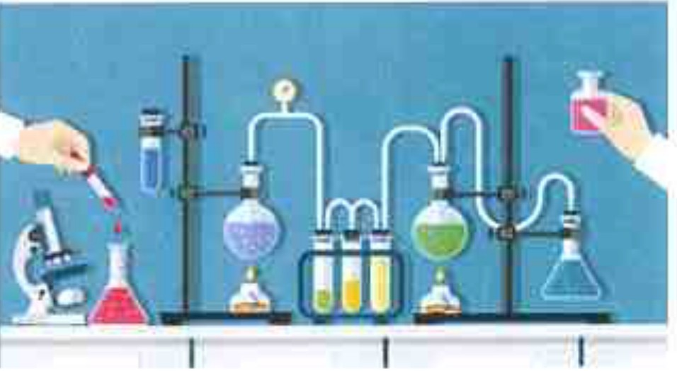
A LEVEL CHEMISTRY

Preparation Task for Year 1 Chemistry

Having completed your GCSEs, now is the time to begin the preparation for your A Level Chemistry
Throughout Year 1, there will be Formal Progress Points. Progression into Year 2 will be based on these assessments. It is therefore of great importance that this Summer task is done well, so that you can hit the ground running and make a strong and positive start.
Rea d and work your way through the attached booklet Answer all questions in the spaces provided and bring the completed workbook with you at the beginning of term.
Thorium
Iodine
Sulfur
Iodine
Sulfur
Lithium
Iron
*Don’t waste it
1. ATOMIC STRUCTURE
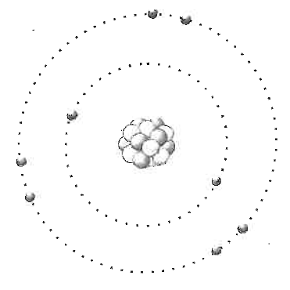
What are atoms like?
- All atoms have a nucleus at their centre containing neutrons and protons.
- Almost all of the mass of the atom is contained in the nucleus which also has an overall positive charge.
- The positive charge arises because each of the protons in the nucleus has a +1 charge.
- The nucleus is tiny compared with the total volume occupied by the whole atom.
- The neutrons in the nucleus have a very similar mass to the protons but they are uncharged.
- The electrons orbit the nucleus in shells (or energy levels). The electrons are much smaller and lighter than either the neutrons or protons
- The volume occupied by the orbits of the electrons determines the size of the atom.

What is the charge on an atom?
The overall charge on an atom is zero.
This is because each +1 charge from a proton in the nucleus is cancelled out by a -1 charge from an electron.
If an atom loses or gains electrons it becomes charged. These charged particles are called ions. The fact that the protons and electrons are oppositely charged also helps to explain why the electrons remain in orbit: opposites attract.

Have a go at these questions:

Copy and complete the table

- What is the charge on an ion formed when an atom loses 2 electrons?
- What is the charge on an ion formed when an atom gains 2 electrons?

Particle | Relative Mass | Relative Charge
Proton | 7
Neutron
Electron | T/184  0

Answers:

1.
2.

2. ATOMIC NUMBER, MASS NUMBER AND ISOTOPES
Atomic and Mass Numbers
The atomic number of an element is given the symbol Z.

It is sometimes called the proton number as it represents the number of protons in the nucleus of the element.

For atoms the number of protons equals the number of electrons, but you need to take care when considering ions as the number of electrons changes when an ion forms from an atom.

The mass·number of an atom is given the symbol A. It represents the total number of neutrons and protons in the nucleus. Subtracting Z from A allows you to calculate the number of neutrons in the nucleus.

Try this question. You may need to refer to the Periodic Table.
- Copy and complete the table.
Element | Symbol | Z | A | No Protons | No Neutrons | No Electrons
Sodium |  |  | 23
 |  | 6 | 12
 |  | 12 |  |  | 12
 |  | 84 | 210
Chlorine |  | 17 | 35
Chlorine |  | 17 | 37

Isotopes
The last two examples in the table above show two chlorine atoms with different numbers of neutrons. These are called isotopes of chlorine. Both are chlorine atoms because they have the same number of protons - but they have different numbers of neutrons. In other words they have the same atomic number but different mass numbers. Isotopes are very common: some occur naturally and some are man-made. Some elements may have a large number of isotopes.

Have a go at these questions:
In terms of the numbers of subatomic particles, state one difference and two similarities between two isotopes of the same element.

- Give the chemical symbol, mass number and atomic number of an atom which has 3 electrons and 4 neutrons.

- Three isotopes of carbon are: carbon-12, carbon-13 and carbon-14. State the numbers of protons, neutrons and electrons in each.

Answers:

3. ARRANGEMENT OF ELECTRONS
Electrons are arranged in energy levels
Electrons orbit the nucleus in energy levels (also known as shells).
The first energy level can contain up to 2 electrons. It is called an s Level.

The second energy level can contain up to 8 electrons. However it is actually split into 2 sub-levels. Two of the electrons are an ‘s level’ and the remaining 6 are ‘p level’.

At GCSE the ‘s’ and ‘p’ levels are not distinguished. You simply combine the 2 ‘s’ electrons with the 6 ‘p’ electrons to make a total of 8.

How can electron arrangements be represented?
You can draw concentric circles to represent different energy levels.
For an atom with 20 electrons:
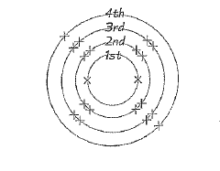
The diagram shows the energy levels filling up with electrons. Remember, you should always start filling the innermost levels first.
Here’s another way to show electron arrangements:

An atom with 6 electrons: 2,4
An atom with 11 electrons: 2,8,1
An atom with 20 electrons: 2,8,8,2

Use the Periodic Table to help answer the following questions:
- Draw diagrams to show the electron arrangements of the following elements: carbon, fluorine, magnesium, sulphur.
- Write the electron arrangements of the following elements using the format shown above: lithium, sodium, potassium, beryllium, magnesium, calcium.
Answers:

4. IONIC BONDING
Reaction between Group 1 and Group 2 elements
Elements in Groups 1, 2, 6 and 7 react to form ionic compounds.
For example: sodium reacting with chlorine to form sodium chloride.
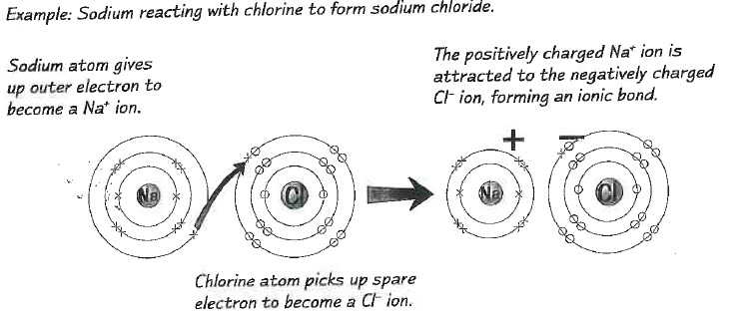
The example shows a typical reaction between a Group 1 element and a Group 7 element. The sodium atom donates its single outer electron to the outer shell of the chlorine atom. As a result, both elements end up with a full outer shell of electrons.
In a similar way, Group 2 elements react by donating two electrons and Group 6 elements react by gaining two electrons.
Have a go at these:
- Draw a diagram showing how a magnesium atom reacts with an oxygen atom. In your diagram try to clearly demonstrate the electron transfer process.
- Draw a diagram showing the electron transfer process that results in the formation of calcium chloride (CaCI).

Answers:

5. COVALENT BONDING
Reaction between carbon and hydrogen
Ionic bonding only really works between metals with one or two electrons in their outer shell, and non-metals that are one or two electrons short of a full outer shell. Elements with half-full shells have to do something different.
The diagram below shows 2 such atoms: carbon and hydrogen.
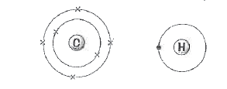
These elements do not gain or lose electrons. They share their electrons rather than transferring them. This results in the formation of covalent bonds. A covalent bond is a shared pair of electrons. When a small number of atoms share electrons in this way a small covalent molecule results.

Such molecules can be represented in several different ways:

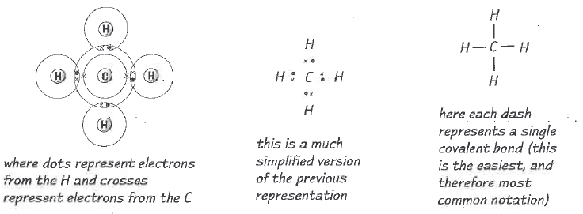
Try this question:
- Draw ‘dot and cross’ diagrams showing the shared electron pairs in the following molecules: hydrogen (H₂), chlorine (Cl₂),ammonia (NH₃), water (H₂0), oxygen (O₂). Ethane (C₂H₆)
Answers:

6. FORMULAE OF COMPOUNDS
Deducing the formulae of ionic compounds
The formula of a compound tells you the ratio of the elements that it contains. This ratio is fixed, and for ionic compounds that means it's easy to work out the formula from the charges on the ions.
Metal ions (and hydrogen ions) always carry a positive charge. whilst non-metal ions carry a negative charge. _{If} you imagine that a positive charge is a 'hook' and a negative charge is an 'eye' then the formula can be deduced by exactly matching up the hooks and eyes. (This is to make the compound electrically neutral - it's the same idea as the ionic lattices further on in this document.)

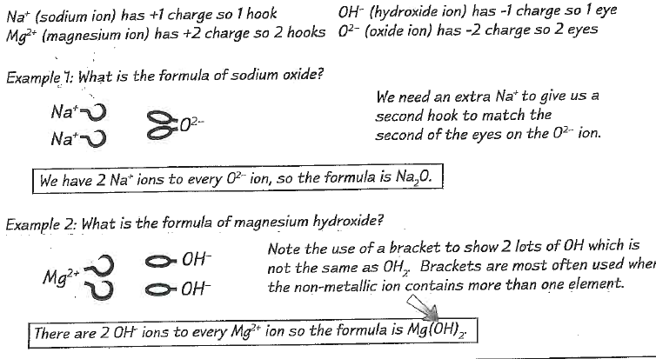
Now try these.
Use the charges on the ions shown below to deduce the formulae of the following ionic compounds:

- sodium chloride | 6. potassium oxide
- calcium bromide | 7. aluminium oxide
- sodium carbonate | 8. potassium nitrate
- aluminium oxide | 9. aluminium sulfate
- iron (II) chloride | 10. iron (III) nitrate

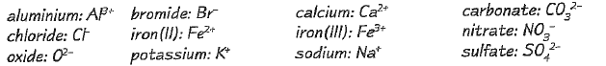

Answers:

7. WRITING AND BALANCING EQUATIONS
Example: write a balanced equation for the reaction of magnesium with hydrochloric acid.
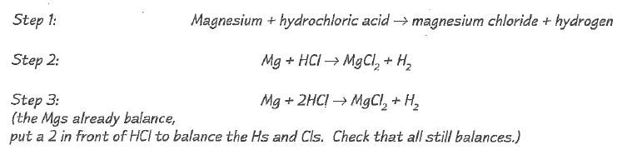
Now try this question.
- Write a balanced symbol equation for the combustion of methane (CH₄) in oxygen:
Step 1 has been done for you
Use everything you have learned in this document so far to answer these questions:
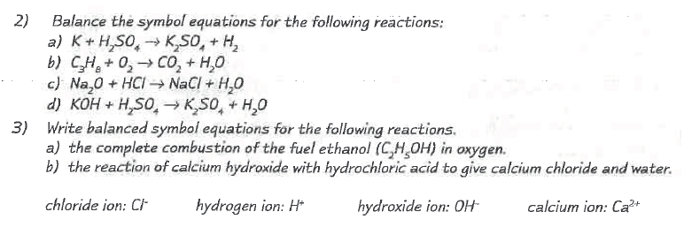
Answers:

8. THE MOLE
A Mole is a number of particles
If you wanted to count the number of atoms that you had in a sample of a substance, you would have to use some very big numbers, and spend a very long time counting.

So you need a unit to describe the amount of a substance that you have - that unit is the mole.

One mole of a substance contains 6.02 " 1023 particles.
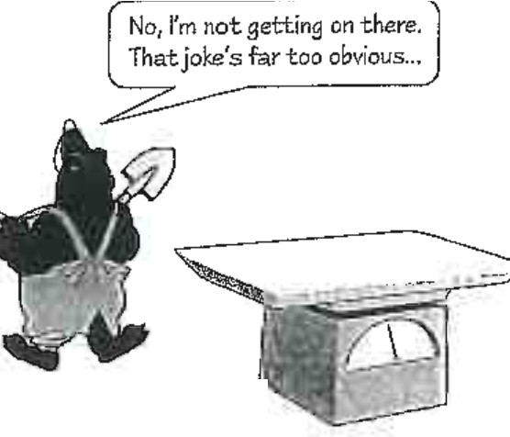
6.02 x 1023 mot' is known as Avogadro's number
The particles can be anything - e.g. atoms or molecules.

So 6.02 x 10²³ atoms of carbon is 1 mole of carbon, and 6.02 x 10²³ molecules of CO₂ is 1 mole of CO₂

Molar Mass is the mass of one Mole
One mole of atoms or molecules has a mass in grams equal to the relative formula mass (A₁ or M₁) of that substance.
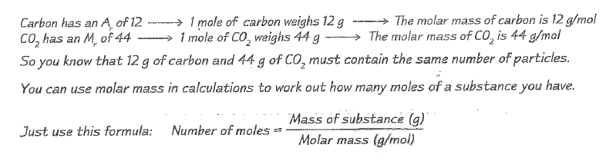
Example: how many moles of sodium oxide are present in 24.8g of Na₂O?
Molar mass of Na₂O = (2x23) + (1x16) = 62g/mol

Number of moles of Na₂O = 24.8g divided by 62g/mol
= 0.4 moles

Use the Periodic Table to help you answer these questions:
- Find the molar mass of zinc
- Find the molar mass of sulphuric acid H₂SO₄
- How many moles of sodium chloride are present in 117g of NaCl
- I have 54g of water (H₂O) and 84g of iron (Fe). Do I have more moles of water or of iron?

Answers:

9. DETERMINATION OF FORMULA FROM EXPERIMENTS
Empirical and molecular formulae
The empirical formula of a compound is the simplest ratio of the atoms of each element in the compound.
The molecular formula of a compound gives the actual number of atoms of each element in the compound.
For example, a compound with the molecular formula C2H6 has the empirical formula CH3.
The ratio of the atoms is one C to every three Hs.

Calculating empirical formulae
Often, the only way to find out the formula of a compound is through experimentation and calculation. You can calculate the formula of a compound from the masses of the reactants.
Here is a simple set of rules to follow when calculating a formula:

- Write the mass or percentage mass of each element.
- Find the number of moles of each substance by dividing by the atomic or molecular mass.
- Divide all answers by the smallest answer.
- If required: multiply to make up to whole numbers.
- Use the ratio of atoms to write the formula (this gives the empirical formula).

Example: find the formula of an oxide of aluminium formed from 9.00g aluminium and 8.00g oxygen.

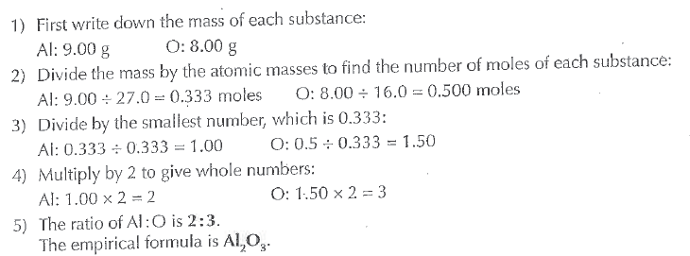
Questions:
- Find the empirical formulae of the following oxides:
- An oxide containing 12.9g of lead to every 1.00g of oxygen
- An oxide containing 2.33g of iron to every 1.00g of oxygen
(Relative atomic mass values: Pb = 207.2, O = 16.0, Fe = 55.8)

- Calculate the empirical formula of the carboxylic acid that is comprised of 4.30% hydrogen, 26.1% carbon and 69.6% oxygen
(Relative atomic mass values: H = 10, C = 12.0, O = 16.0)

Answers:
- (a)

- (b)

2.

10. CALCULATION OF MOLECULAR FORMULAE
Use the Relative Formula Mass to work out the Molecular Formula
To find the molecular formula from the empirical formula, you need to know the relative formula mass of the compound. This will usually be given to you in the question. Read through the example below and then try the questions.
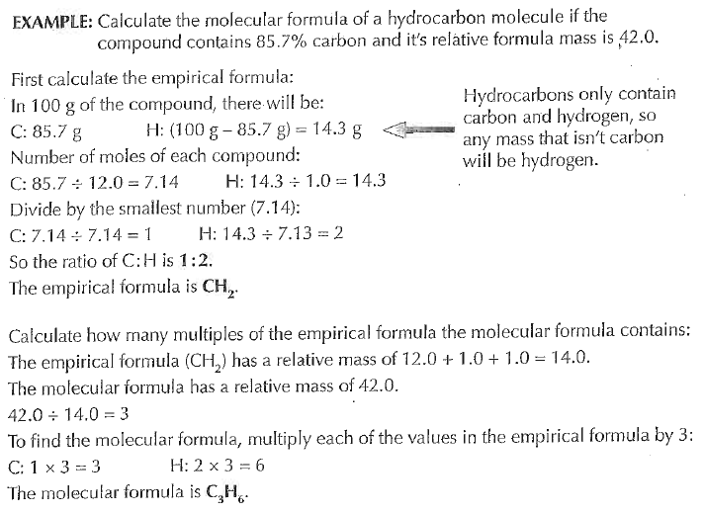
The example above uses percentage compositions rather than the mass of each element in the compound. You can calculate the percentage composition yourself using the formula:

Questions:

- Calculate the molecular formula of a compound containing 52.2% carbon, 13.0% hydrogen and 34.8% oxygen if the relative formula mass of the compound is 46.0
(Relative atomic mass values: C = 12.0, H = 1.0, O = 16.0)

- Calculate the molecular formula of a hydrocarbon with a relative formula mass of 78.0 that contains 92.3% carbon
(Relative atomic mass values: C = 12.0, H = 1.0)

- Find the percentage composition of oxygen in each of the following compounds:
- Ethanol (C₂H₅OH)
- Nitric acid (HNO₃)
- Propanone (C₃H₆O)

Answers:

10. MAKING USE OF THE PERIODIC TABLE
The Periodic Table holds lots of useful information
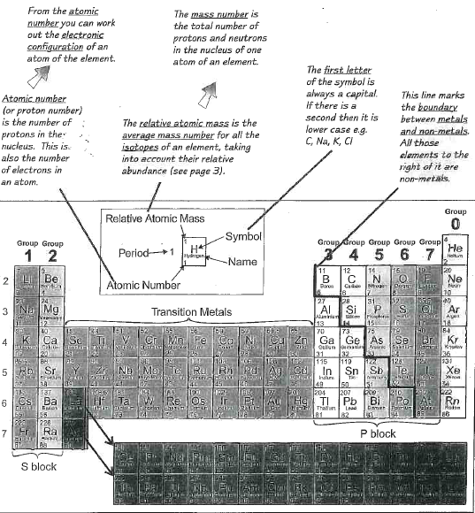

A more attractive version is shown below!
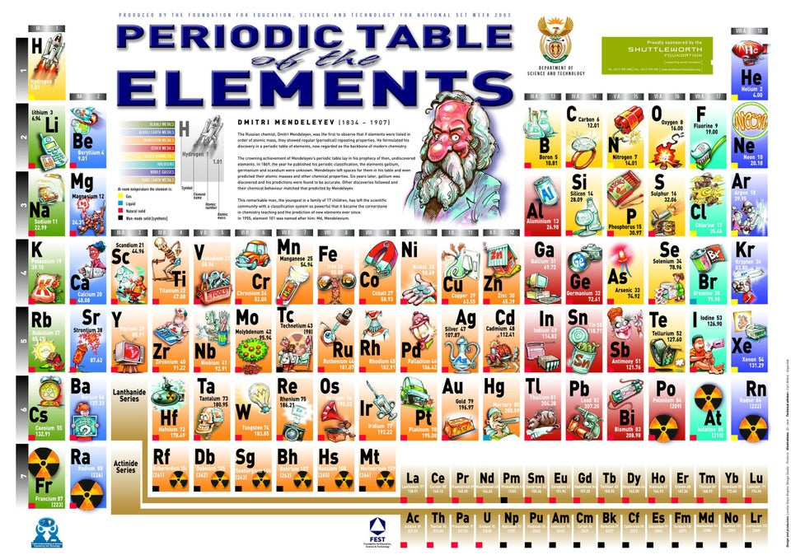
You can follow trends in physical and chemical properties down vertical groups and across horizontal lines.
All elements in a group have the same outer electron configuration and so form ions with the same charge.
Knowing the number of electrons in the outer shell means you can work out the formulae of compounds.
Learn and practice some important skills
You'll find chemistry heaps easier if you get used to working with the basic information that's contained in the Periodic Table.
- One of the most important things that you can learn is the names and symbols of the elements -particularly the more common ones that you'll need to use a lot.
- If you know the atomic number of an element in the Periodic Table, you can work out its electronic configuration.
- Being able to do that will help you to work out the formulae of compounds, ionic or covalent, quickly.

Use these questions and the Periodic Table to improve your skills.
- Find the symbols or names of the following elements: calcium, vanadium, phosphorous, Br, t in, Au, W, potassium, manganese, boron, Sb, thallium.
- Find the proton number for each of the elements in question 1.
- Using only the proton number, write out the electronic configurations, using both crosses and the shorthand (2,8,4), for these elements: Na, 5, Ca, N, Mg, He.
- What is the charge on the ions formed by each of these elements: K, magnesium, nitrogen, sulfur, Al, I?
- Work out the formulae of the following compounds: magnesium oxide, lithium bromide, aluminium sulfide, iron(ll) oxide, copper(ll) chloride.
- Use the following information to predict the properties of a bromide.
Fluorine is a highly reactive gas with a boiling point of -188°C
chlorine is a reactive gas with a boiling point o f - 35°C,
iodine is a fairly unreactive solid with a boiling point of 184 °C.

Answers:

