Hair & Beauty

Welcome to
Course Code: CSER046
Duration: Sept ’23 to June ’24
Attendance: 3-4 days a week
Campus: Chichester
Contact your Study Programme Leader:
01243 786321 Ext 2720
claire.parker@chichester.ac.uk
Chichester College

Level 3 Diploma in
Beauty Therapy Techniques

Dear Student,

I look forward to inviting you to your Level 3 in Beauty Therapy at Chichester College.
- There is a £60.00 compulsory fee for course consumables that you will need to pay prior to enrolment.
- This fee can be paid via our online store from Monday 14th August 2023 as below.
CCG Online Store (chichester.ac.uk) - Please be aware that the payee will need to register their details on the E-Store before they can pay the supplement.
Your course requires you to have a clean and tidy uniform, you will find attached links to order this. Please order as soon as possible to guarantee delivery in time for your start date. For returning students - If your uniform from last year still fits and looks smart then you do not need to purchase a new one.

Your course also requires the purchase of a kit, the order form is attached.

The first week of your course will be Transition/Induction for one day only.
- Friday 8th September. Arrive at 10am in B207, we should be complete by lunch time.

If you have any queries regarding your course or need any assistance, please do not hesitate to contact me via email – Claire.parker@chichester.ac.uk or extension 2720.
I hope you have a great summer and I look forward to seeing you in September.
Claire Parker
Study Programme Leader
C&G Level 3 Beauty Therapy

To ensure progression is successful please bring with you for your induction:
- Work Placement confirmation details minimum of 1 day a week

- Complete A&P workbook

- Completed Pathologies assignment – Copy sent to me prior to Fri 8th September.

- Progression Video – sent to me by 28th August.

- Pens and Notepad.

English and Maths

All students aged 16-18 years on a full-time course are required to update their English and Math’s skills if they do not hold a GCSE grade A/9-C/4 in both subjects. So please be aware that if you do not have these qualifications, you will be required to undertake a GCSE resit (or equivalent qualification) alongside your main program of study. This is compulsory and not optional. Please be aware that you cannot be awarded for one qualification without passing the other.

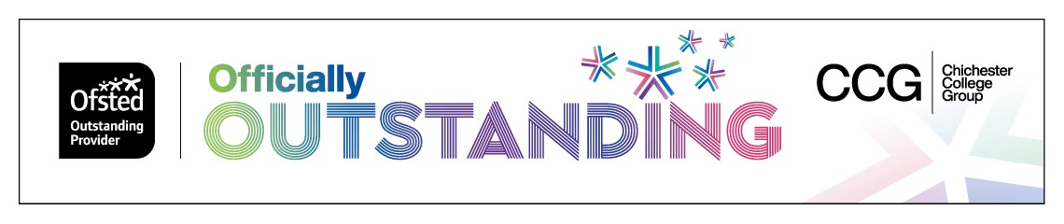

Are you ready to study Level 3 Beauty Therapy?
Uniform reminder -
If you are applying for student finance, please do this as early as possible, so that we can order your uniform for you as soon as possible. You can apply for finance as early as the end of June 2023.
As you know during the course, long hair must be tied up at all times whilst in the salons for both professionalism, as well as for hygiene purposes. Long ponytails need to be in a bun or braided.
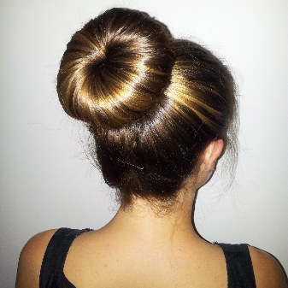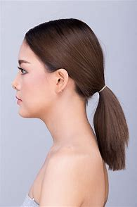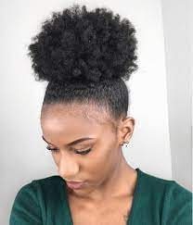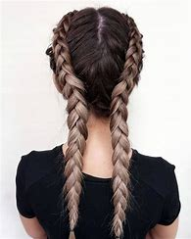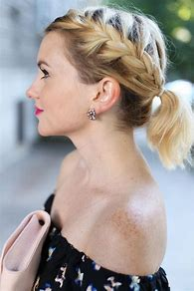
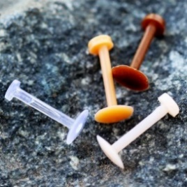
Facial piercings – our awarding bodies for Beauty Therapy do not allow face piercings and they only allow one small pair of studs in the ear lobe to be worn. To stop a piercing closing, we advise you to purchase some skin toned retainers such as in the picture below. While using ELECTRICAL machines you cannot have METAL piercings
Nail Extensions and Eyelash Extensions are not allowed for the reasons stated below:
- False nails are unhygienic and harbour bacteria, some clients may be allergic to acrylic, or nail varnish and long nails also scratch clients and make it hard to perform detailed work.
- The awarding bodies we use to assess our students do not allow false nails or eyelashes (for further information on this please speak to your course manager). If a student has these on, they will fail a practical exam.
This look is not professional, safe or hygienic and students will not be allowed to enter the salons/studios presented in this way.
New tattoos and new piercings (anywhere on the body) should be avoided whilst studying on beauty or makeup courses, as these have a healing time of up to 6 weeks, which means you cannot participate in practical, and we cannot pair you with a partner. Please save any new tattoos or piercings you would like to get until the summer holidays, when they have time to heal fully.

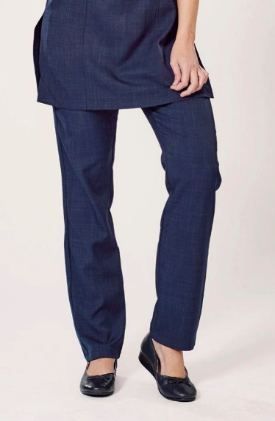
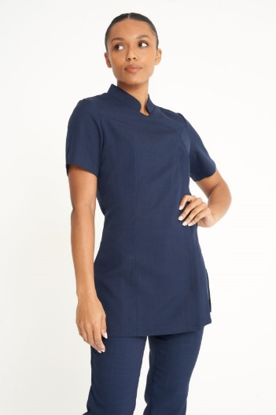
Your course uniform.
Beauty courses will wear the following uniform:
The tunic and trousers may be worn with a long sleeve, plain black t-shirt underneath in colder weather. Your shoes must be plain black low heeled, closed in toes, shoes or trainers (no other colours on the logo, laces or soles):
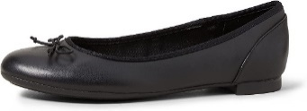
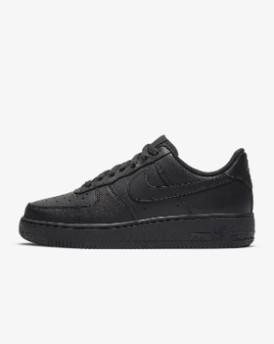

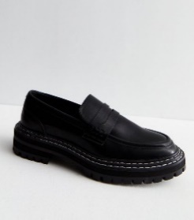

Pathologies Summer Assignment for Level 3 in Beauty Therapy
- This assignment is to be handed in on the first day back in September.
Please include;
- Symptoms
- Causes (to include if hereditary or not)

Please use the following font: Arial size 12, Please print your work to hand in on the date shown.

Digestive system
- Cirrhosis of the liver
- Coeliac disease
- Chron’s disease
- Gall stones
- Halitosis
- Hepatitis
- Hiatus hernia
- Irritable bowel syndrome (IBS)
Endocrine
- Diabetes insipidus
- Diabetes mellitus (type 1 & type 2)
- Hormone imbalance
- Hyperthyroidism
- Polycystic ovaries
- Skin irregularity
Reproductive system
- Endometriosis
- Menstrual problems
- Respiratory system
- Asthma
- Bronchitis
- Emphysema
- Hay fever
- Sinusitis

Renal system
- Cystitis
- Nephritis

Nervous system
- Bell’s palsy
- Cerebral palsy
- Epilepsy
- Fever
- Migraine
- Multiple Sclerosis
- Parkinson’s
- Sciatica
- Vertigo

Skeletal
- Bunions
- Bursitis
- Fractures
- Hammer toes
- Herniated (slipped) Disc
- Kyphosis
- Lordosis
- Osteoarthritis
- Osteoporosis
- Rheumatoid Arthritis
- Rickets
- Scoliosis
Muscular system
- Carpal Tunnel
- Cramp
- Fibrositis
- Low back pain
- Lumbago
- RSI (Repetitive strain injury)
- Sprain
- Tennis / Golfers elbow
- Tendonitis
Cardiovascular system
- Angina
- Deep vein thrombosis (DVT)
- Haematoma (bruising)
- Hypertension
- Hypotension
- Phlebitis
- Stroke
- Varicose veins
Lymphatic system
- Allergies
- Cancer
- Fever
- HIV and Aids
- Lymphedema
- Mastitis
- Oedema

