Hair & Beauty

Welcome to Chichester College
Course Code: CSER007F1A Duration: Sept ’23 to June ’24 Attendance: 3-4 days a week Campus: Chichester
Contact your Study Programme Leader:
01243 786321 Ext 2295
tracey.lamb@chichester.ac.uk

Dear Student,

I look forward to inviting you to your Level 2 in Beauty Therapy at Chichester College.
- You will enroll for your course on Tuesday the 5th of September. The time will be confirmed by an email that will be sent by Chichester College on August 1^{st.} It is compulsory that you bring evidence of GCSE results and ID to enroll.
- Please complete the attached Student Profile (below) and email to me, along with a copy of your GCSE results by Friday 25th August (email address as above)
- There is a £60.00 compulsory fee for course consumables that you will need to pay prior to enrolment.
- This fee can be paid via our online store from Monday 14th August 2023 as below
- CCG Online Store (chichester.ac.uk) - Please be aware that the payee will need to register their details on the E-Store before they can pay the supplement.
Your course requires the purchase of uniform, you will find attached links to order this. Please order as soon as possible to guarantee delivery in time for start date.

Your course also requires the purchase of kits, the order forms for your course will be sent to you once your conditional offer has been confirmed and once your GCSE results have been submitted to me on the email address above.

The first week of your course will be Transition/Induction for two days only.
- Your first day is Wednesday 6th September, starting at 9:15 and finishing no later than 16.15.
- Day 2 is Thursday 7th September commencing at 09.15 (Assessment Day) finishing no later than 16:15.
- On Wednesday 6th September please meet in B209 classroom.
If you have any queries regarding your course or need any assistance, please do not hesitate to contact me via email tracey.lamb@chichester.ac.uk or extension 2295.
I hope you have a great summer and I look forward to seeing you in September.
Tracey Lamb
Study Programme Leader
C&G Level 2 Beauty Therapy

Please bring with you for your induction:
- Pens and Notepad.
- Lunch or money to buy lunch and bottled water.

English and Maths

All students aged 16-18 years on a full-time course are required to update their English and Math’s skills if they do not hold a GCSE grade A/9-C/4 in both subjects. So please be aware that if you do not have these qualifications, you will be required to undertake a GCSE resit (or equivalent qualification) alongside your main program of study. This is compulsory and not optional. Please be aware that you cannot be awarded for one qualification without passing the other.
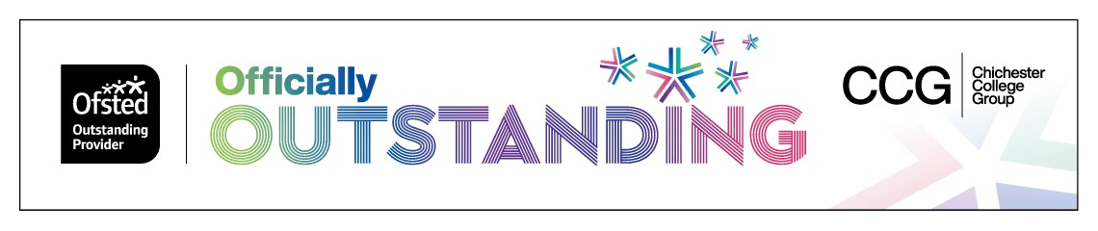

Are you ready to study Beauty Therapy?
The beauty therapy industry sets a code of ethics which includes the wearing of a professional uniform. As not all students will have their uniform at the start of term, we ask students to follow our professional standards by having in place a pair of black trousers (NOT leggings or Jeans), black plain full length ‘T’ shirt and low heeled, closed in shoes (for health and safety purposes), such as those in the pics below. We recommend purchasing these items from less expensive stores such as Primark, Tesco’s, Sainsbury’s, Peacocks, Amazon and New Look, as they are only for use until the course uniform is received.
If your uniform has arrived before your induction starts in September, then please wear your uniform to induction.
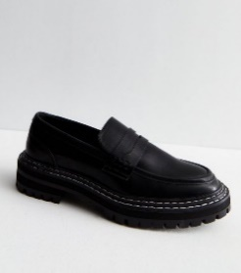
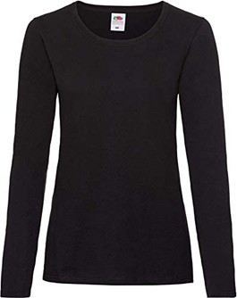
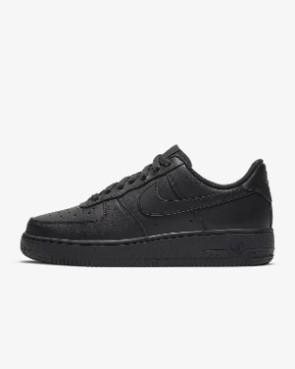
If you are applying for student finance, please do this as early as possible, so that we can order your uniform for you as soon as possible. You can apply for finance as early as the end of June 2023.
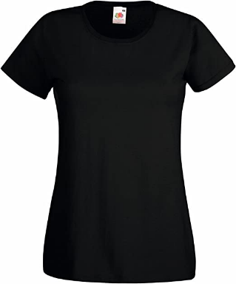

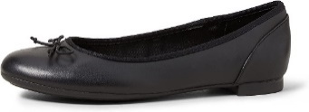

During the course, long hair must be tied up at all times whilst in the salons for both professionalisms, as well as for hygiene purposes. Long ponytails need to be in a bun or braided.
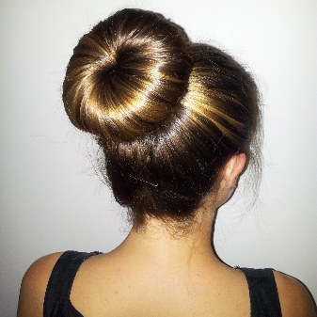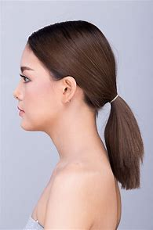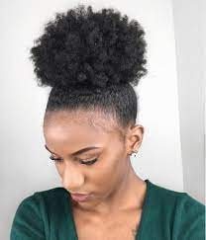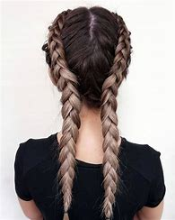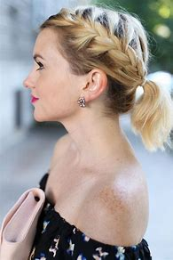
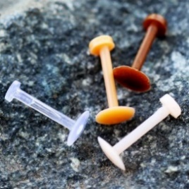
Facial piercings – our awarding bodies for Beauty Therapy do not allow face piercings and they only allow one small pair of studs in the ear lobe to be worn. To stop a piercing closing up, we advise you to purchase some skin toned retainers such as in the picture below.
Nail Extensions and Eyelash Extensions are not allowed for the reasons stated below:
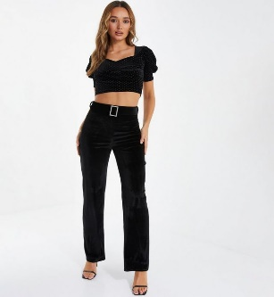
- Students are required to work on each other for manicures and eye treatments and this cannot occur if someone is wearing false lashes or false nails.
- False nails are unhygienic and harbour bacteria, some clients may be allergic to acrylic, or nail varnish and long nails also scratch clients and make it hard to perform detailed work.
- The awarding bodies we use to assess our students do not allow false nails or eyelashes (for further information on this please speak to your course manager). If a student has these on, they will fail a practical exam.
This look is not professional, safe or hygienic and students will not be allowed to enter the salons/studios presented in this way.
New tattoos and new piercings (anywhere on the body) should be avoided whilst studying on beauty or makeup courses, as these have a healing time of up to 6 weeks, which means you cannot participate in practical, and we cannot pair you with a partner. Please save any new tattoos or piercings you would like to get until the summer holidays, when they have time to heal fully.

Your course uniform.
Beauty courses will wear the following uniform:
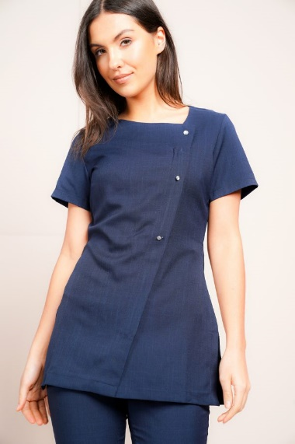
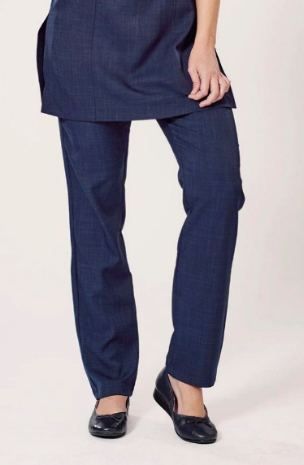

Hair and Makeup courses will wear the following tunic, with your own supplied plain black, full-length trousers or leggings (not jeans):
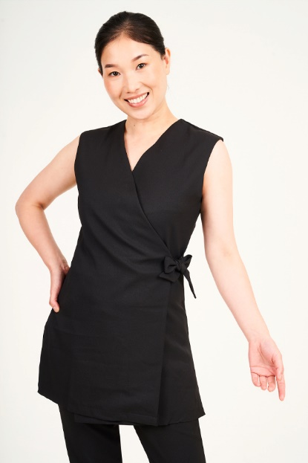
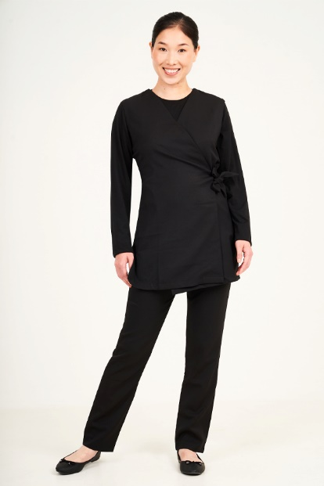
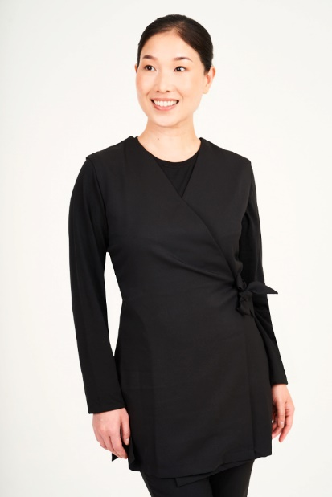

The tunic and trousers for both courses may be worn with a long sleeve, plain black t-shirt underneath in colder weather. Your shoes must be plain black low heeled, closed in toes, shoes or trainers (no other colours on the logo, laces or soles):

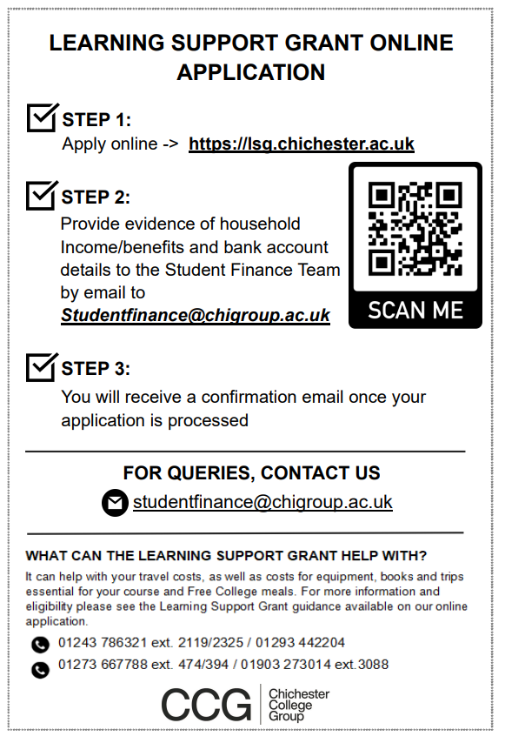

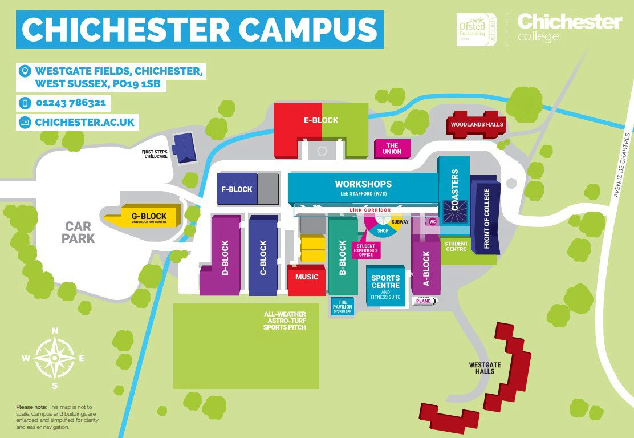
Where will I be studying?
The course will take place in B Block, Chichester Campus.

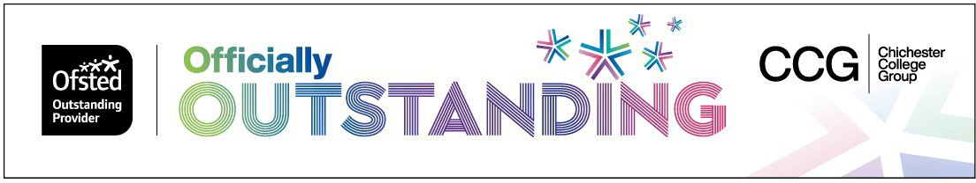

Service Industries Student Profile
2023-2024

Details
Name: Date of Birth:
Email: Mobile Number
Home address:

Course Applied for:

Qualifications:
English Grade/Predicted Grade: Maths Grade/Predicted Grade:
Language
Literature
Other:

Introduction: Tell me a bit about you, discuss your subject choice and why you have chosen it.
Hobbies and Interests:
Do you have any currently experience and skills within the beauty industry?
Conclusion: What are your aspirations for this year? Why Chichester College? Do you have any experience in the subject matter? What are the top three skills you currently have and what areas do you require to develop?

