**Adding A Forum**



There are lots of uses of forums from a simple forum providing a social space for students. Tutors can use them for course announcements or as a help centre where tutors and students can give advice and support.

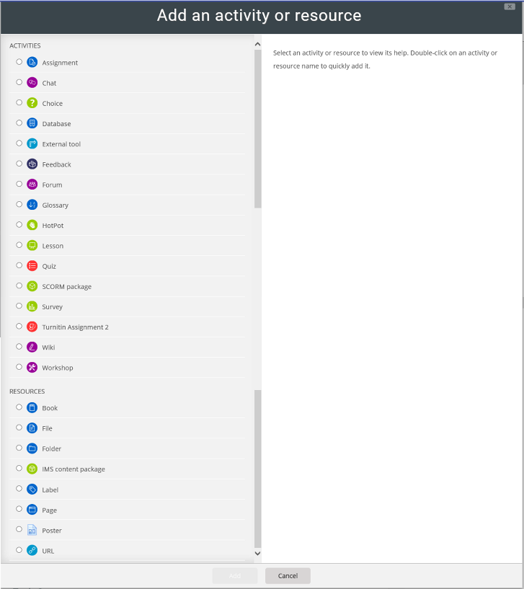

Then click Add

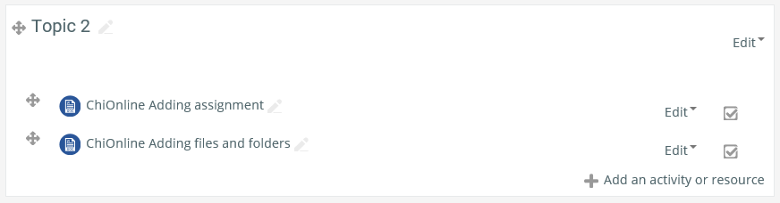

Click Add an activity or resource

Select Turnitin Assignment 2 from the list

When you select an activity a brief description and uses is displayed on the right. If you need more help there is also a More Help link which links to Moodle Docs about this activity

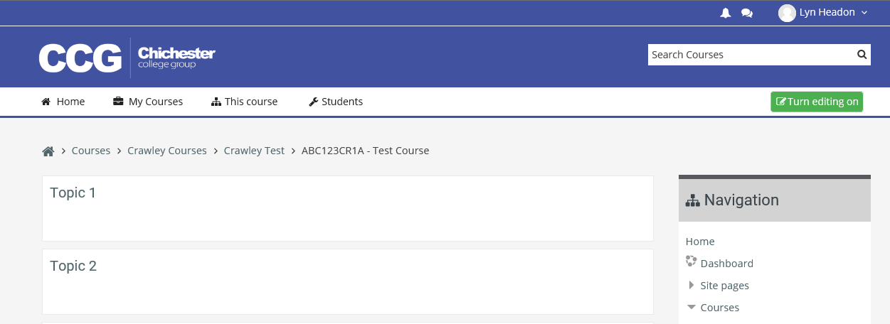

Before making any changes you must switch to editing mode by clicking on the **Turn editing on** button

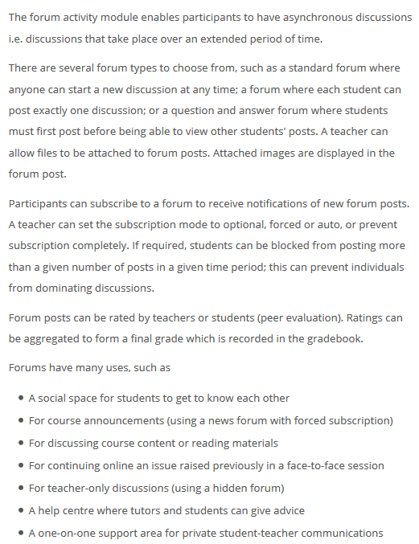

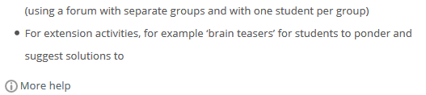

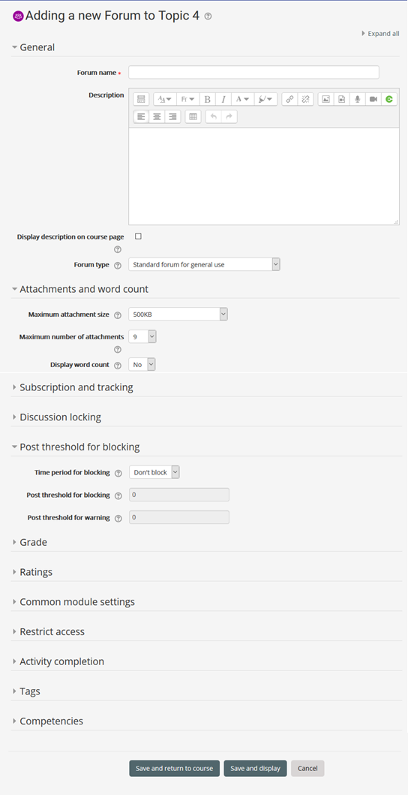

Add a description (optional)

Name the Forum

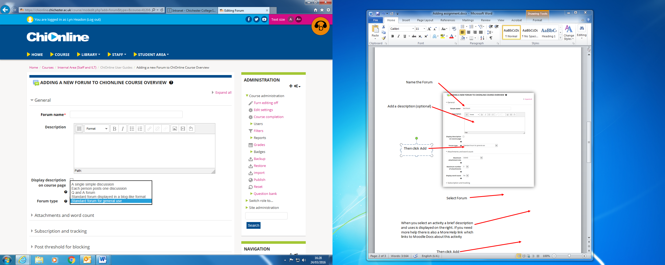

There are several forum types to choose from the most commonly used are:

* standard forum for general use , in this forum anyone can start a new discussion at any time
* Q and A forum, students must post before being able to view other students' posts

You can restrict the number of attachments, set 0 if you don’t want any attachments

You can set a posting threshold: set the number of days in the Time period for blocking box. Then set the number of posts before blocking, and before a warning. Setting this will stop anyone from spamming the forum with posts.

The grey arrows will open or collapse each section

There are other options that you can set most are self-explanatory

Don’t forget to save the forum

The website link can be edited in the same way as files and folders (see instructions in Adding files and folders help sheet)



A Forum can be identified from its icon

DON’T FORGET TO TURN EDITING OFF WHEN YOU HAVE FINISHED



First click on the forum icon from your course

Once you have added the forum you will need to add some discussion topics/questions

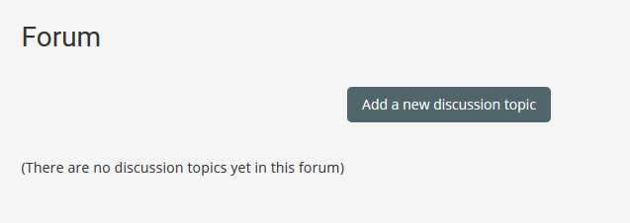

Then click on Add a new discussion topic

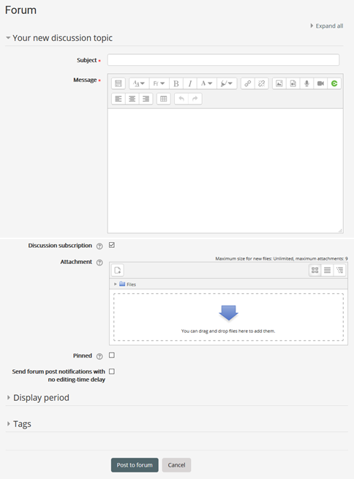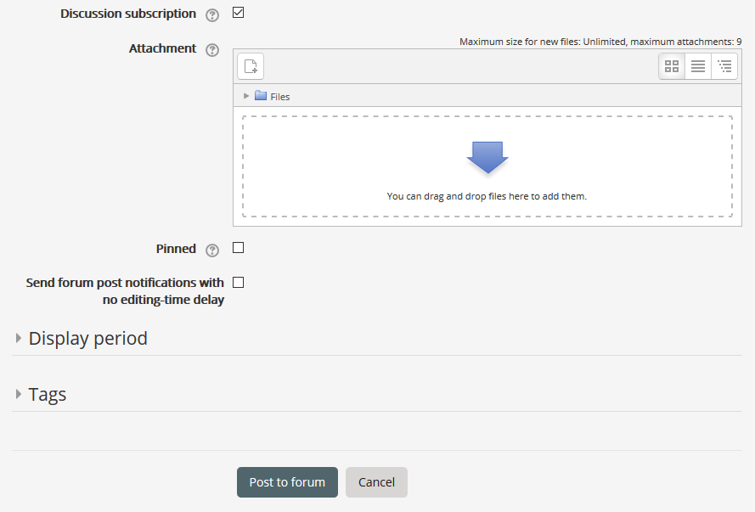

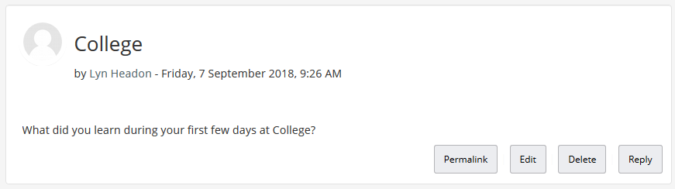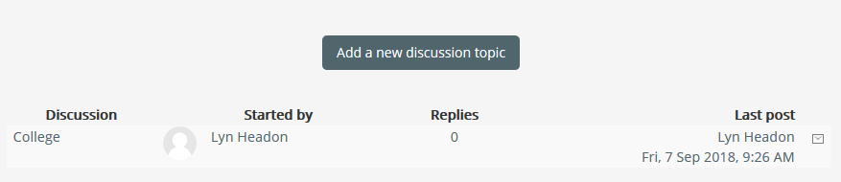

The person who started the discussion is here

Click the subject to open the discussion

The message shows here

To add another message, or to reply to a message a student has left click on Students will only have the option to reply to a message

When you enter a forum you will see a list of discussion subjects, click on the discussion to view it or add to it. This is also what a student sees when they enter a forum

Save by clicking Post to forum

You can upload files or pictures here if necessary

And a Message

Add a subject