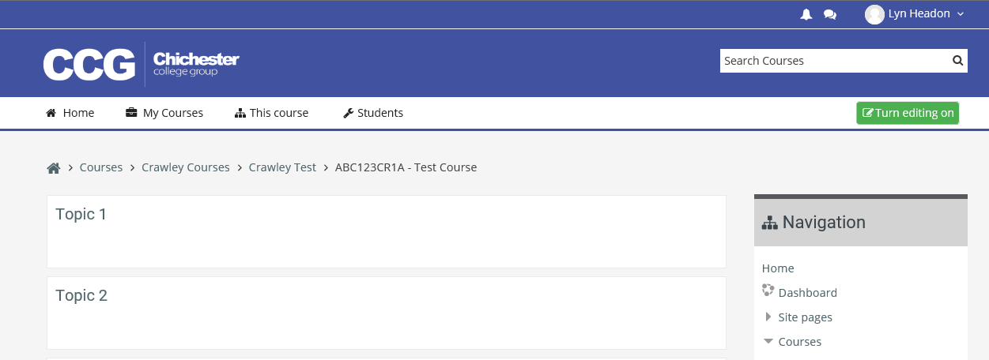**Adding an Assignment**

Before making any changes you must switch to editing mode by clicking on the **Turn editing on** button



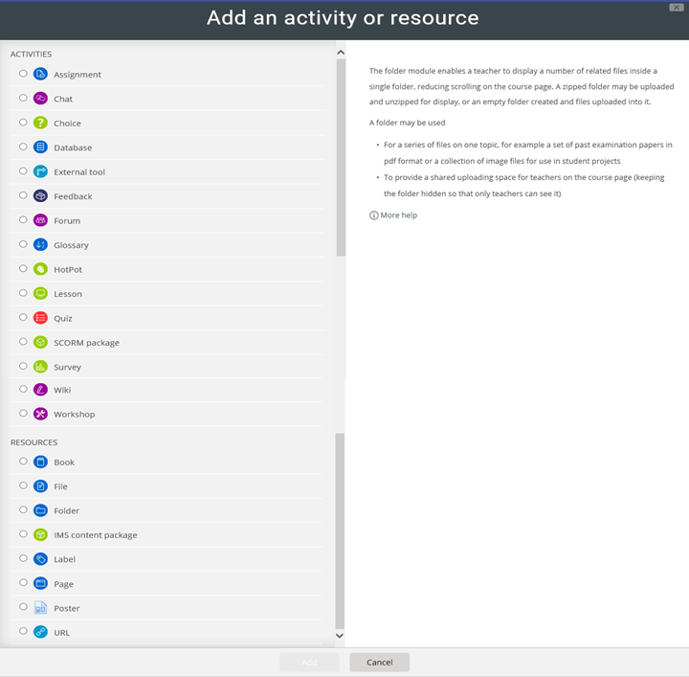

Click Add an activity or resource

Then click Add

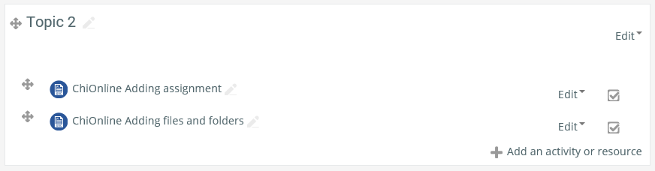

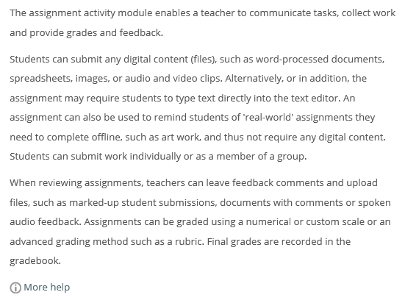

Select Assignment from the top of the list

When you select an activity a brief description and uses is displayed on the right. If you need more help there is also a More Help link which links to Moodle Docs about this activity

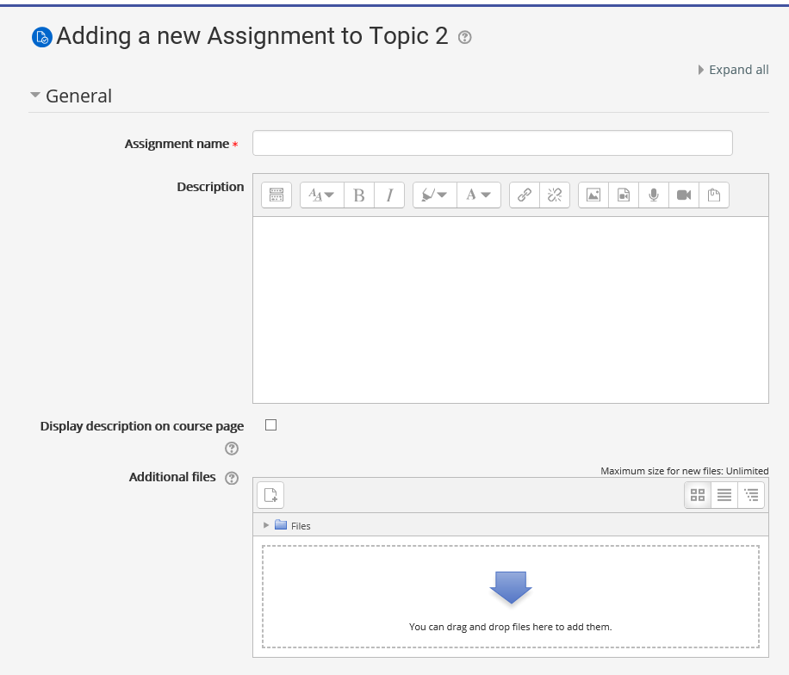

Give the Assignment a name

Add a description telling the students what to do for the assignment

You can upload a file here, perhaps with more information or instructions for the students

There are lots of other options I have covered the ones I feel are most useful

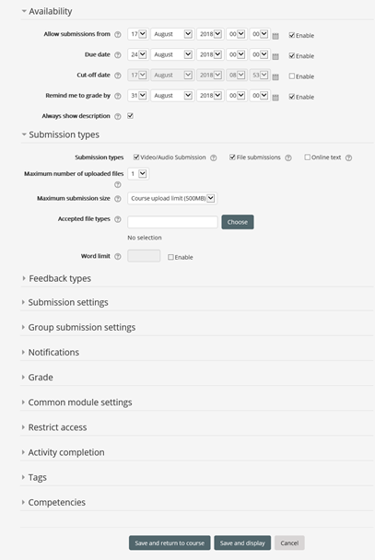

Clicking the small grey triangle arrows will open or collapse the sections

You can add dates to start and end dates for submissions

Select the type of submission: Online text, File submission or Video/Audio

If you have allowed a file submission you can select the number of files that can be submitted

If you have allowed Online text to be submitted you can add a word limit

There are lots of other options that you may or may not use they are fairly self-explanatory

When you are done scroll to the bottom of the page and click on Save and return to course

An Assignment can be identified from its icon, it also displays the due date and submissions info for students

The Assignment can be edited in the same way as files and folders (see instructions in Adding files and folders help sheet)

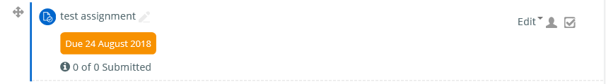

DON’T FORGET TO TURN EDITING OFF WHEN YOU HAVE FINISHED

To access or grade assignments that have been submitted click on the assignment icon

You can see the number of participants, the number of submissions and number of submissions still to be graded

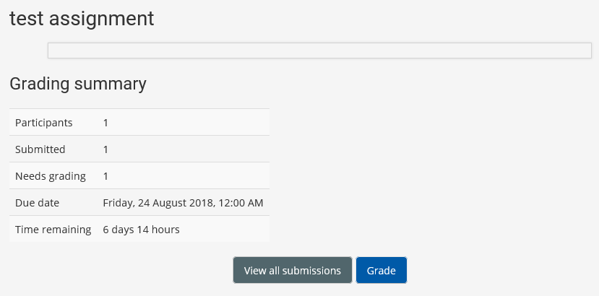

You can also see the due date and time remaining for submissions

Click on View/grade all submissions to see the assignments that have been submitted

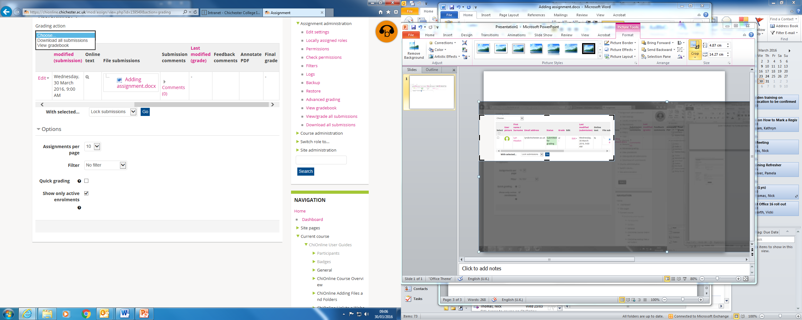

You can download multiple files by selecting Download all submissions from the dropdown list

Or a single assignment by selecting them individually

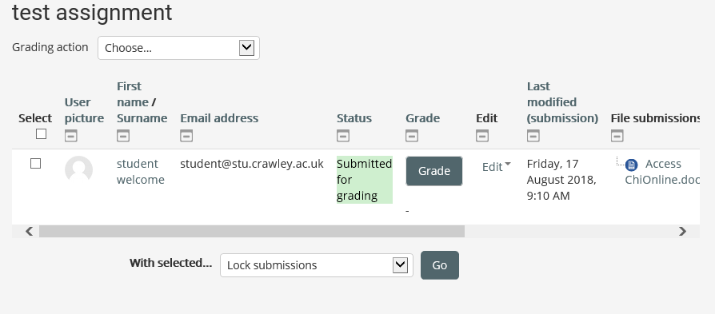

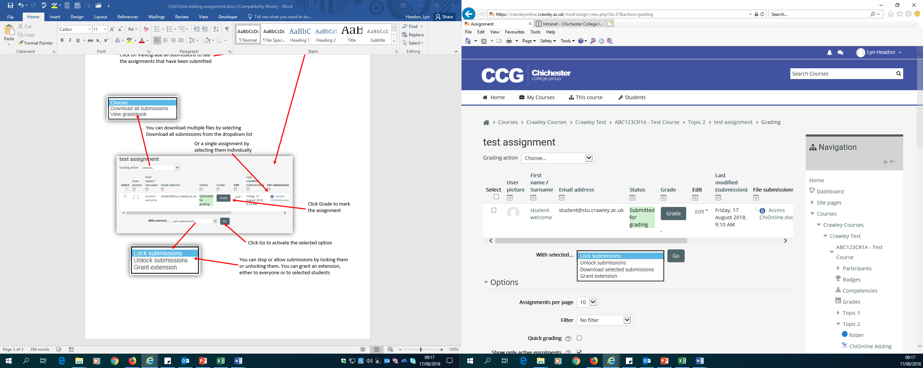

Click Grade to mark the assignment

Click Go to activate the selected option

You can stop or allow submissions by locking them or unlocking them. You can grant an extension, either to everyone or to selected students