**Adding Files**



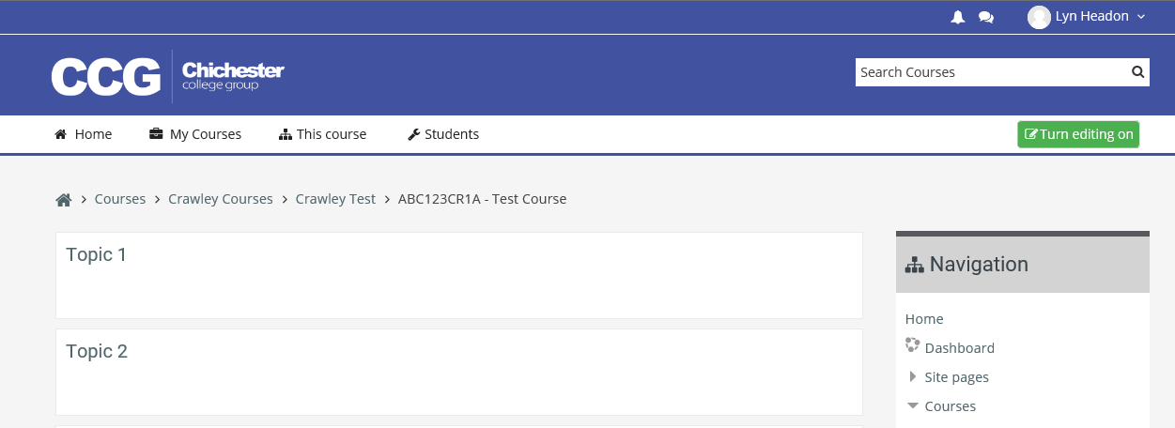

Before making any changes you must switch to editing mode by clicking on the **Turn editing on** button

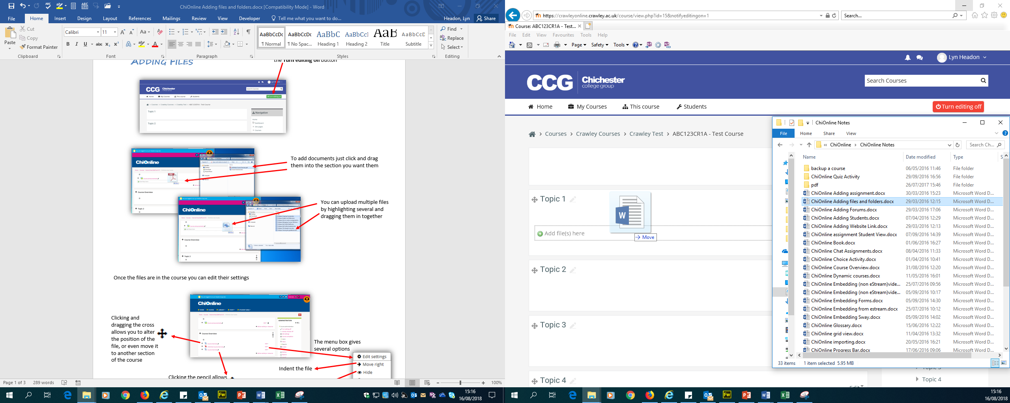

To add documents just click and drag them into the section you want them

You can upload multiple files by highlighting several and dragging them in together

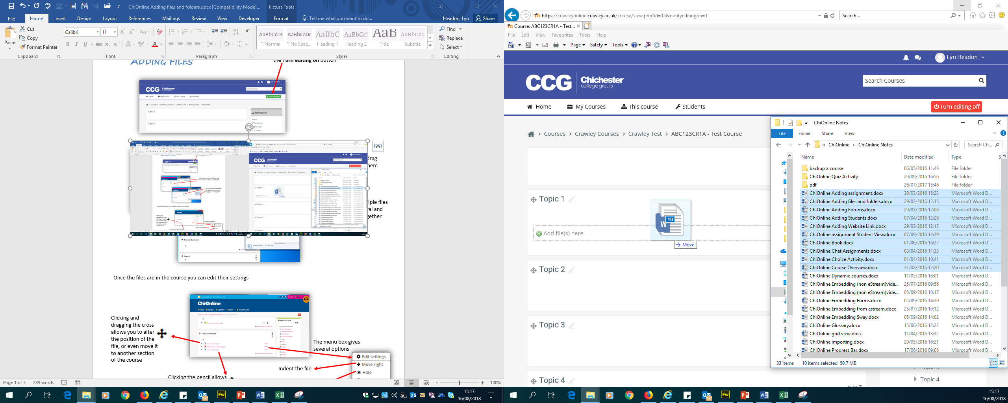

Once the files are in the course you can edit their settings

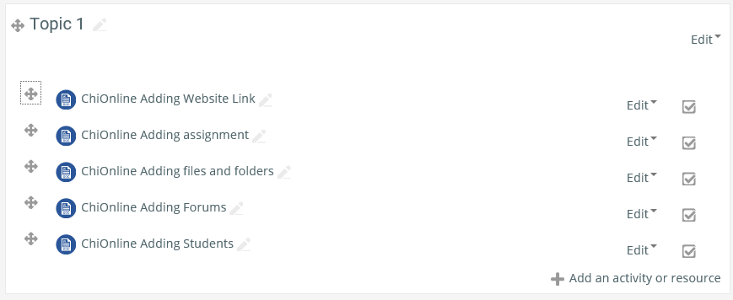

Clicking and dragging the cross allows you to alter the position of the file, or even move it to another section of the course

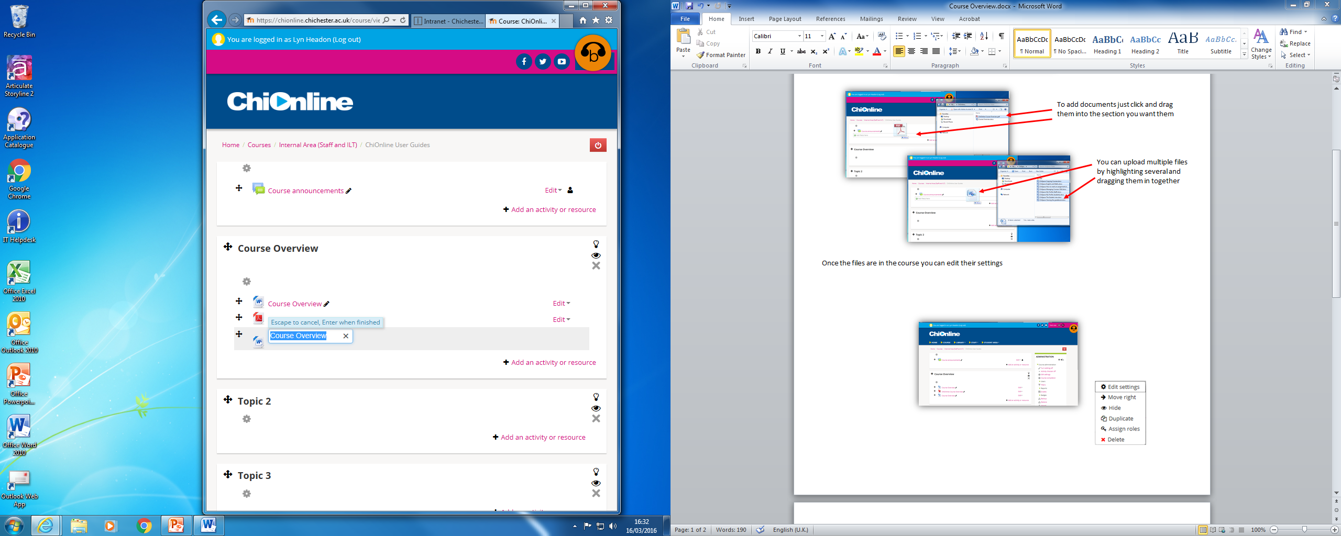

Click Edit to open the menu box

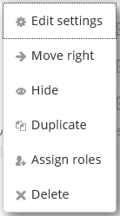

Indent the file



Clicking the pencil allows you to rename files

Hide the file from students

Duplicate the file

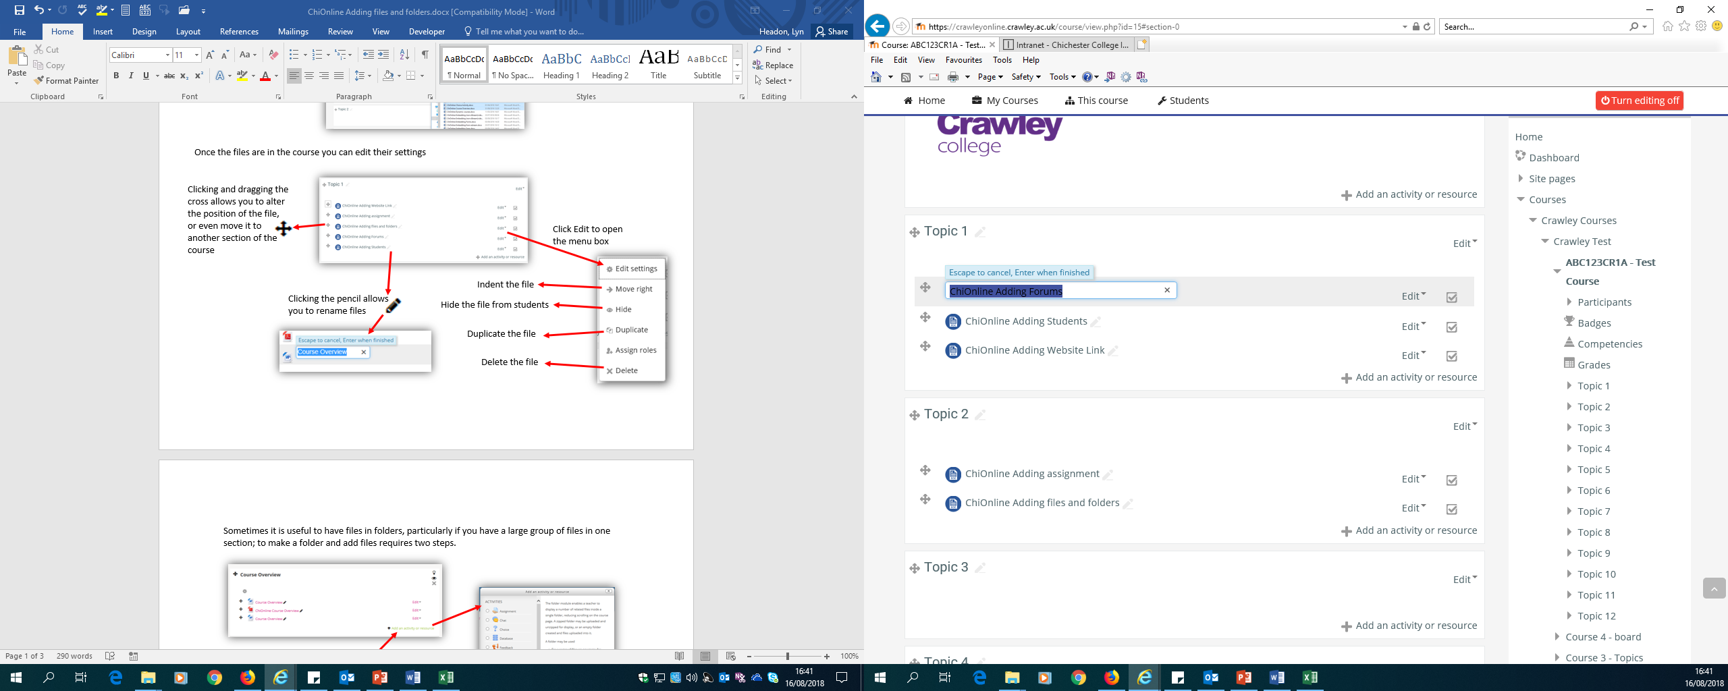

Delete the file

Sometimes it is useful to have files in folders, particularly if you have a large group of files in one section; to make a folder and add files requires two steps.

Click Add an activity or resource

Save and return to course

You can drag and drop files directly here

(these can be added or edited later)

Add a description (optional)

Name the folder

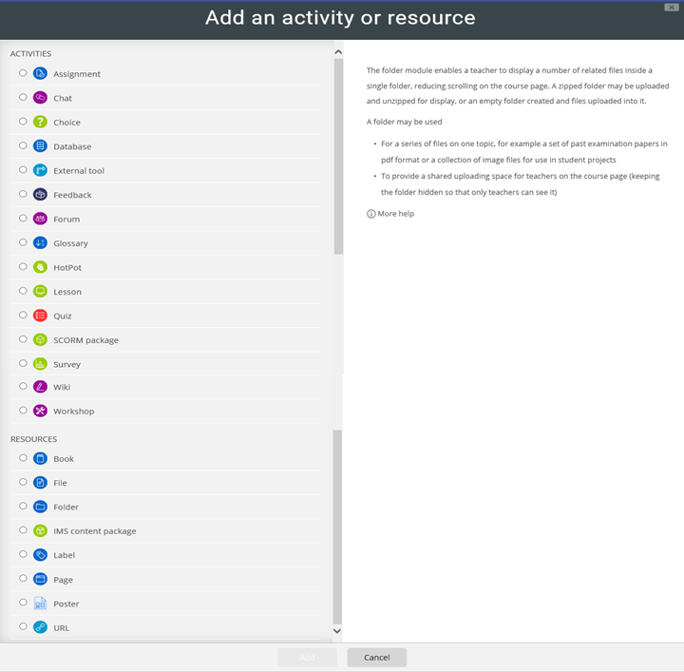

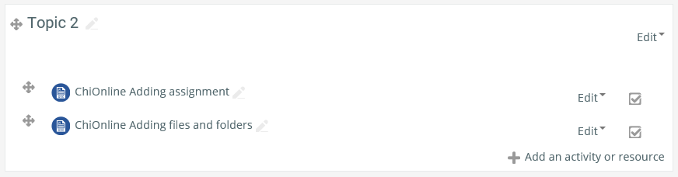

When you select an activity a brief description and uses is displayed on the right. If you need more help there is also a More Help link which links to Moodle Docs about this activity

Scroll down and select Folder

Then click Add

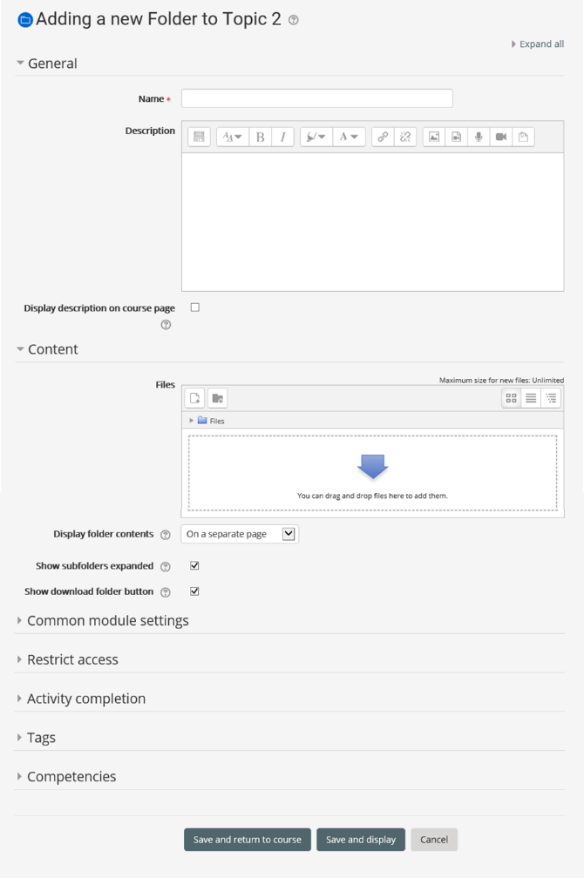

You can set for folders to be expanded as well as adding a button allowing users to download the while folder

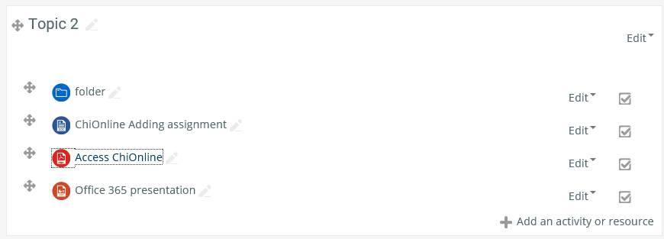

You can always tell what type of activity the link is by the link icon when a student clicks the link the file or folder will open



Clicking on the folder name opens the folder menu

Clicking the pencil allows you to rename the folder

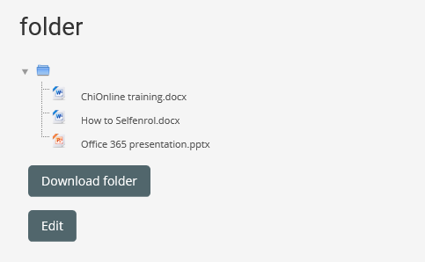

Any files in the folder are displayed

If you selected the option in the setup a download button allows users to download the whole folder

Click Edit to add/remove files

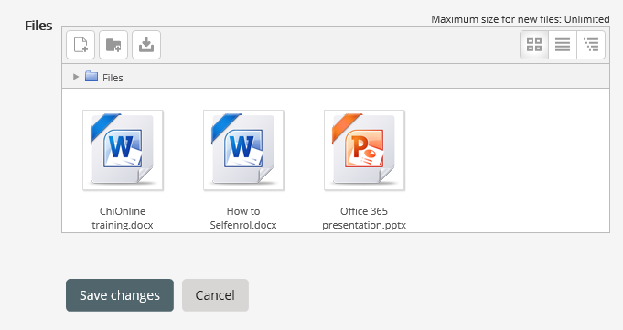

Drag and drop files into the box then click save changes

DON’T FORGET TO TURN EDITING OFF WHEN YOU HAVE FINISHED

**Please Note:** Any file type can be uploaded to Moodle, however the learner will need the correct software on their device/computer to open the file (only relevant if you are using specialist software)