GCSE to A LEVEL
Summer Project

Name:
Subject: A Level English Language
The purpose of this A Level Summer project is to introduce you to studying this subject at A Level standard. You will need to complete 10 hours of study on each subject every week, 4½ in class with your teacher and the rest as independent learning. Therefore, it is important that you enjoy this subject and that you start to practice your study skills as early as possible. Some subjects have significant maths content (for example business, psychology, economics); others require strong essay writing skills (for example history, English). Think about the study skills and underpinning knowledge you will require in this subject – not just the title.

If after completing this project you think this may not be your ideal choice, you can ask to transfer to another subject at the start of term, as long as you have the entry requirements and it fits alongside your other choices on the A Level Matrix (timetable). If you do decide to change subject, you will be required to complete the Summer project for your new choice too.

This is also your first taste of Flipped Learning and elements will be used within your first week of lessons.

Please ensure your name, student number and subject are clearly noted on each page and bring it with you to hand in at Enrolment.

We hope you enjoy this project as you start your A Level journey.

HOW TO SUBMIT:
Please print your completed project and bring a copy with you to Induction in a clearly labelled plastic wallet.
If you don’t have access to a printer, electronic copies can be emailed as a Word or PDF attachment to ALevel_EnglishLanguage@chichester.ac.uk with the email clearly labelled ‘English Language Summer Project’ prior to Induction.

Summer Task 1 (Preparation for Paper 1)

Language Analysis of two texts
This task is designed to get you to consider the uses of language and presentational features in two texts that are linked by a theme, a skill you will be developing for A Level English Language
Texts A and B focus on the theme of child labour.
Question 1
Analyse how Text B uses language to create meanings and representations.
For Text A write 400 words on:
• Purpose(s) and audience(s)
• The representation of the issue/theme

Question 2
Analyse how Text B uses language to create meanings and representations.
For Text B write 400 words on:
• Purpose(s) and audience(s)
• The representation of the issue/theme

Question 3
Compare and contrast Text A and Text B, showing ways in which they are similar and different in their language use. Write 300 words.

Text A

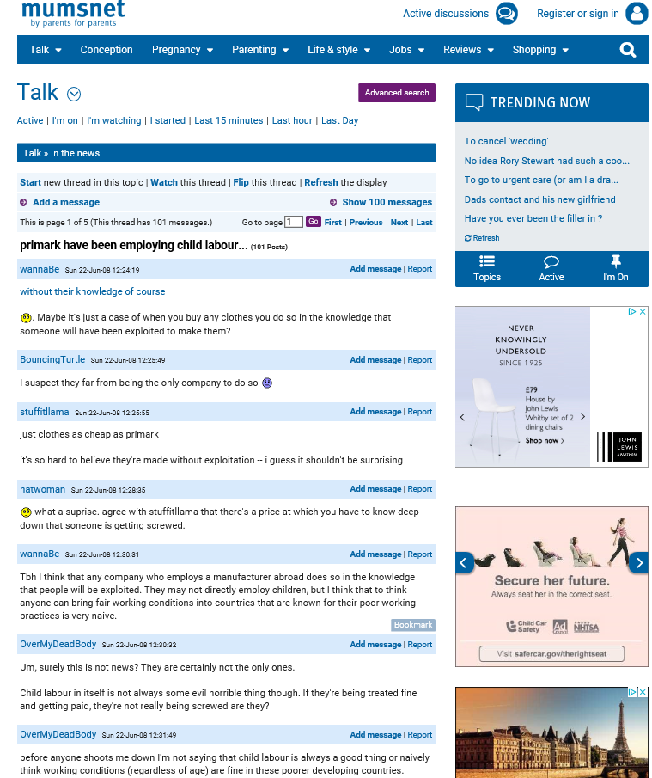

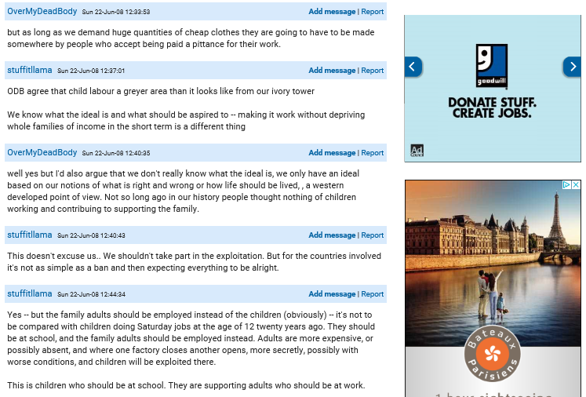

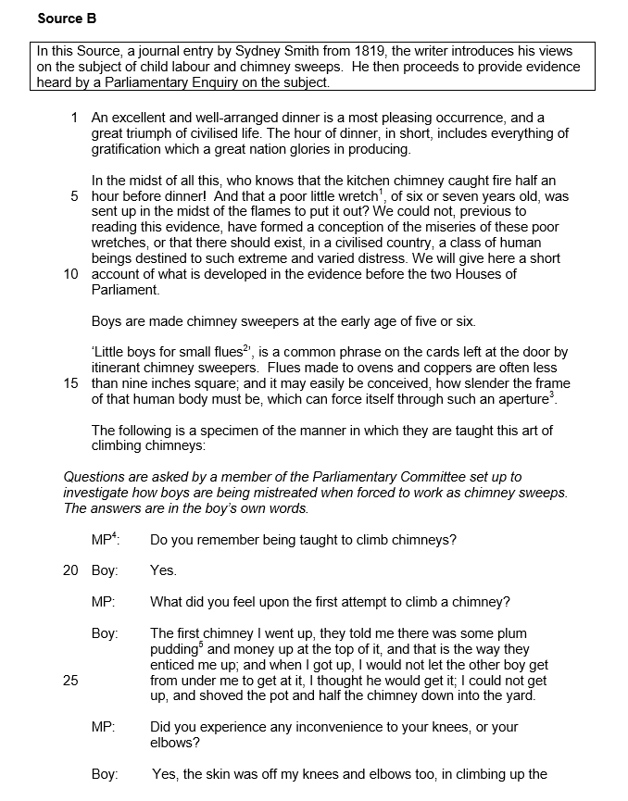

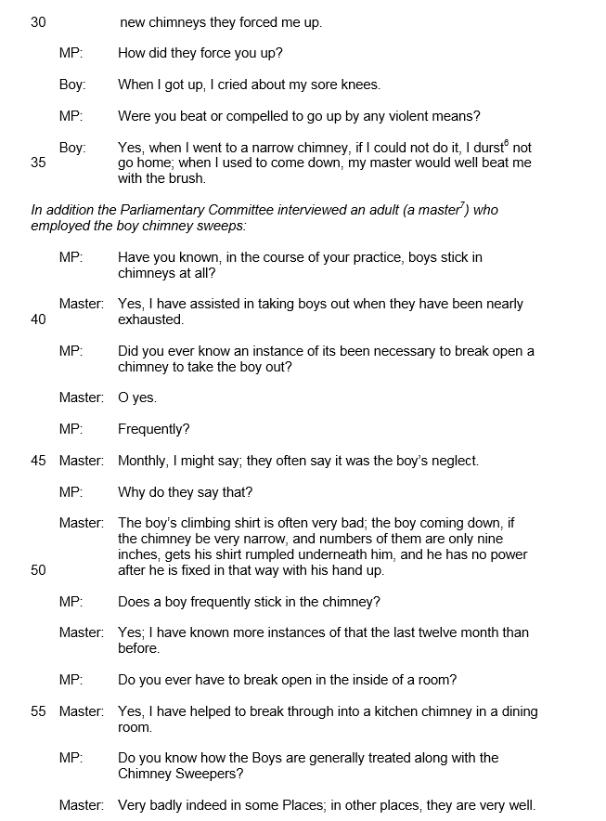
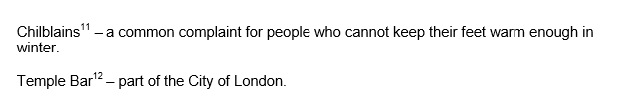

Summer Task 2 (Preparation for Paper 2)
Whilst Paper 1 is all about analysing texts (a skill you will have developed for your GCSE English Language exam), in Paper 2 we broaden out and look at ideas, concepts and theories about language use. So you might engage with more of a debate question on how our gender, age, ethnicity, social class, the social groups we belong to, how our hobbies or occupations, or where we live (region), all affect the way that we use language.
Such examples above are known as ‘variation factors’ or ‘extra-linguistic variables’ (terms you will become used to seeing and using next year).
For now, it will be useful to do some wider reading into how such issues are written about. Whilst many linguists (language theorists) comment on variation in language (the study of which is known as sociolinguistics), it also seems that everyone has something to say about language. Think about examples you might have encountered – people commenting on or judging people by their accents, or the way that people speak, the idea that ‘slang’ makes people sound less intelligent – or more ‘cool’, the idea that people change the way they speak depending on who they are talking to etc.
TASK Do some wider reading on how the above ideas about language are represented in the media (online or newspaper articles, blogs or forums etc.)
- Find and read at least 3 different texts about language
- THEN write a summary of each text that you’ve read reflecting on how the writer (or narrator) uses language about the language issue and stating your own views on the language issue too
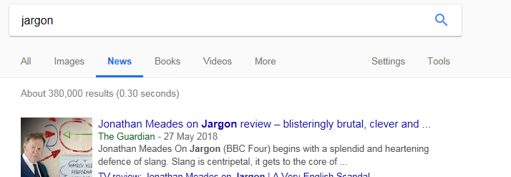
To find texts you might want to do an internet search trying combinations such as ‘language and gender’, ‘slang’ or ‘jargon’ in the conventional search engine or the ‘news’ tab (as below)

Here’s a link to a blog written by Dan Clayton aimed at A Level English Language students to explore http://englishlangsfx.blogspot.co.uk/. He shares lots of links to different online texts about language as well so would be useful for the task above.
Remember – aim to find texts that you find genuinely intriguing. There is no ‘right’ or ‘wrong’ way to approach this. The idea here is to get you thinking about how language is used in society by and about individuals – and to begin to get you involved in the debate!

Key words for PAPER 2

- Gender
- Age
- Ethnicity
- Social class
- Social groups
- Hobbies
- Occupation
- Region
- Slang
- Jargon
- Identity
- Devian

