AddITIONAL CONSIDERATION: GUIDANCE FOR STUDENTS

Contents
1. Introduction 1
2. Advice for students 1
3. How to request Additional Consideration 1
4. Self-certification for absence from assessment 2
4.1 How to self-certify 2
5. Full request for Additional Consideration 2
5.1 How to submit a full request for Additional Consideration 4
6. Where to get help with your request 4
7. Confidentiality 4
8. Outcomes of requests 4
8.1 Upheld outcomes 4
8.2 Not upheld 5
9. Outcome review 5
10. FAQs 5
11. EXAMPLE FORMS 10
Self-Certification request – Example form 11
Full Request for Additional Consideration – Example form 13

Introduction
If you experience unforeseen circumstances which have left you unable to attend, submit or complete an assessment to the best of your ability, you can submit a request for Additional Consideration to help mitigate the impact on your studies.
Additional Consideration includes two routes you can follow as described in the table below. Please make sure to read this guidance fully before submitting a request.
Self-certification | Full request
For circumstances that impacted you for seven days or less, resulting in absence from time-bound assessments, such as scheduled exams. | For circumstances that have impacted any assessment type, resulting in:  - absence from an assessment / failure to submit assessed work (non-submission/attendance)  - Submission of work within the two-week late period (late submission)  - Unrepresentative performance in an assessment
No supporting documents required | Supporting documentation should be provided.
Must be submitted within 7 days AFTER last assessment date affected | Requests must be submitted as soon as possible AFTER the impacted assessment deadline, and no later than 14 calendar days after the last affected assessment date
A maximum of ONE request per semester | No maximum

Advice for students
You should read the below advice to make sure you fully understand the Additional Consideration process before submitting a request. Incomplete or inaccurate requests will not be accepted.
The University’s Additional Consideration regulations can be found within section B5 of the General Examinations and Assessment Regulations (GEAR), accessible via the support area of your MyStudies Account. Students of the Brighton and Sussex Medical School (BSMS) should consult BM BS Programme Examination and Assessment Regulations (PEAR), section C12.
This process applies to all undergraduate and postgraduate taught provision, including that delivered by Partner Institutions. Postgraduate Research students are exempt and should refer to the Doctoral College’s Code of Practice and regulations for research Degrees.

How to request Additional Consideration
To request Additional Consideration you should complete an Additional Consideration form (ARGEAR3) and submit it to the Additional Consideration Office at AdditionalConsideration@brighton.ac.uk. You will receive an email to confirm receipt of your form, normally within 3 working days of submission, and you can expect to receive a decision, normally within 14 calendar days of your submission.
Please ensure that you fully complete your form. If we have to contact you to request further information, then you can expect to receive your outcome within 14 calendar days of providing the full information.
All correspondence regarding your request will be sent to your University student email account. Please carefully check your University email address; if you do not respond to our queries then your case will be closed.
If your case is complex it may be escalated to a committee for decision. You will be advised if your request needs to be considered by committee, and can expect to receive a decision within 14 days of the meeting. Committees meet at least once per month throughout the academic year but can only consider a set number of requests, therefore there may be a delay at busy periods.

Self-certification for absence from assessment
You may self-certify to cover absence from a time-bound assessment if you have experienced unforeseen and unexpected circumstances, outside of your control. These circumstances may include short-term illness, acute worsening of a long-term condition or emergency caring responsibilities. Examples of time-bound assessment include:
Time-Bound Assessment examples
Written Exams | Practical Skills Assessments
For example:  - Seen and Unseen Exams taken under timed conditions, including Multiple –Choice, Open Book, Short Answer, Essay and problem-based questions | For example:  - Viva Voce  - OSCE  - Laboratory test  - Observed practice  - Practical Skills exam  - Presentation
Assessments exempt from self-certification include: coursework, written assignments, reports, dissertations, portfolios and project output, attendance at taught sessions.
If you are unsure if your assessment is time-bound and eligible for self-certification you should seek advice from your School Office before submitting an application.
Your self-certification request must also meet the following criteria:
- You may self-certify for a period of up to and including seven consecutive calendar days which include the last assessment date. This period may include multiple impacted time-bound assessments.
- The deadline to submit a request is within seven calendar days of the last assessment date.
- A self-certification request cannot be made in advance of your impacted assessments
- A maximum of ONE self-certification period per semester can be made.
- You may self-certify without providing supporting documentation of your circumstances.
- You cannot apply for self-certification for coursework. If your difficulties are short-term and occur close to a coursework submission deadline a more suitable solution may be to apply for an extension to deadline.

4.1 How to self-certify
To self-certify you should complete in full sections A and B of the Additional Consideration request form (ARGEAR3).
The deadline for submission is within seven calendar days of the last affected assessment date.

5. Full request for Additional Consideration
You may submit a full request for Additional Consideration if you have experienced unforeseen and unavoidable circumstances outside your control that have prevented you from either demonstrating or acquiring the skills, knowledge or competencies required to meet the learning outcomes associated with an assessment.
You can submit a full request for Additional Consideration for the following reasons:
- absence from an assessment;
- failure to submit or undertake assessed work (non-submission);
- failure to submit work by the deadline, including any agreed extension (late submission);
- unrepresentative performance in all or part of an assessment.
It is not possible to list all of the circumstances which may be deemed unforeseen or unavoidable but the following are examples of the kinds of circumstances which would normally be considered valid:
- serious personal illness, including mental illness;
- serious personal accident or injury or hospitalisation;
- evidence of long-term health condition worsening;
- death or serious illness of family member or close friend;
- unforeseen and unavoidable caring responsibilities for a dependent;
- significant adverse personal or family circumstance;
- unforeseeable IT/technical issues that are very close to the deadline for uploading/submitting the assessment and/or prevent student engagement with the assessment (e.g. failure of wifi/university IT system/failure of specific packages or equipment which are only available with the University, and where this failure is documented by a member of the University’s technical staff).
The following are the kinds of circumstances that are NOT normally accepted under Additional Consideration, even where they can be supported by independent supporting documents:
- paid employment commitments for full-time students;
- any ongoing situation known to the student e.g., long term medical condition for which the student is already receiving reasonable or appropriate adjustments;
- non-serious domestic or personal disruptions e.g., car breakdown, lateness of lift to University, missing a bus or train, oversleeping; moving house, job interview/change of job, holidays, minor illnesses (e.g., a cold)
- study related circumstance e.g. misunderstanding examination timetable, or not knowing about the assessment; computer/printer/equipment problems, other University deadlines/poor time management;
- other circumstances which it is reasonable to suppose might have been foreseeable and/or preventable.
Supporting documentation should be provided to support your request and should be from a professional source and cover the appropriate period of time. Examples of such documents include:
- a medical certificate or letter from a medical practitioner e.g., a doctor;
- other certificate or official record;
- letter or form from an appropriate professional (e.g., counsellor or University Support Service the student has been supported by),
- supporting statement from a Personal Academic Tutor, or similar;
- third party confirmation e.g., police report.
Please do not submit photographic evidence of illness or injury to support your request
Supporting documentation should be submitted as a separate document, and dated. Documentation must be in a standard format, legible and written in English. It is your nsensibility to arrange translation of all documentation into English.
You are required to provide supporting documentation to validate your request where this is readily available. If you are unable to provide supporting documents to there is a space to explain this on the form, and requests will be considered on a case-by-case basis, usually at a meeting of the Additional Consideration Sub Committee.
Requests should be submitted AFTER the impacted assessment deadline and as close to the circumstances as possible, and no later than 14 calendar days of the last assessment date affected by the circumstances described on your form.
Additional Consideration cannot be requested in advance of a submission date. If you are unable to meet your assessment deadlines the appropriate route for you to follow now may be to request an extension to deadline.

5.1 How to submit a full request for Additional Consideration
To submit a request for full consideration you should complete sections A and C of the additional consideration request form (ARGEAR3) and submit it Additional Considerations Office via email to AdditionalConsideration@brighton.ac.uk. You should attach supporting documentation to verify your circumstances. Please submit your request as soon as possible AFTER the affected assessment deadline and no later than 14 calendar days of the last assessment date affected by the circumstances described on your form.
Normally, requests will be submitted prior to the release of Course Examination Board results. If you are submitting a request after receiving your results, then you must attach a copy of your results notification email with your request. We cannot consider any claims received more than 14 days after receipt of your Examination Board results email.

6. Where to get help with your request
You are encouraged to contact one of our support services, such as your Personal Academic Tutor, a Student Support and Guidance Tutor, the Brighton Students' Union, or your Course/ Module Leader to get help with your request and guidance on whether a request for self-certification or full request for Additional Consideration is the most appropriate route for you, or if you need help providing supporting documentation.
If you are unsure of your module or assessment details please contact your School office for guidance.
Please also see the Additional Consideration Student FAQs (See page 7) for further practical guidance on completion of the form and the Additional Consideration process.
If you have a Learning Support Plan (LSP) you should seek advice from the Disability and Dyslexia Team before submitting a request for Additional Consideration. Additional Consideration should not be used as an alternative to Learning Support Plans, but there may be occasions where unforeseeable factors present themselves which mean that a Learning Support Plan is unable to provide adequate reasonable adjustments for a situation alone. To claim in these circumstances you will need to provide recent evidence that the condition has worsened or flared.
We would also suggest that you seek advice from the Disability and Dyslexia Team if your request relates to a long term condition and you do not yet have an LSP in place.

7. Confidentiality
We appreciate that the information you disclose to us will be of a personal, private and sensitive nature. The form ARGEAR3 is confidential and information about the private nature of a request will only be disclosed to authorised persons. If supporting documents indicate a fitness to practise issue or a safeguarding concern, we may share information to relevant authorised persons.

8. Outcomes of requests
Your request will be processed by the designated Initial Assessors and may be considered by the University’s Additional Consideration Sub-Committee (ACSC) if your case is complex.

8.1 Upheld outcomes
Where your request is upheld, the decision will be notified to your School and recorded on your Student Record and taken into account by the Course Examination Board which considers your progression or final award. Note that the Course Examination Board is only notified of the outcomes of the request (upheld), they are not provided with the details of the request. The Course Examination Board will determine how your upheld Additional Consideration will be applied when considering your progression or final degree result.

Additional consideration requested for: | Outcome
Absence from an assessment (non- attendance) or failure to submit or undertake an assessment (non- submission).  and  Unrepresentative performance in all or part of an assessment (i.e. where performance might reasonably be supposed to have been affected) and where the module is failed (also refer Section B5.8.3). | Deferral– the assessment is deferred if the Course Examination Board deems that the assessment should be taken again and that the student should suffer no detriment.  Accordingly, first attempts will remain as a first attempt and not be capped; deferrals of subsequent capped attempts remain capped but the attempt number does not increase.  The Course Examination Board may, at its discretion, and having due regard to the standard of the award and the course outcomes, allow a student's overall performance to compensate for failure or unrepresentative performance in the affected module(s).
Failure to submit work for assessment by the deadline (late submission). | The face value mark is allowed to stand (face value mark could be either a pass or fail).
For further guidance on the possible outcomes for Additional Consideration please refer to GEAR B5.4 for self-certification, and B5.8 for Full Requests for Additional Consideration.
Upheld Additional Consideration will not increase your module mark or change your final award classification.

8.2 Not upheld
Where your request is not upheld this means that you have not met the criteria for Additional Consideration. You will be notified of this via email with the reason why your request has not been upheld. If you believe the decision of the Additional Consideration Office to be incorrect, you can submit an Outcome Review.

9. Outcome review
A student may submit a request an Outcome Review on the following grounds:
- That the Additional Consideration procedures were not followed properly;
- That the university did not fully consider the request, for example, it overlooked relevant information that the student included;
- That the university did not give reasons for its decision;
- That the student has new supporting documents that they were unable, for good reason, to provide earlier in the process.
A student may submit a request for an Additional Consideration Outcome Review within 14 calendar days of the Additional Consideration outcome being released to the student. The Outcome Review form must be used.

10. FAQs
How do I submit a request for Additional Consideration?
If you would like to submit a request for additional consideration or self-certification, please submit a completed Additional Consideration form to this email address. Guidance on completing the form can be found on the Problems with your course page.
When should I submit my request for Additional consideration?
You should submit your request after the impacted assessment deadline and as close to the circumstances as possible. The following deadlines apply:
- Self-certification requests must be submitted WITHIN 7 calendar days of the last affected assessment date (all missed assessments in the 7-day period can be included on the request).
- Full requests must be submitted as soon as possible AFTER the impacted assessment deadline, and no later than 14 calendar days after the last affected assessment date.
Applying as early as possible will help to ensure your Course Examination Board is aware of the upheld Additional Consideration request so that this can be applied when making progression and award decisions.
Can I submit a self-certification request for more than one time-bound assessment in a semester?
Students may self-certify once per semester for time bound assessments that fall within one 7-day period (GEAR B5.2.3). This request may include all affected time bound assessments that fell within that affected period (up to a maximum of seven days).
I am outside of the deadline to submit a self-certification request, what can I do now?
You may submit a full request for Additional Consideration as soon as possible AFTER the impacted assessment deadline, and no later than 14 calendar days after the last affected assessment date.
I have submitted my form but have not received a confirmation email
All requests will normally be acknowledged within three working days. If you have not received an acknowledgement, please check your university email address as all communication will be sent to this address. It is possible that our correspondence has gone to your Junk mail so please check there. If you have not received anything, please check that you have submitted to the correct email address AdditionalConsideration@brighton.ac.uk or resubmit to this address.
I am having trouble submitting my Additional Consideration form.
Here are some things you can try:
- Ensure you are sending the email to additionalconsideration@brighton.ac.uk
- Follow the guidance from Outlook for attaching a document -- please ensure you attach the file as an attachment and not through OneDrive
- If the files are too large, put them in compressed (zip) files and send the zip file(s) to us as an attachment; if they are still too large, you can send them in separate emails.
- Send the email with the form attached from your @brighton.ac.uk or @bsms.ac.uk email address
- Contact the IT service desk for help – explain that we cannot access files sent through OneDrive, SharePoint or other cloud sharing services
Please note we are unable to accept posted forms.
I find the form complicated to complete, where can I get help?
Please read the full guidance here before submitting your request. Note incomplete forms will not be accepted so if you are unsure about how to complete the form you should seek support. You are encouraged to contact one of our support services, such as your Personal Academic Tutor, a Student Support and Guidance Tutor, the Brighton Students' Union, or your Course/ Module Leader to get help with your request, and guidance on whether a request for self-certification or full request for Additional Consideration is the most appropriate route for you, or if you need help providing supporting documentation.
Please also refer to the example completed forms at the end of this document for guidance.
I am unsure what supporting documentation to provide, where can I get help?
You are encouraged to contact one of our support services, such as your Personal Academic Tutor, a Student Support and Guidance Tutor, the Brighton Students' Union, or your Course/ Module Leader to get help with your request
Please note that it is your responsibility to provide your supporting documentation. We cannot request this on your behalf.
My supporting documentation is not written in English, can I submit this with my request?
Documents must be translated into English, and the translation is the student’s responsibility. We would recommend that you contact either your Student Support and Guidance Tutor or the Brighton Students' Union for advice on how you may be able to obtain a translation of the documents.
I feel too embarrassed to provide information about my circumstances or submit supporting documentation, what can I do instead?
Lengthy personal accounts are not necessary for additional considerations requests. Keep your description of your circumstances focussed, ensure you explain what the circumstances were and why this impacted the assessments. The Office need to be able to conclude with confidence that your circumstances meet the grounds and that this is supported by independent documentation.
All forms and supporting documentation will be processed sensitively and confidentially, and in line with GDPR (General Data Protection Regulation). The details of the request are only shared with those involved in making the decision about whether the request can be upheld or not. This would be the Initial Assessor in the central additional consideration office and potentially the additional considerations sub-committee. All requests are anonymised for the purpose of the sub-committee.
If supporting documents indicate a fitness to practice issue or a safeguarding concern, we may share information to relevant authorised persons.
Please note that outcome decisions do not contain any details of the circumstances that have/are affecting student, only whether the request had been upheld or not, and details of the upheld assessments.
Why does the form ask me to confirm that I have a Learning Support Plan in place?
If you have a Learning Support Plan (LSP) you should seek advice from the Disability and Dyslexia Team before submitting a request for Additional Consideration. Additional Consideration should not be used as an alternative to Learning Support Plans, but there may be occasions where unforeseeable factors present themselves which mean that a Learning Support Plan is unable to provide adequate reasonable adjustments for a situation alone.
If you have a Learning Support Plan you should seek advice from the Disability and Dyslexia Team before submitting a request for Additional Consideration, if your circumstances relate to the reason you have an LSP in place.
What is the difference between a request for Late submission and Non-submission/ attendance?
You should submit a request for Late Submission if your circumstances prevented you from submitting by the assessment deadline, but you managed to submit within the two-week late period. You may also submit a request for Unrepresentative Performance alongside this, if your circumstances also impacted on the quality of your submitted work.
You should submit a request for non-submission/attendance if your circumstances prevented you from submitting your assessment by the assessment deadline or within the two-week late submission deadline or prevented you from attending your assessment.
Why can’t I request Additional Consideration for non-submission AND late submission / unrepresentative performance?
We cannot consider a request for Additional Consideration for Non-submission AND late submission / Unrepresentative Performance against the same assessment. The type of Additional Consideration that you require depends on whether you submitted work for each assessment. You should only submit a request for non-submission/attendance if your circumstances prevented you from submitting your assessment (or prevented you from attending an in-person assessment). If you did not submit the work, then you do not need to claim for Unrepresentative Performance as your work will not have been marked.
You should submit a request for Late Submission if your circumstances prevented you from submitting by the assessment deadline, but you managed to submit within the two-week late period. You may also request for Unrepresentative Performance alongside this.
If a module has two or more assessment tasks, please add each task on a separate line on the form and request the appropriate type of Additional Consideration for that task.
I have experienced technical difficulties with a submission. Can I apply for additional consideration?
University regulations (see GEAR B5.7.16) permit students to apply for Additional Consideration in limited and specific circumstances:
vii. unforeseeable IT/technical issues that are very close to the deadline for uploading/submitting the assessment and/or prevent student engagement with the assessment (e.g., failure of Wi-Fi/university IT system/failure of specific packages or equipment which are only available with the University, and where this failure is documented by a member of the University’s technical staff).
Hardware failure (e.g., computer/printer/equipment problems) are not normally accepted as grounds for Additional Consideration. Poor time management is also not grounds for Additional Consideration and so you must ensure you leave enough time to submit any assessment.
You need to provide supporting documentation from an independent source verifying the technical issue experienced, for example a service notice from the Wi-Fi provider. As a minimum, evidence is required that you notified the University of the issue(s), ideally before the deadline, and that you provide evidence of this correspondence as part of any Additional Consideration request. Note copies of assessment scripts and screen shots of error messages are not acceptable supporting documentation.
How long is the Additional Consideration process?
If you have completed your form correctly and provided suitable supporting documentation, your case will normally be reviewed, and an outcome communicated to you within 14 calendar days. This outcome will let you know whether your request has been upheld, not upheld or escalated to the Additional Consideration Sub-committee for decision.
If your case is escalated to an Additional Consideration Sub-committee, you will be informed of the date of the Sub-Committee and should expect to receive your outcome within 14 days of that committee meeting. Your request will be considered by the next available committee, this may not be the next committee on the calendar.
Why have I been asked to provide supporting documentation/further supporting documentation?
Supporting documentation is expected to be provided alongside full requests for additional consideration where it is expected that this documentation would be readily available. This documentation should be provided with your original request. The office may determine the documentation you have provided is inadequate and provide you with an opportunity to provide stronger documentation.
Examples of acceptable supporting documentation include:
- a medical certificate or letter from a medical practitioner e.g., a doctor;
- other certificate or official record
- letter or form from an appropriate professional (e.g., counsellor the student has been supported by), or pro-forma from university support services;
- supporting statement from a Personal Academic Tutor, or similar;
- third party confirmation e.g., police report.
Photographs are not acceptable supporting documentation, including photographs of prescribed medication.
Exceptionally, where supporting documentation is not available (this will apply only where it is not possible to gain independent supporting documents, and not simply where you have not obtained documents which would have been readily accessible) you will need to provide a rationale explaining why you cannot provide documents to verify your request. If this rationale is accepted your request will be considered at a meeting of the Additional Consideration Sub-committee.
Why has my case been escalated to an Additional Consideration Sub-Committee?
Cases will be escalated to an Additional Consideration Sub-Committee for various reasons, including where your circumstances are complex or if supporting documentation was not provided. The form will be treated as confidential, with your personal details removed. The members of the Sub-Committee will decide whether or not to uphold your request and you will be contacted with the outcome, normally within 14 calendar days of the meeting.
My additional consideration request has been upheld, what happens now? When can I submit my assessment?
If your request for additional consideration was upheld, the decision will be noted on your student record and your school will be informed. The examination board will take these circumstances into account when considering your progression or final degree result.
Additional Consideration cannot be used to request a new assessment date, nor can it be used to raise marks.
Upheld Additional Considerations requests will be notified to the Examination Board to be taken into account when considering your marks, and any deferral attempts will normally be taken in the normal referral period. The normal outcomes where additional consideration are upheld are:

Additional consideration requested for: | Outcome
Absence from an assessment (non- attendance) or failure to submit or undertake an assessment (non- submission).  and  Unrepresentative performance in all or part of an assessment (i.e., where performance might reasonably be supposed to have been affected) and where the module is failed (also refer Section B5.8.3). | Deferral– the assessment is deferred if the Course Examination Board deems that the assessment should be taken again and that the student should suffer no detriment.  Accordingly, first attempts will remain as a first attempt and not be capped; deferrals of subsequent capped attempts remain capped but the attempt number does not increase.  The Course Examination Board may, at its discretion, and having due regard to the standard of the award and the course outcomes, allow a student's overall performance to compensate for failure or unrepresentative performance in the affected module(s).
For specific queries around submissions, please contact your school office. The Additional Consideration office does not make decisions about how the additional considerations are applied to your profile for award and progression (e.g. decisions about deadlines, extensions, deferrals or referrals).
Will my grade be uplifted if I have an upheld Additional Consideration request?
No. The Examination Board will be able to see that you have an upheld additional consideration request and will factor this into their decisions around your progression or final degree result, but they will not uplift your grades. They may allow you to re-submit the assessment or re-sit the exam as a first attempt/without a cap at pass mark.
What is a late request?
If you submit a full request for Additional Consideration more than 14 calendar days after the last impacted assessment date then your request is considered late. You should complete Section C3.6 of the form, providing a reason for missing the deadline for additional consideration. Please note not being aware of the Additional Consideration process is not sufficient for late requests to be accepted. Normally late requests are only accepted where the unexpected or unforeseen circumstances prevented submission by the deadline (e.g., you were unwell during that period).
The final date that Additional Consideration requests can be accepted is two weeks after you have received notification of your course examination board results. Any requests received after this date will not be considered.
My Additional Consideration Request has not been upheld, what can I do now?
If your request was not upheld, you may submit a request an Outcome Review on the following grounds:
- That the Additional Consideration procedures were not followed properly;
- That the university did not fully consider the request, for example, it overlooked relevant information that the student included;
- That the university did not give reasons for its decision;
- That the student has new supporting documents that they were unable, for good reason, to provide earlier in the process.
A student may submit a request for an Additional Consideration Outcome Review within 14 calendar days of the outcome of the Additional Consideration Sub-committee being released to the student. The Outcome Review form must be used.
Your outcome email will give you the reason the request was not upheld and you can use this feedback to guide you.

11. EXAMPLe FORMS
Please find on the following pages an example of a completed self-certification request and a full request for Additional Consideration form for guidance.
Please note that these examples are intended as a guide for students whose work has been impacted by unforeseen and unavoidable circumstances, and who wish to submit a request for Additional Consideration. You are strongly encouraged to contact one of our support services, such as your Personal Academic Tutor, a Student Support and Guidance Tutor, or your Course/ Module Leader to get help with your request, and guidance on whether a request for self-certification or full request for Additional Consideration is the most appropriate route for you, or if you need help providing supporting documentation.

Self-Certification request – Example form
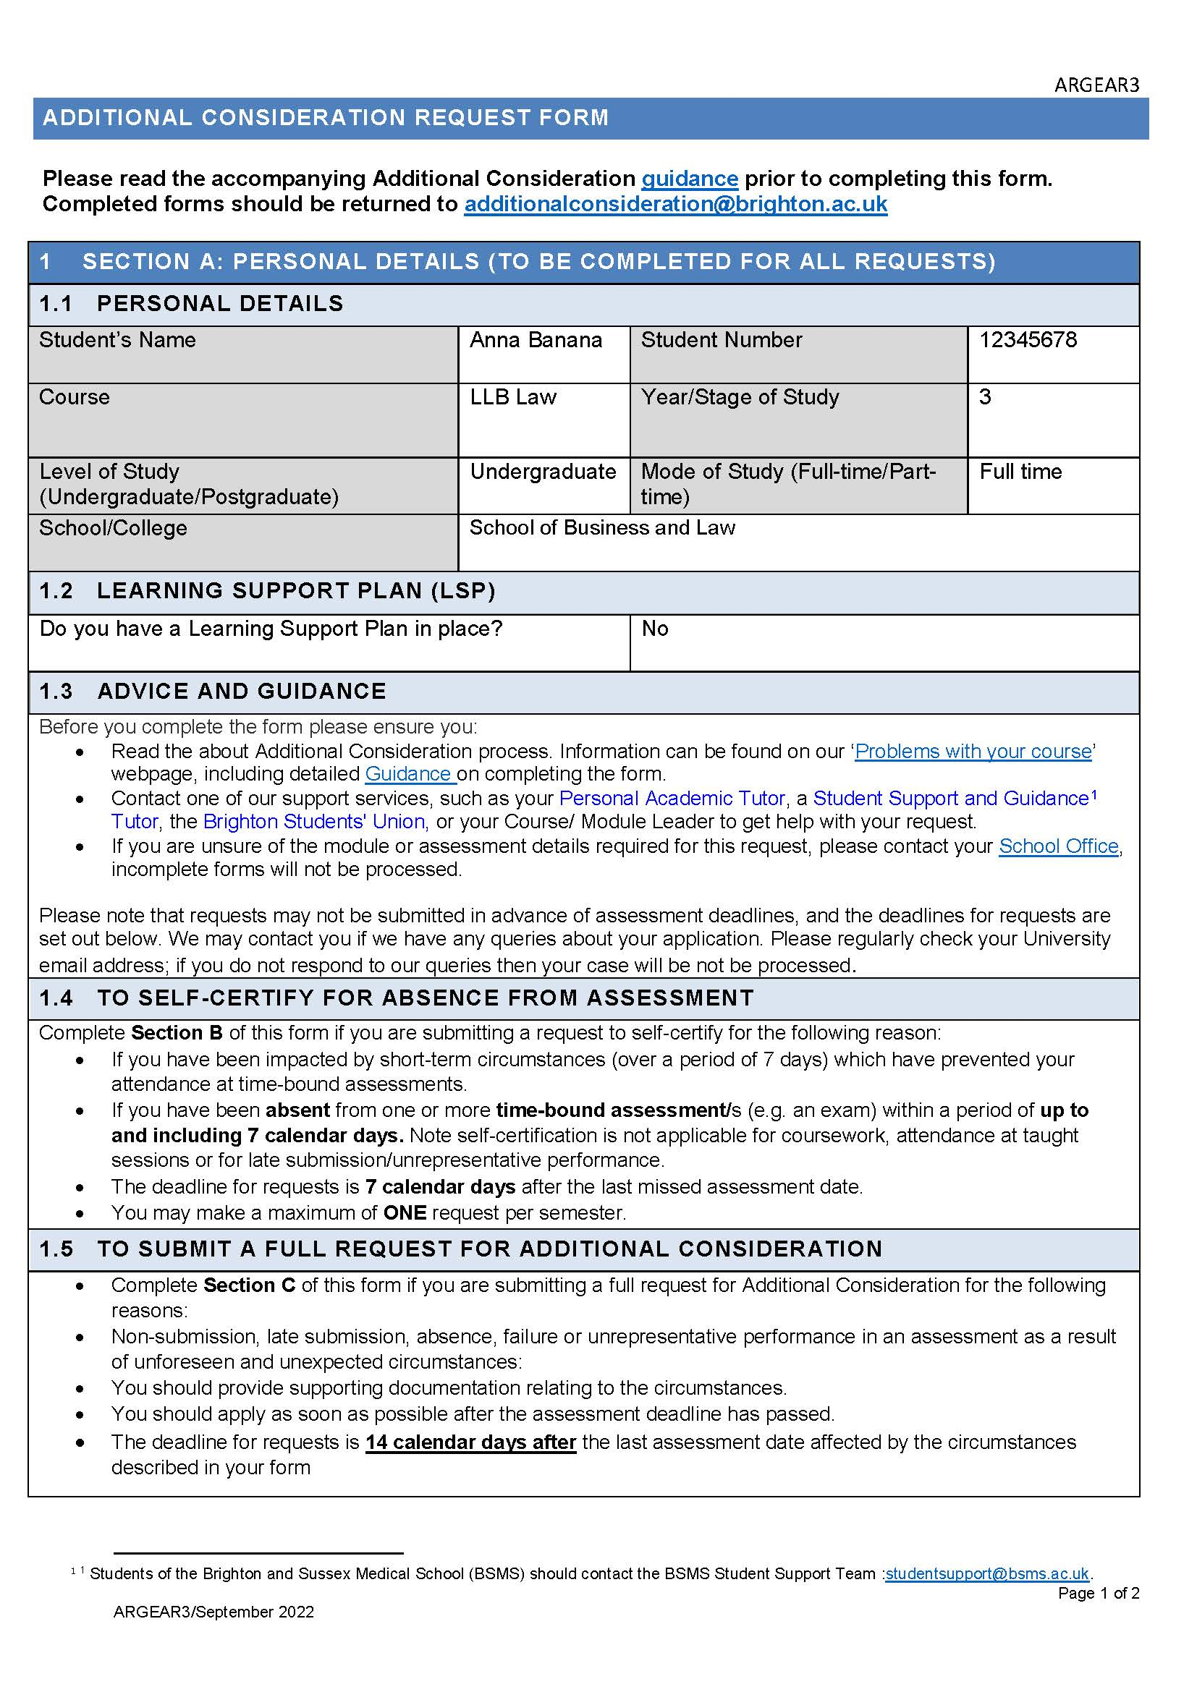

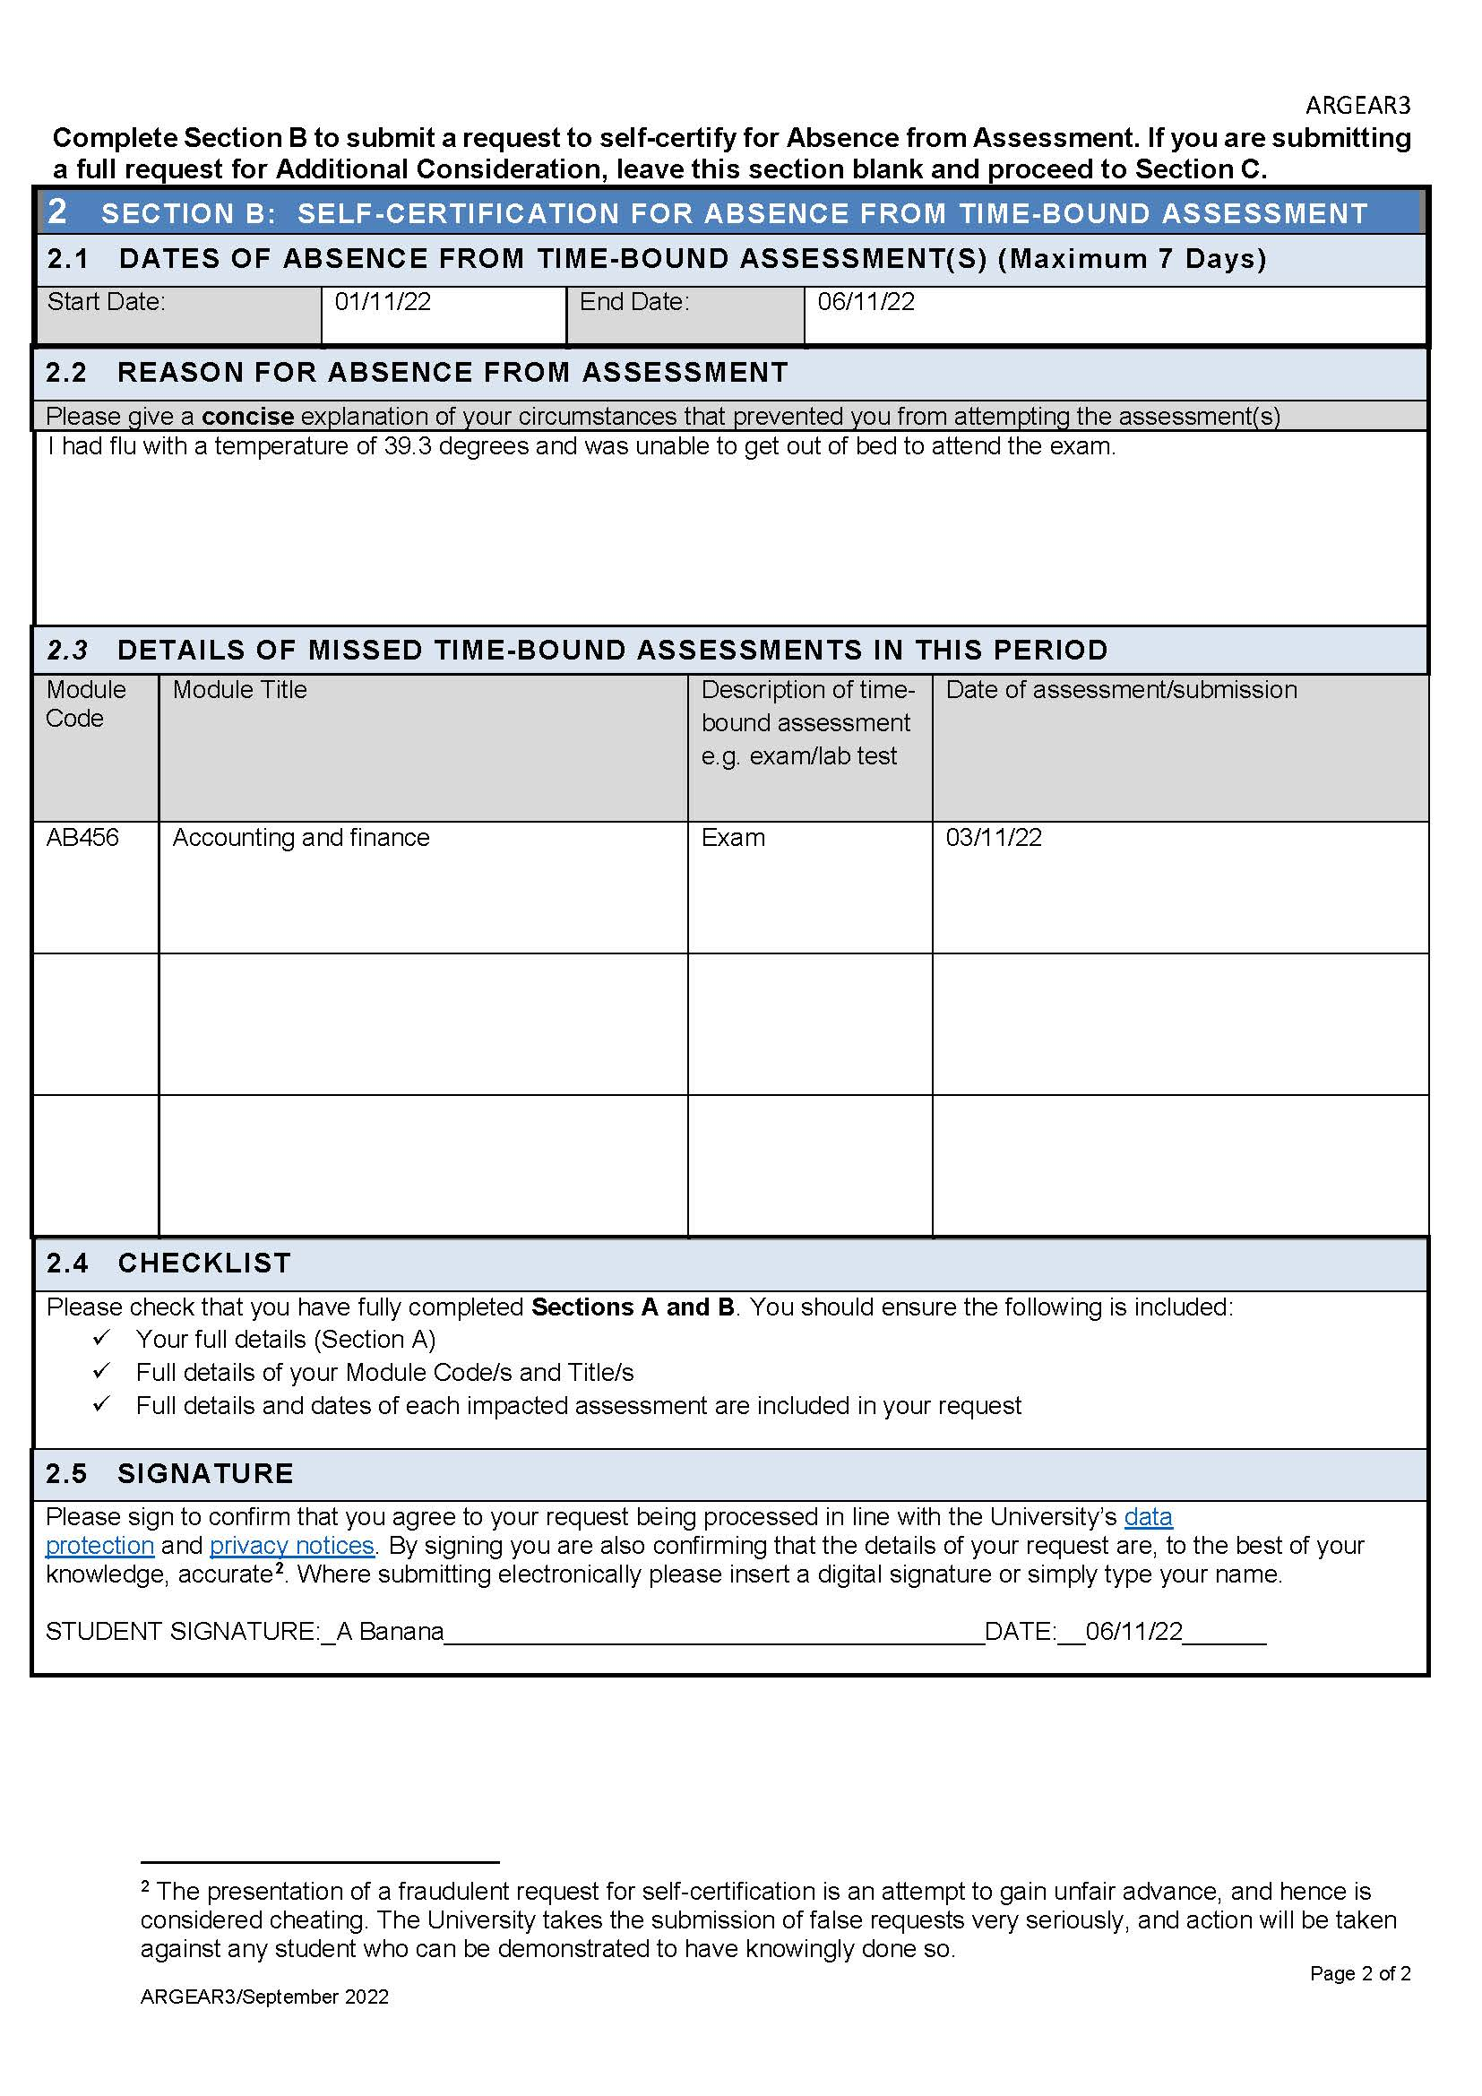

Full Request for Additional Consideration – Example form
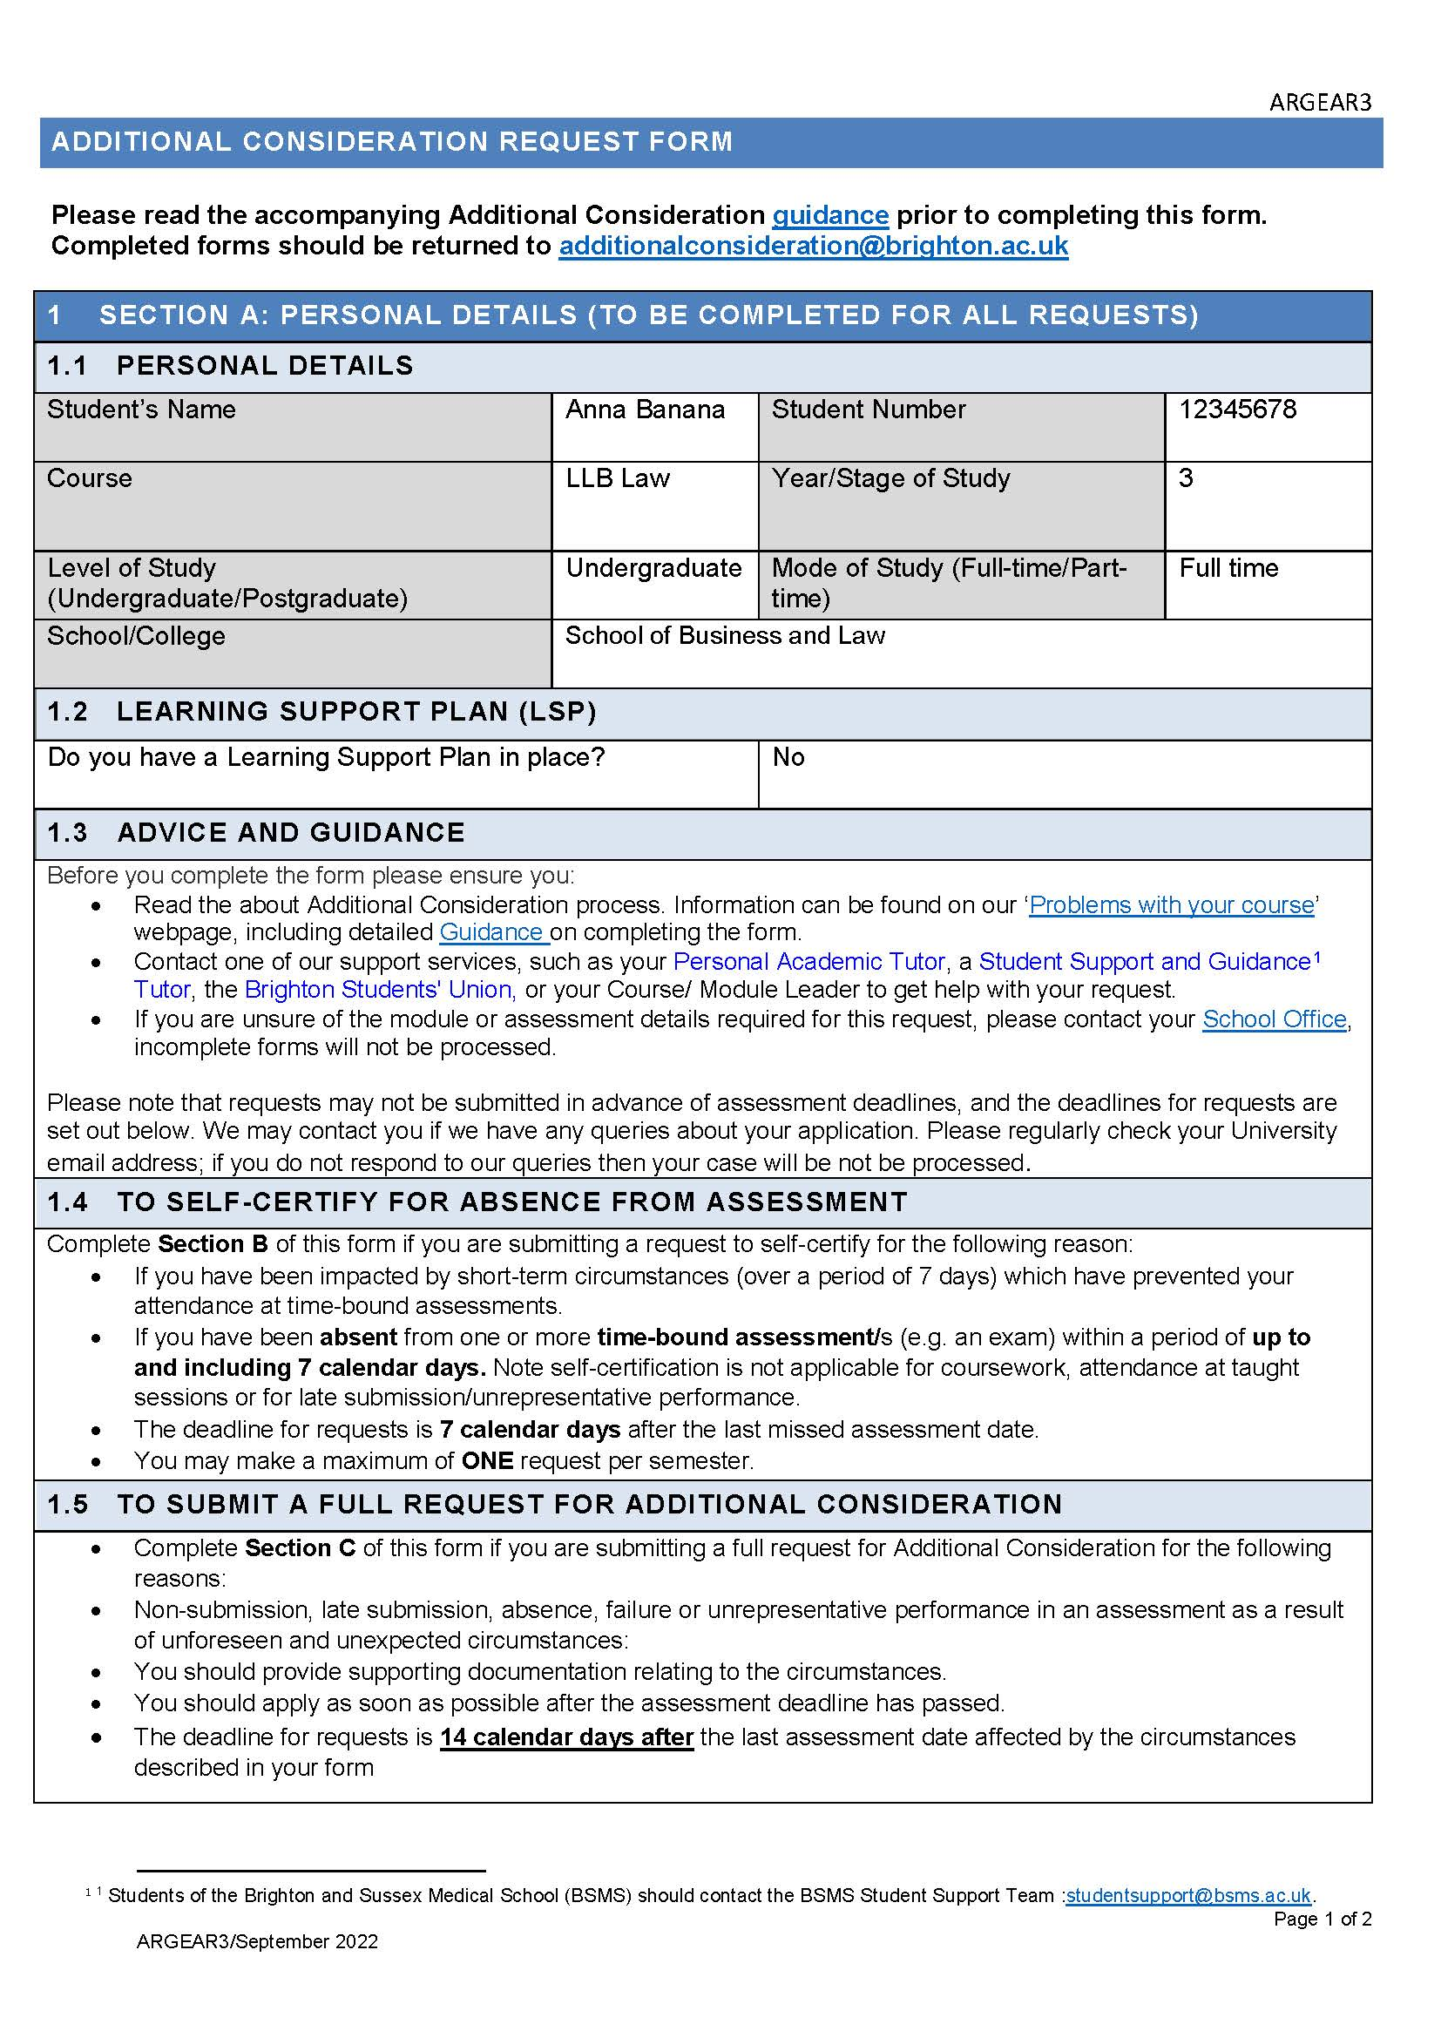

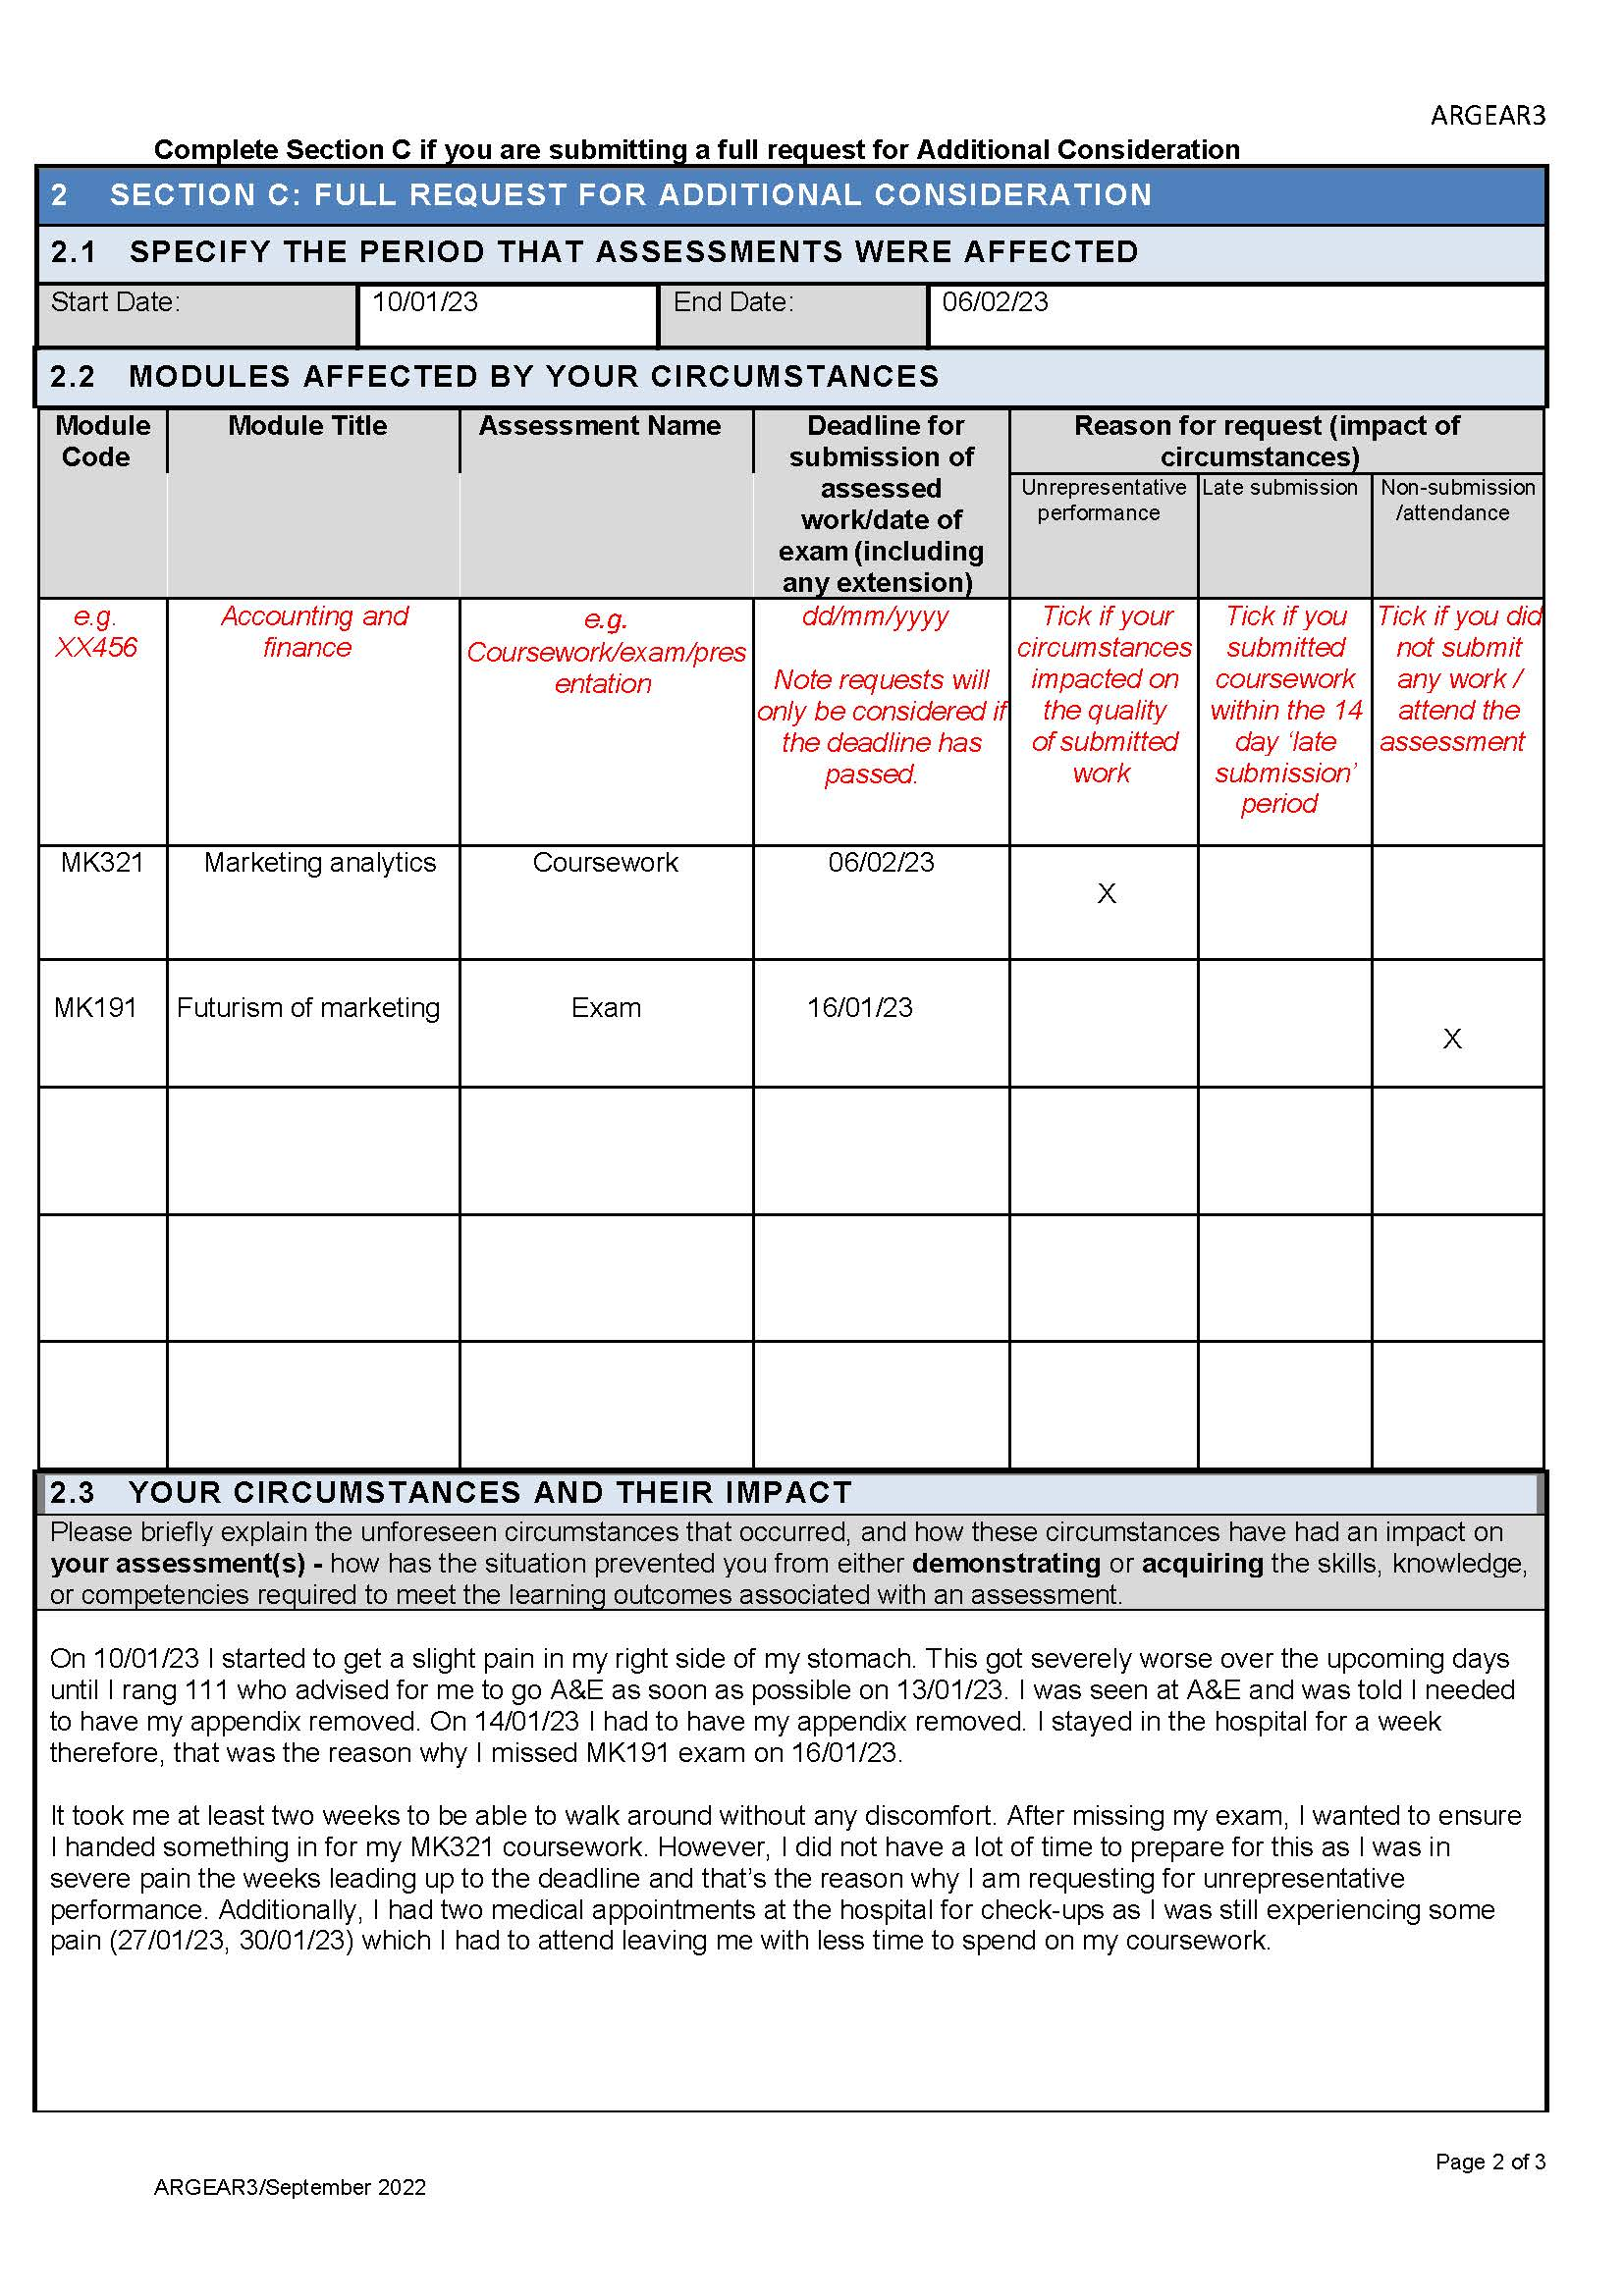

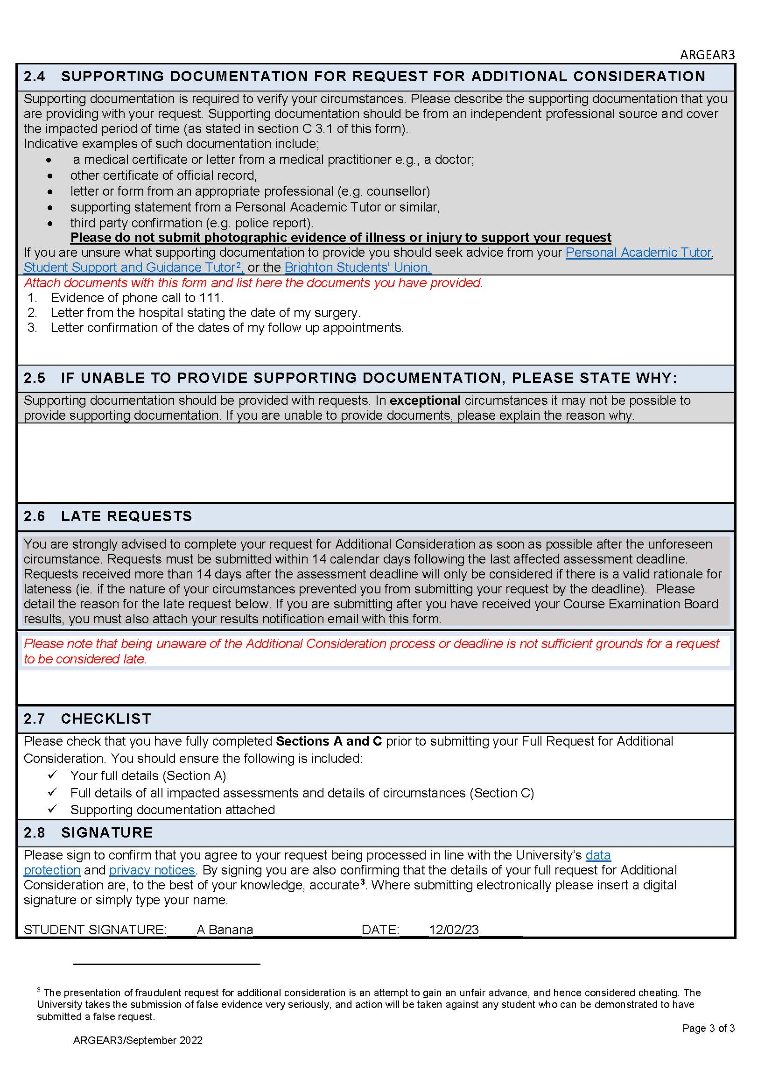

Please note that some assessment modules may be exempt from self-certification due to Professional, Statutory and Regulatory Body accreditation (PSRB) or other course-specific regulations.

