We are Hiring!

We are looking to hire tomato pickers for the summer at our Barnham growing site.
Position: Seasonal crop workers
Summary of position: We are looking for motivated individuals to work in our greenhouses picking tomatoes and doing general work to the crop.
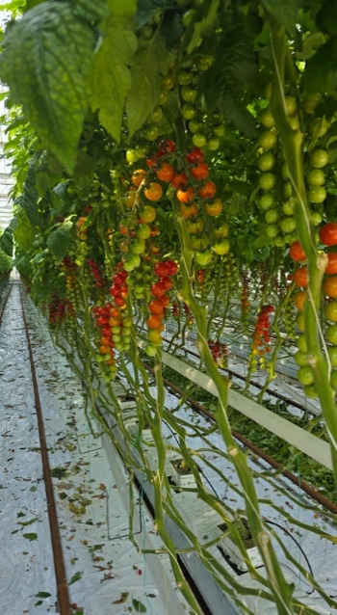
Training will be given, and the vacancies are based on daytime work, we start early/finish early giving you a lot of your day back! and we are flexible with working times during the day.
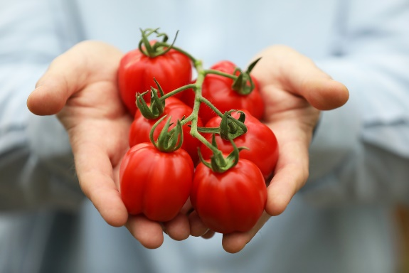
This role is based in greenhouses which can become hot working environments
Job type: Temporary seasonal worker
Hours available: up to 39 Hours per week
Salary: up to £11.44 hr
For more information or to apply please email your CV to duncan.toms@thegreenhousesussex.co.uk

