INTRODUCTION TO A LEVEL POLITICS

This pack contains a programme of activities and resources to prepare you to start A-level Politics in September. It is aimed to be used now and throughout the summer holidays to ensure you are ready to start your course in September. The suggested activities will help you to engage with relevant political events, processes, institutions, and ideas.
If you have any questions, please feel free to drop us an email:
ALevel_Politics@chichester.ac.uk

Introduction
What will I study on this course?
A-Level Politics puts you at the heart of the action in terms of understanding the world around us. All decisions that impact daily life are political. This course will give you an insight into the ideas, institutions and organisations that regulate and control our modern lives.
UK Politics
Why are things the way they are? Who has power in this country? How do we bring about change? How different are the main parties? Why don’t young people seem to care about politics? All of these are pertinent questions to explore through the study of UK politics. From the very origins of democracy and the struggles to obtain the vote, through to how Boris Johnson won in December 2019, all will be explored.
UK Government
You’ll explore where power lies in the country, what limits there are on the power of a Prime Minister, and explore the extent to which we are actually free and democratic within the UK system. You’ll study the major branches of government and come to understand the relationships between the executive, legislative and judicial branches of the UK government.
US Government and Politics
How does power operate in the US? How does it contrast with the UK? How can someone get the most votes, but not become president? The interplay between the great institutions of state will be explored and, using comparative theory, contrasted with their UK counterparts.
Ideologies
What is the role of the state? Are people fundamentally good? For whom should government work? Is radical change good? The answer to many of these questions, and more, form the foundation stones of the ideas that have shaped the world for centuries. We will endeavour to unravel them.
What skills will this course develop?
Politics is all about construction of a persuasive, evaluative argument. Learning to explore the competing explanations and, through rigorous integration, explaining a position. This course will develop your written and spoken communication skills, it will develop your critical faculties and make you more responsive to the position of authors. You will improve your ability to present a written argument, alongside the essential skills of independent research and time management, which will serve you well for the transition to undergraduate study. Most importantly it will equip you with a political awareness and ensure you are an informed citizen within our modern democracy.
The Textbook
The textbook that we use covers all the content from both Year 1 and Year 2.
There may be the opportunity to change subjects in the first weeks of term, so if you don’t want to buy the textbook just yet that’s fine.

The publisher has a free preview of the first chapter available online: https://bit.ly/4261aOi

You may wish to read and make some notes on this chapter to prepare you for our first lessons.

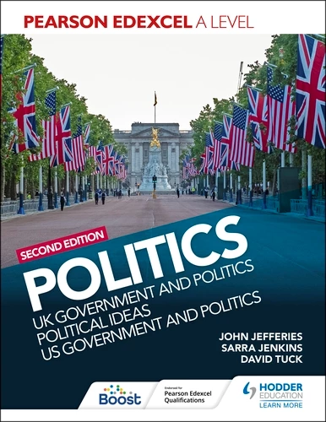
Pearson Edexcel A Level Politics 2nd edition: UK Government and Politics, Political Ideas and US Government and Politics
David Tuck, Sarra Jenkins, John Jefferies
ISBN: 9781398369160
https://amzn.eu/d/0eZUNrs
Have a Look at Some Past Papers
It will be really useful to be familiar with how you are going to be assessed, and what kinds of questions you will be asked.
Politics A-Level is entirely exam-based, and the questions on those exams will all be essay questions.
You can visit the ‘Revision World’ website to see some examples of past papers: https://revisionworld.com/a2-level-level-revision/government-politics-level-revision/government-politics-level-past-papers/edexcel-level-government-politics-past-papers

Listen to Politics Podcasts

The Rest is Politics: https://www.goalhangerpodcasts.com/the-rest-is-politics

Two men who’ve been at the heart of the political world - former Downing Street Director of Communications and Strategy Alastair Campbell and cabinet minister Rory Stewart - join forces from across the political divide. The Rest Is Politics lifts the lid on the secrets of Westminster, offering an insider’s view on politics at home and abroad, while bringing back the lost art of disagreeing agreeably.

Pod Save the UK: https://crooked.com/podcast-series/pod-save-the-uk/

Pod Save the UK is your weekly fix of political news, big ideas and a shot of inspiration. Each week hosts, comedian Nish Kumar and journalist Coco Khan are joined by politicians, experts, and famous friends to unpick the latest news, look for solutions, and inspire action.

Politico’s Westminster Insider: https://www.politico.eu/westminster-insider-podcast/

Claiming to give the listener a real sense of how Westminster’s corridors of power work, this podcast provides interesting context to overarching topical themes – including how to charm a US president and the history of pandemics in the Western world.

FiveThirtyEight Politics Podcast: https://fivethirtyeight.com/tag/politics-podcast/

Established by US uber-pollster Nate Silver, who has become something of an oracle every four years for the US elections, FiveThirtyEight gives a good rundown of the biggest news Stateside.

The Political Party: https://www.podbean.com/podcast-detail/yd23p-337c0/The-Political-Party-Podcast

Stand-up comedian Matt Forde offers an enjoyable peek behind the scenes in Westminster and beyond. Forde is well versed in the world of politics, having spent time as a political adviser himself. Guests include MPs and special advisers from all political hues, past and present.

The Economist Radio: https://www.economist.com/podcasts

The respected magazine also boasts a range of podcasts, including its daily round-up of news, The Intelligence, and The Jab, focusing on the global vaccination race. Checks and Balance, its weekly look at American politics, is also worth a listen.

KEEP UP WITH THE NEWS!

This is probably the most useful thing that you can do now and throughout your a Level Politics study!

As a politics student, you need to be interested in and informed about the world we live in.

We’ll be discussing and analysing events in the news as they happen, so it’s crucial that you’re well informed.

News Sources:

BBC News – www.bbc.co.uk This is the best place to go for unbiased and neutral news reporting. In particular, if you look at their Politics section there is political news from around the world and keep an eye out for coverage of Question Time.

The Economist – www.economist.com There are plenty of interesting articles to access for free which are not just to do with economics but to do with global politics and current affairs.

Guardian – www.guardian.co.uk In particular, the Guardian ‘Long Reads’ section has lots of interesting in-depth journalism on some controversial areas.

Independent – www.independent.co.uk This newspaper is great for both UK and US politics and also has a good section called ‘Climate Blogs’

Telegraph – www.telegraph.co.uk This newspaper is good for current affairs but also has some interesting opinion pieces written by its columnists.

Political blogs or websites:
• A Level Politics – www.alevelpolitics.com
• Conservative Party members’ blog – www.conservativehome.com
• Novara Media – www.novaramedia.com
• Left Foot Forward – www.leftfootforward.org
• Labour List – www.labourlist.org
• Craig Murray – www.craigmurray.org
• Iain Dale – www.iaindale.com/articles
• Coffee House – The Spectator – www.blogs.spectator.co.uk
• Politics.co.uk – www.politics.co.uk
• Oxford University Politics Blog – www.blog.politics.ox.ac.uk
• Total Politics – www.totalpolitics.com
• The Today Programme on BBC4 - www.bbc.co.uk/programmes/b006qj9z
• Newsnight on BBC2- www.bbc.co.uk/programmes/b006mk25
• Panorama - www.bbc.co.uk/programmes/b006t14n

Read Politics Books
These are all popular books about politics and are great for extending your political knowledge and understanding.
Activity- You could write a book review on it and hand this to your teacher in September.
UK Politics & Government
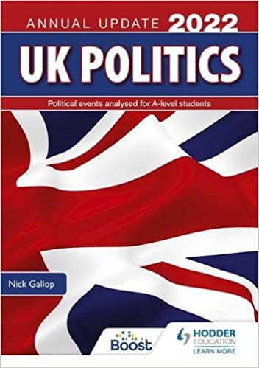
Gallop, N., UK Politics Annual Update 2022 – this annual book written for A Level Politics students includes all of the recent big political events. Events this time include the government response to the COVID-19 pandemic, Black Lives Matter protests and the state of political parties.
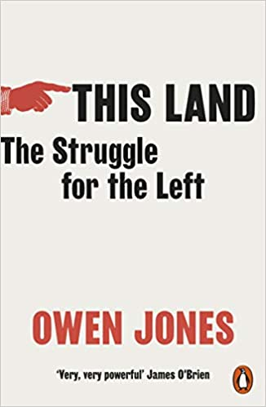
Jones, O., This Land – written by Owen Jones, a columnist for the Guardian and activist for Labour, this book looks to build a more equal society using figures from across the political spectrum.

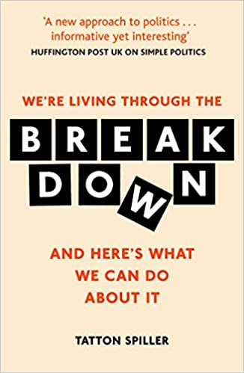
Spiller, T., We’re Living Through the Breakdown – this book is written by Tatton Spiller of Simple Politics, and looks at how we can understand politics in an age of huge change.

Political Ideas
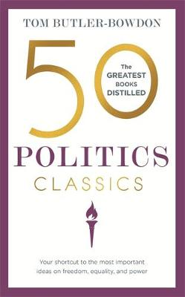
50 Politics Classics – a great book that helps to condense the main ideas of many key thinkers, including Thomas Hobbes, Mary Wollstonecraft and more.
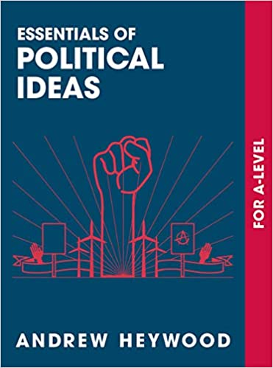
Essentials of Political Ideas – an A Level book that looks into the political ideas, their thinkers and other revision tips.

US Politics
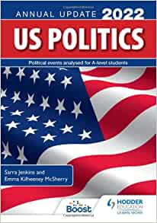
US Politics Annual Update 2022 – similar to the UK edition, this book is written for A Level Politics students, and includes updates about the COVID-19 pandemic in the USA, and the 2020 presidential election.
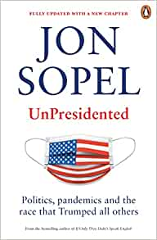
UnPresidented – written by the BBC’s North America correspondent, this book looks at the 2020 presidential election from behind the scenes, an election like no other.

Watch A Level Politics Videos on YouTube
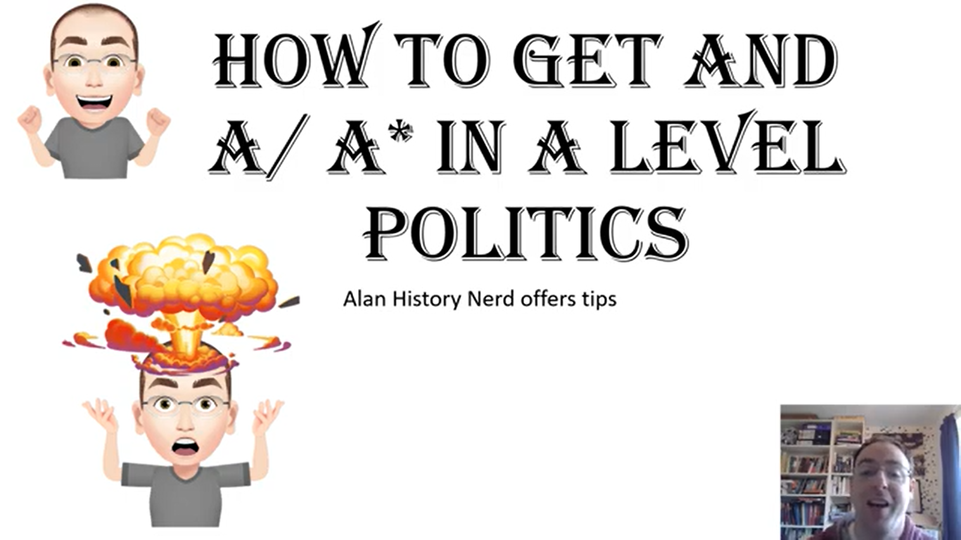
The ‘Alan History Nerd’ Channel on YouTube is a highly recommended source for Edexcel A Level Politics content. Alan has videos covering the entire specification. Have a look at these videos, starting with Component 1 content, to build your subject knowledge ahead of the start of term.
Component 1 Playlist:
https://www.youtube.com/playlist?list=PL6DY9psvTXR8Adco-7Boci02oSoGuYyfV

Component 2 Playlist:
https://www.youtube.com/playlist?list=PL6DY9psvTXR_MIxyq7SmAJgvI1o9GN-4N

Political Ideas Playlist:
https://www.youtube.com/playlist?list=PL6DY9psvTXR-kw-8zindGCmPTc8-9O3Ia

Component 3 Playlist:
https://www.youtube.com/playlist?list=PL6DY9psvTXR9Ey9Kv96A8zW9BM2f0J20h

Effective Note Making

Making effective notes in lessons is an essential skill for A-level Politics. Practice producing notes using the Cornell System by summarising two of the ‘Alan History Nerd’ videos you have watched. Pick videos that are at least 10 minutes long from the Component 1 playlist. Complete your notes in the following format and show them to your teacher when you start your course in September.

SUBJECT: TOPIC:

DATE:
LESSON FOCUS:
QUESTIONS & CUE WORDS | NOTE TAKING  1. Record: During the video use the note-taking  column to record the lesson using concise sentences and abbreviations.  2. Questions: As soon after class as possible, write  questions in the left hand column based on the notes in the note taking column. Writing questions helps to clarify meanings, reveal relationships, establish continuity, and strengthen memory. Also, the writing of questions sets up a perfect stage for exam studying later.  3. Recite: Cover the note-taking column with a sheet of paper. Then, looking at the questions or cue-words in the question and cue word column only, say aloud, in your own words, the answers to the questions, facts, or ideas indicated by the cue-words.  4. Reflect: Reflect on the material by asking yourself questions, for example: “What’s the significance of these facts? What principle are they based on? How can I apply them? How do they fit in with what I already know? What’s beyond them?  5. Review: Spend at least ten minutes every week  reviewing all your previous notes. If you do, you’ll  retain a great deal for current use, as well as, for the exam.
SUMMARY

After class, use this space at the bottom of each page to summarize the notes on
that page.

Adapted from: How to Study in College 7/e by Walter Pauk, (2001) Houghton Mifflin Company

