GCSE to A LEVEL
Summer Project
Subject: A Level Politics

NAME:
The purpose of this A Level Summer project is to introduce you to studying this subject at A Level standard. You will need to complete 10 hours of study on each subject every week, 4½ in class with your teacher and the rest as independent learning. Therefore, it is important that you enjoy this subject and that you start to practice your study skills as early as possible. Some subjects have significant maths content (for example business, psychology, economics); others require strong essay writing skills (for example politics, history, English). Think about the study skills and underpinning knowledge you will require in this subject – not just the title.
If after completing this project you think this may not be your ideal choice, you can ask to transfer to another subject at the start of term, as long as you have the entry requirements and it fits alongside your other choices on the A Level Matrix (timetable). If you do decide to change subject, you will be required to complete the Summer Project for your new choice too.
This is also your first taste of Flipped Learning and elements will be used within your first week of lessons.
We hope you enjoy this project as you start your A Level journey.
Have a good summer and we look forward to seeing you in September.

HOW TO SUBMIT:
- Download this document and type directly into it.
- Make sure that you have included your name at the top of this page.
- If you need to complete it using pen and paper, make sure to include your name and organise it logically with clear headings.
- Email the completed project to ALevel_Politics@chichester.ac.uk before Induction or bring a physical copy with you to induction.
- Format your email professionally and appropriately (i.e., don’t just send me a blank email with a file attached!).
TASK 1: Investigate your MP
Research your local MP, who are they; which party do they represent; which constituency do they represent; what have they recently shown an interest in; research their voting history to see where they stand on key issues; and anything else you would like to know about them! If your MP has recently changed, tell us about who the previous MP was and why you think your constituency voted for someone else.
You can find who your MP is by searching your postcode on this website:
https://members.parliament.uk/

What I’ve found out about my local MP:

TASK 2: Keeping up with the news
Keeping up with political news is ESSENTIAL for A Level Politics! The BBC News politics page is the best place to start:
https://www.bbc.co.uk/news/politics
This summer, we've got a general election, which is a great opportunity to get more engaged in UK politics and to increase your knowledge about UK's political systems and structures. Write a summary of the 2024 UK general election. Include the main events and policies of the campaign, the results, including vote share, seat share in the House of Commons, and the turnout. Most importantly, include an analysis of what you think were the most important factors that determined the outcome of the general election.

The 2024 General Election:

TASK 3: News Quiz
Keep up with the news over the summer break. Create a 5-question quiz to test the rest of the class’s knowledge of the summer’s big UK politics stories. You’ll quiz your new classmates in your first lesson (make sure to include the answers and don’t make them too easy!).
1
2
3
4
5

TASK 4: Should 16-year-olds have the right to vote?
Read the source below. Highlight, in two different colours, arguments for giving 16- to 18-year-olds the vote and arguments against giving 16- to 18-year-olds the vote.

In the UK, the minimum voting age is 18, except in Scotland, where 16-and-17-year-olds have been given the right to vote in local and Scottish parliamentary elections. By and large, 16-year-olds haven’t yet entered the world of home ownership, employment, tax, or pensions, but these economic issues are often at the forefront of election campaigns. The main argument against lowering the voting age is that a lack of experience in these matters prevents young people from making a considered judgement at the ballot box. Opponents also point to the fact that 18 to 24-year-olds have the lowest turnout of any age group in elections, reflecting an apparent lack of interest in politics. These critics question whether an even younger generation would be any different. And there are concerns that teenagers who do want to cast their votes would be impressionable and easily influenced by radical politics, or would not fully think things through and would blindly vote for the same party as their parents.
But calls to lower the voting age come from a range of sources—adults as well as teenagers themselves, backed up by youth organizations, pressure groups, and politicians. 16-and-17-year-olds in the Isle of Man, Jersey, Guernsey, Brazil, and Austria already have the vote. They can also vote in some elections in Germany, Malta, and Norway. Evidence from the Scottish Independence Referendum, substantiated by research from Austria and Norway, shows—aided by encouragement from families and schools—16-and-17-year-olds have higher rates of turnout than 18 to 24-year-olds. For supporters, it’s about giving young people a say in matters that directly affect them, such as tuition fees. It’s also thought that lowering the limit will encourage civic-mindedness at an earlier age and establish an interest in the political system, which will be continued throughout a person’s life. Scotland’s positive experience of including 16-and-17-year-olds in the 2014 Independence Referendum led to the lowering of the voting age for local and Holyrood elections.
A study by the University of Edinburgh during the Referendum found that some teenagers were initially doubtful of their own abilities to make the right decision, but that this led them to actively seek out information to help inform their judgement. In some cases, teenagers even influenced their parents’ voting intentions with their new-found knowledge. But as there are no immediate plans for the UK Government to debate lowering the voting age for general elections, it is unlikely that all 16-year-olds will get the chance to put that to the test any time soon.

1. Define the following political and non-political words from the source.

Word | Definition
Parliamentary elections
Forefront
Ballot box
Turnout
Impressionable
Radical politics
Blindly
Pressure groups
Substantiated
Tuition fees
Civic mindedness
Referendum
Holyrood
Voting intentions

2. Using the source, match up 3 arguments that support the view that 16- to 18-year-olds should be given the vote with 3 counter-arguments that support the view that they should not. Ensure each pair consists of a point and counterpoint that is logically connected and directly addresses one another.

Arguments for giving 16- to 18-year-olds the vote | Arguments against giving 16- to 18-year-olds the vote

3. You are now going to practice analysing one of these arguments. You are going to use evidence to back up your analysis. You will need to do some additional research to answer these questions.
The source states that the 18-24 age group has the lowest turnout in UK elections so therefore even younger voters are likely to have an even lower turnout.

What is turnout?
For example, what was the turnout for 18–24-year-olds in the 2019 general election?
How does this compare with turnout for that age group in the 2017 and 2015 general elections?
Why, therefore, could it be argued that it is not a good idea to extend the vote to 16- and 17-year-olds?
In the 2014 Scottish Independence Referendum (the first UK vote to
give 16-year-olds the vote), what was the turnout for 16–18-year-olds?
Write a conclusion arguing that 16–18-year-olds should not get the vote (even if you don’t agree). Make sure to address the evidence, especially any evidence that would seem to go against the argument.

Well done, the work you have just completed has given you a basis for the source-based essay questions you will face in your A Level Politics exams.
it wasn’t that hard, was it?

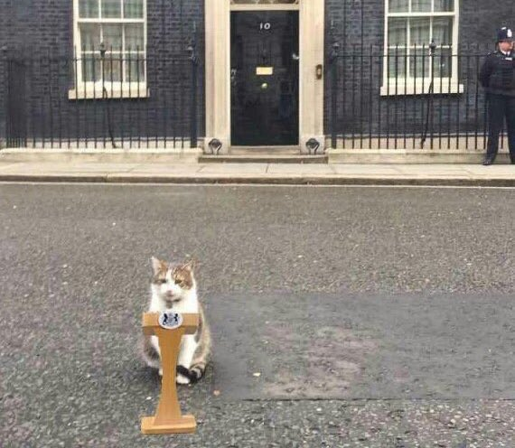
See you in September!

