POST-RESULTS SERVICES: DEADLINES, FEES AND CHARGES Summer 2024 series

Aim
This fact sheet provides information on the type of services available after the publication of GCSE, A Level, T Level, BTEC, Cam Tech and other exam results. These services are available for students to look in more detail at their results e.g. to request a remark, clerical re-check, or to gain a better understanding of the marks received for future reference. A fee is applicable for some services.

If possible, you should have a discussion with your tutor before accessing these services.

Post-results services that are available

- Reviews of Results (RoR)

If you are unhappy with your results and feel that a unit or paper has not been fairly marked, you can ask for:

- Clerical re-check which means that your unit or paper will be looked at to make sure it was all marked and that the marks were added up correctly.
- Review of marking to ensure that the mark scheme was applied correctly.
- Priority review of marking. If your place in Higher Education depends upon the outcome of a results enquiry you can submit a request for a priority review of marking. Please be aware that if you want to request a copy of your script, first, this is unlikely to arrive before the deadline for you to request a priority remark.
- Appeals. If you are not satisfied with the outcome of the Review of Results.

- Access to Scripts (ATS)

It may help you to request a photocopy of your unit or paper.

- Copy of script to review marking. This will enable you to look at the way it has been marked and decide if a review is justified. You can show it to your teacher and ask for advice.
- Copy of script to support teaching and learning. This may help you to learn from this exam and support future study and revision.
- Post-review of marking copy of script. This will allow you to see how the original marking has been reviewed by the reviewer.

Important messages:

- Please be aware that grades can be lowered as well as raised. You will be asked to sign a form indicating that you are aware that marks (and grades) can go down as well as up.

- Each unit or paper is classed as a separate request. If you sat two or three papers for a subject you will need to decide which paper(s) you wish to be reviewed. Any fees will need to be paid for each paper.

Costs: Payment must be made to the Exams Office before the request can be processed. Your money will be refunded if the outcome of the enquiry is a change to your certification grade. There is no refund if any adjustment to the mark does not alter the grade. See end of this document for payment instructions.

A Level / T Level / Cam Tech / BTEC / other level 3 results
Post-results service |  | Deadline  (Final date for requesting) | AQA fees and charges | OCR/Cam Tech fees and charges | Pearson GCE/BTEC fees and charges | WJEC / Eduqas fees and charges
RoR Service 1  Clerical re-check |  | 23rd September 2024 | £9.70 per unit | £10.00/free | £12.50/same | £ 11.00
RoR Service 2  Review of marking |  | 23rd September 2024 | £48.65 per unit | £61.50/same | £51.70/44.50 | £46.00
RoR Priority Service 2  Review of marking |  | 20th August 2024 | £57.85 per unit | £70.75 | £61.60/61.60 | £55.00
RoR Service 3  Review of moderation |  | 23rd September 2024 | £ 281.15 (half if cohort <5) | £284.50 (<=5)  /£266 | £247.80 (<=5) | £ 32.00 per candidate in sample
 | Appeals  (Stage 1)  Preliminary Appeal | Within 30 calendar days  (of the awarding body issuing the RoR outcome) | £124.90 | £187.75 |  | £120
 | Appeals  (Stage 2)  Appeal Hearing | Within 14 calendar days  (of receipt of the preliminary appeal outcome letter) | £214.90 | £268.25 |  | £200
ATS  Copy of script to support review of marking |  | 27th August 2024 | Free | Free | Free/same | Free
ATS  Copy of script to support teaching and learning |  | 23rd September 2024 | Free | Free | Free/same | Free
ATS  Post-review of marking copy of script |  | 23rd September 2024 | Free | Free | Free | Free

GCSE
Post-results service |  | Deadline  (Final date for requesting) | AQA English GCSE fees and charges | OCR fees and charges | Maths GCSE/Pearson fees and charges | WJEC / Eduqas fees and charges
 | RoR Service 1  Clerical re-check | 23rd September 2024 (takes up to 10 days) | £8.70 | N/A | £11.90 | N/A
 | RoR Service 2  Review of marking | 23rd September 2024 | £42 | N/A | £42.40 | N/A
 | RoR Service 3  Review of moderation | 23rd September 2024 | £ 252.20 (half if cohort <5) | N/A | £236.00 (<=5) | N/A
 | Appeals  (Stage 1)  Preliminary Appeal | Within 30 calendar days  (of the awarding body issuing the RoR outcome) | £ 124.90 | N/A | £ | N/A
 | (Stage 2)  Appeal Hearing | Within 14 calendar days  (of receipt of the preliminary appeal outcome letter) | £214.05 | N/A | £ | N/A
 | ATS  Copy of script to support review of marking | 3rd September 2024 | Free | N/A | Free | N/A
 | ATS  Copy of script to support teaching and learning | 23rd September 2024 | Free | N/A | Free | N/A
 | ATS  Post-review of marking copy of script | 18th September 2024 | Free | N/A | Free | N/A

How to request a post-results service

All requests for a Post Result Service must be made using the contact details below. Exam boards charge for these services and the full costs must be paid when you make the request. You will be notified when your enquiry outcome / photocopy / original script is available for collection, at which time you must show your ID.

College name | Exams telephone | Exams email | Exams office
Brighton Metropolitan College | 01273667788 | examsbrighton@gbmc.ac.uk | PT5.02
Brinsbury College | 01243 786321 ext 1191 | brinsburyexams@chichester.ac.uk | Student Records
Chichester College | 01243 786321 ext 2193 | exams@chichester.ac.uk | A234
Crawley College | 01293 442210 | exams@crawley.ac.uk | TG06
Haywards Heath College | 01444 711901 | exams@haywardsheath.ac.uk | Main Office
Northbrook College | 01903 273075 | examsnorthbrook@gbmc.ac.uk | BWB1.20
Worthing College | 01903 275755 | worthingexams@worthing.ac.uk | G32

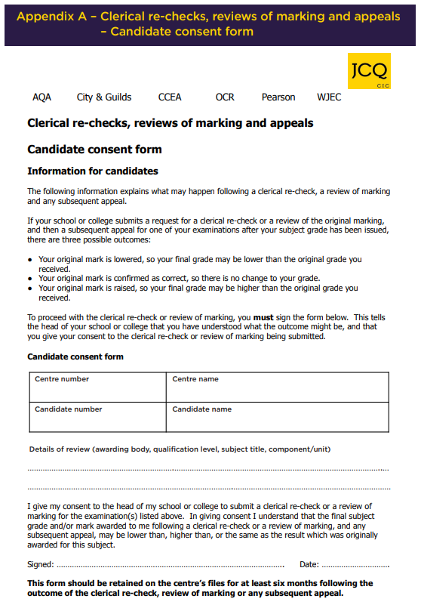

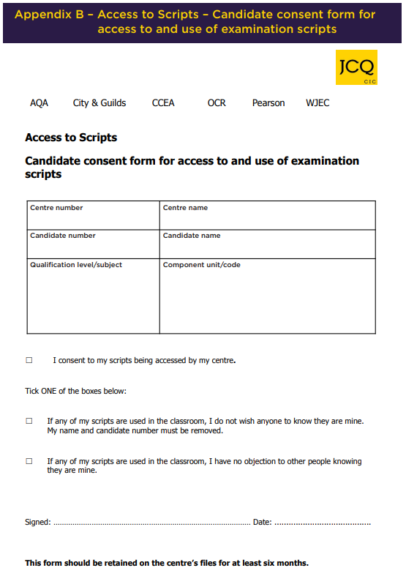

This service is not available to individual candidates
This service is to request a copy of script to support a non-priority review of marking
Where a copy of a post-review of marking script is required, this should normally be applied for at the same time as the review of marking request to meet the relevant non-priority RoR service deadline
This service is not available to individual candidates
This service is to request a copy of script to support a non-priority review of marking
Where a copy of a post-review of marking script is required, this should normally be applied for at the same time as the review of marking request to meet the relevant non-priority RoR service deadline

