What is Psychology?

A guide to help you get ready for A-level Psychology

This pack contains a programme of activities and resources to prepare you to start an A-level in Psychology in September. It is aimed to be used now and throughout the remainder of the summer term and over the summer holidays to ensure you are ready to start your course in September. The suggested activities will start to engage with and enjoy the world of psychology! You are not to complete every task, in other words you can select activities that you are interested, for example you could watch a couple of TED talk or a complete aMassive online Learning Course. We have provided a range of activities so that everyone finds a task that engages them. Psychology is a fantastic subject to study, and we hope you enjoy your learning.
The different approaches in Psychology
Psychology is the scientific study of the mind and how it dictates and influences our behaviour, from communication and memory to thought and emotion. It is a relatively new subject which only became named approximately 120 years ago! To help you gain a better insight into what are the different points of view as to what causes us to be how we are, please read through the relevant sections on the simply psychology website. Here is the link:
What is Psychology? | Simply Psychology
This website is also easy to read and will give you a great understanding of the wide range of topics covered in the subject. Do make notes on what you read too.
What is Psychology? (all-about-psychology.com)
Also, here are the exam board links for both qualifications. While these documents are aimed mainly at teachers, you need to have copies of these so you know what you will learn on whichever course you choose to study.
A Level Psychology exam board website
AS and A Level Psychology | Eduqas
Applied Certificate in Psychology exam board website:
BTEC Nationals | Applied Psychology (2018) | Pearson qualifications
TED Talks
Download the TED talk app to your device. It’s brilliant!!!
- Localisation of Brain Function - The Biological Approach
This short 5 minute video explains a very famous case study (HM) – a man who had his hippocampus removed from his brain!

https://www.ted.com/talks/sam_kean_what_happens_when_you_remove_the_hippocampus

- How reliable is your memory? 19 minutes long – The Cognitive Approach
Elizabeth Loftus is a world famous cognitive psychology who is an expert witness used in court cases to educate the jury on how unreliable our memory is. We learn about on of her famous studies in year one.
https://www.ted.com/talks/elizabeth_loftus_how_reliable_is_your_memory
3. The riddle of experience vs. memory, Daniel Kahneman
If you're looking for highly credentialed TED speakers, Kahneman's résumé won't fail to impress. A Nobel Prize-winning psychologist and bestselling author, Kahneman uses his 20 minutes on the TED stage to explain that there are actually two flavours of happiness: the kind we experience in the moment and the kind we experience in our memories. Maximizing your own well-being in life means keeping both in mind.
https://www.ted.com/talks/daniel_kahneman_the_riddle_of_experience_vs_memory
4. How we read each other's minds, Rebecca Saxe – The Biological Approach
According to Saxe, a professor of neuroscience at MIT, you don't need tarot cards or ESP to read people's minds. A functioning right temporo-parietal junction will do just fine. In her talk, Saxe explains how this brain region allows humans to be uncannily good at sensing other people's feelings, thoughts, and motivations.
https://www.ted.com/talks/rebecca_saxe_how_we_read_each_other_s_minds

5. The paradox of choice, Barry Schwartz
More choice is always better, right? Not according to Schwartz, a psychologist who argues that having to decide which of approximately 6,000 brands of similar toothpaste to buy "has made us not freer but more paralyzed, not happier but more dissatisfied.
https://www.ted.com/talks/barry_schwartz_the_paradox_of_choice

6. Are we in control of our own decisions?, Dan Ariely – Cognitive
This talk "uses classic visual illusions and Ariely’s own counterintuitive (and sometimes shocking) research findings to show how we're not as rational as we think when we make decisions.
https://www.ted.com/talks/dan_ariely_are_we_in_control_of_our_own_decisions
7. Flow, the secret to happiness, Mihaly Csikszentmihalyi – Positive Approach
In this talk, legendary psychologist Csikszentmihalyi dares to ask one of life's biggest questions: What makes us happy? The answer isn't fame or money, he insists, but flow -- that lost-in-time feeling you get when you focus intensely on work you're good at.
https://www.bing.com/videos/search?q=ted+talk+secret+to+happiness&docid=608028143069498837&mid=1D47A08B5D9A78063D391D47A08B5D9A78063D39&view=detail&FORM=VIRE
8. The psychology of evil, Philip Zimbardo - Social Approach
Psychology isn't all happiness and flourishing, of course. The discipline also delves into the darker sides of human nature and what drives us toward unethical or even downright evil behaviour. That's the topic of this talk by ‘superstar’ Zimbardo in which "he shares insights and graphic unseen photos from the Abu Ghraib trials."
But don't worry, it's not all gloom and doom. He also ‘talks about the flip side: how easy it is to be a hero, and how we can rise to the challenge.’
https://www.ted.com/talks/philip_zimbardo_the_psychology_of_evil
9. Using the biology of stress positively – 14 minutes talk – Biological Approach
Kelly explains how individuals manage the negative impact of stress differently and how we can all learn to enhance our way of managing stress. This topic is taught on our year 2 of the A Level
https://www.ted.com/talks/kelly_mcgonigal_how_to_make_stress_your_friend
10. The power of vulnerability, Brené Brown
One of the top-five-most-popular TED Talks of all time, this moving account of Brown's own struggles with shame and control weaves together sometimes hilarious personal anecdotes with hard research to convince viewers that forging real connections requires the bravery to be vulnerable.
https://www.ted.com/talks/brene_brown_the_power_of_vulnerability
If these links don’t work, you will find these easily with a google search using TED talk and the name of the speaker.
Complete a summary of each talk using the Cornell note making format on explained on the next page.
Effective Note Making
Making effective notes in lessons is an essential skill for A-level Psychology. Practice producing notes using the Cornell System by summarising two of the TED talks you have listened to. Complete your notes in the following format and show them to your teacher when you start your course in September.

SUBJECT TOPIC
DATE
LESSON FOCUS

QUESTIONS AND CUE-WORDS | NOTE TAKING  1. Record: During the lecture, use the note-taking column to record the lesson using concise sentences and abbreviations.  2. Questions: As soon after class as possible, write questions in the left hand column based on the notes in the note taking column. Writing questions helps to clarify meanings, reveal relationships, establish continuity, and strengthen memory. Also, the writing of questions sets up a perfect stage for exam studying later.  3. Recite: Cover the note-taking column with a sheet of paper. Then, looking at the questions or cue-words in the question and cue word column only, say aloud, in your own words, the answers to the questions, facts, or ideas indicated by the cue-words.  4. Reflect: Reflect on the material by asking yourself questions, for example: “What’s the significance of these facts? What principle are they based on? How can I apply them? How do they fit in with what I already know? What’s beyond them?  5. Review: Spend at least ten minutes every week reviewing all your previous notes. If you do, you’ll retain a great deal for current use, as well as, for the exam.
SUMMARY
After class, use this space at the bottom of each page to summarize the notes on that page.

Adapted from: How to Study in College 7/e by Walter Pauk, (2001) Houghton Mifflin Company
Some Topics to Research
Obedience - this relates to the social approach in the Applied Cert course and it is a small topic in Component 2 of the A Level course
Obedience is a form of social influence where an individual acts in response to a direct order from another individual, who is usually an authority figure. It is assumed that without such an order the person would not have acted in this way.
Stanley Milgram (1963) wanted to investigate whether Germans were particularly obedient to authority figures as this was a common explanation for the Nazi killings in World War II.
https://www.simplypsychology.org/obedience.html
https://www.simplypsychology.org/milgram.html
Criminal psychology – this is a year 2 topic on the A Level course (not Applied Cert course)
Criminal psychology looks at the interaction between psychology and criminology and criminal justice. It is concerned with using psychological research and theories to analyse and improve the criminal justice system. Try the ‘You be the Judge’ activity by following this link. YOU hear the case, YOU decide the sentence!
http://ybtj.justice.gov.uk/
Issues in mental health - this relates to Health Psychology module on Applied Cert course and the year 2 topics of stress, schizophrenia on the A Level course
What do we mean by mental health? Which behaviours should be classified as ‘sane’ or ‘insane’, and which should be medicated or treated non-biologically? Perhaps we shouldn’t treat any mental illness at all and simply accept the diversity of human behaviour? Follow these links to find out more about the explanations and treatments of mental illness.
A great starting point is the NHS website.
https://www.nhs.uk
After that explore:
https://www.mind.org.uk
https://www.nhs.uk/news/mental-health/regular-exercise-may-help-lower-your-risk-depression/
https://www.nhs.uk/news/mental-health/could-virtual-reality-help-cure-fear-heights/

Make summary notes on the material.
Read Psychology Based Books
These books are popular books about psychology, and great for extending your knowledge and understanding.
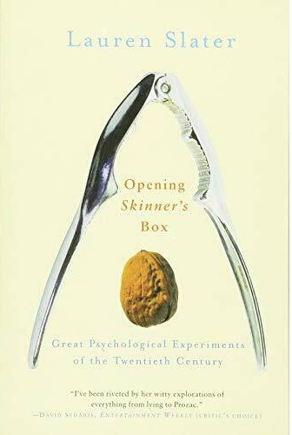
In Opening Skinner's Box, Lauren Slater sets out to investigate the twentieth century through a series of ten fascinating, witty and sometimes shocking accounts of its key psychological experiments. Starting with the founder of modern scientific experimentation, B.F. Skinner, Slater traces the evolution of the last hundred years' most pressing concerns - free will, authoritarianism, violence, conformity and morality. Brilliant read for all A Level Psychology students.

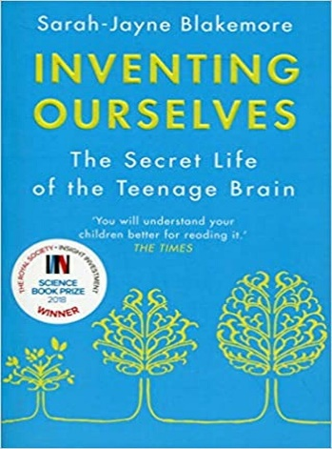
Drawing upon her cutting-edge research Professor Blakemore explores: What makes the adolescent brain different? Why does an easy child become a challenging teenager? What drives the excessive risk-taking and the need for intense friendships common to teenagers? Why it is that many mental illnesses – depression, addiction, schizophrenia – begin during these formative years. And she shows that while adolescence is a period of vulnerability, it is also a time of enormous creativity and opportunity.

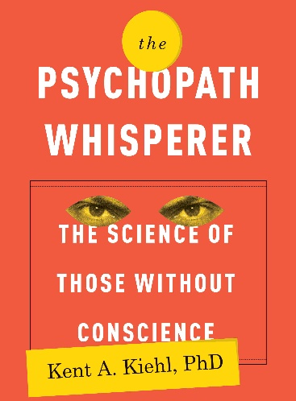
We know of psychopaths from chilling headlines and stories in the news and movies from Ted Bundy and John Wayne Gacy, to Hannibal Lecter and Dexter Morgan. As Dr Kent Kiehl shows, psychopaths can be identified by a checklist of symptoms that includes pathological lying; lack of empathy, guilt, and remorse; grandiose sense of self-worth; manipulation; and failure to accept ones actions. But why do psychopaths behave the way they do? Is it the result of their environment how they were raised or is there a genetic component to their lack of conscience? This relates to our year two topic of criminal behaviour.

These are numerous books you could read. There are great books available on audible, kindle too. Choose anyone that takes your fancy! Write a book review on it and hand this to your teacher in September.
Online Learning Courses
A Massive Open Online Course (MOOC) is an interactive step-by-step course aimed at reaching an unlimited number of participants worldwide to create a community of lifelong learners. There are many different MOOC providers that cover a huge variety of different subject and topic interests.
Typically a MOOC will involve 2-3 hours study per week for 6 weeks or so. MOOCs are free of charge. All required course materials will be provided for you online, which is also 100% free! Each course is open to anyone with internet access across the world and all you need is your wonderful brain!
Here are a few that you may wish to try:
Positive Psychology topic taught on year one – the science of happiness
https://www.edx.org/course/the-science-of-happiness-3

General wellbeing & effective mindset training course:
https://www.edx.org/course/psychology-of-personal-growth

Follow the course learning instructions & complete all tasks, keep a record of what you do and save all work as evidence of your learning.

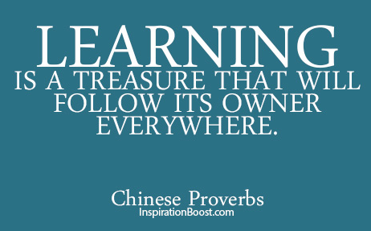

Good luck!

