Travel and Tourism  Cristiana Bernat  Monday pm 13:15-15:45  Room: D310 & Hush  Units: 56 & 57  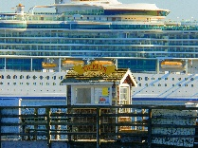 | Creative Media  Daniel Pope  Friday am 9:30-12:15  Room: L115  Units: 30,32 & 37   | Performing Arts  Aimee-Lauren Rolfe  Wednesday pm 1:30 – 4:00pm  Room: Studio  6 Credits  Units: 69 & 58  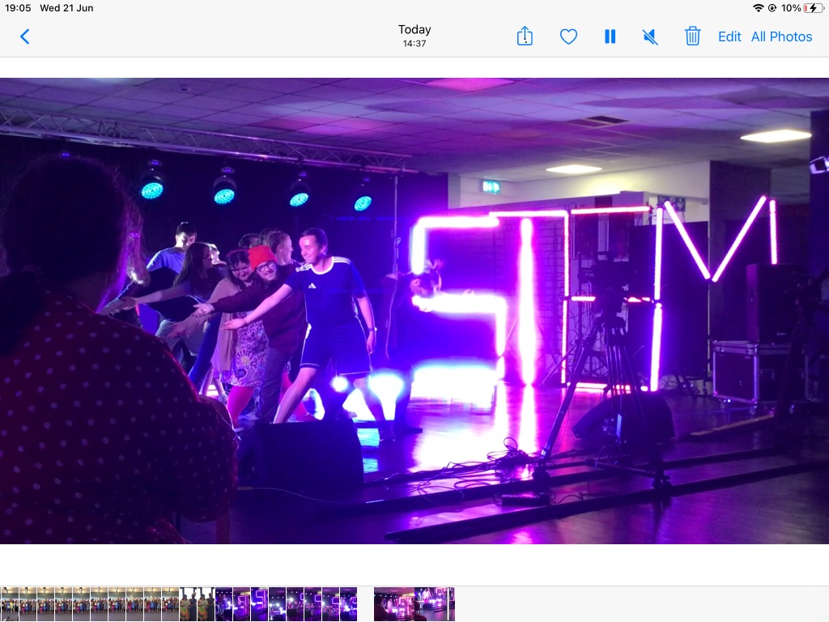
Construction  Andy Neil – W009 Tuesday PM: 13:45 – 15:45  Units: Unit 9 & 17   | Hair and Beauty  Fran Skinner  Friday  Hair am 9:00 – 12:15  Units 61 & 62  Beauty pm 13 -15:30  Units 64 & 65  Beauty Salon (third floor D-Block)    Hair  Beauty | Health and Social Care  Kirstie Berkeley – M009  Thursday pm 1315-1545  Units 70 & 71  
Hospitality  Lecturer: Jenny Thomas  Wednesday am 9:15 – 12:15  Room: Restaurant 58/D104/5  Units 24 & 27  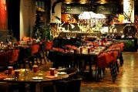 | Motor Vehicle  Lecturer: Sam Lucas  Wednesday am - W12  0915 – 1215  Units 19/20/21  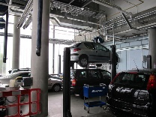 | Public Services  Lecturer: Crisitana Bernat?  Friday pm: 1315 –1545  Room: Hush 2  Units 67 Working in a team  47 Developing customer service skills  
Horticulture
Lecturer: Nikki Sanger
Friday pm 13:15 – 15:45
Room: M126
Units 01 & 75

