

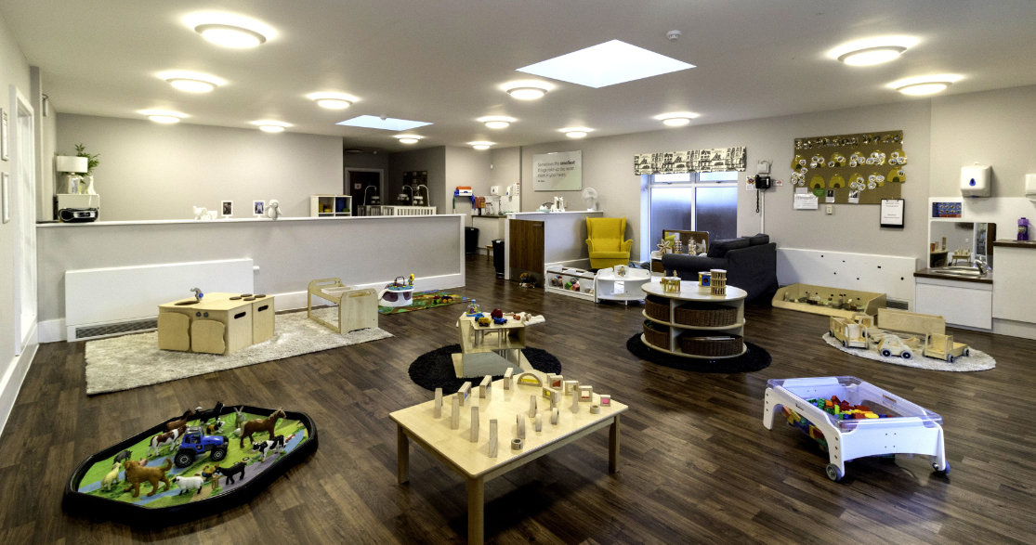

JOB OPPORTUNITIES HERE AT EAST GRINSTEAD

ARE YOU A STUDENT LOOKING TO STEP INTO THE WORLD OF CHILDCARE?

WE ARE LOOKING FOR STUDENTS WHO WOULD LIKE TO WORK AFTER SCHOOL HOURS WITH THE OPPORTUNITY TO BECOME A QUALIFIED EARLY YEARS PRACTITIONER

PLEASE GET IN TOUCH FOR A CHAT!

[eastgrinstead@busybees.com](mailto:eastgrinstead@busybees.com)

01342 306500