GCSE > A LEVEL

Summer Project

|  |
| --- |
| Name: |
| Subject: A Level Photography |

The purpose of this A Level Summer project is to introduce you to studying this subject at A Level standard. You will need to complete 10 hours of study on each subject every week, 4½ in class with your teacher and the rest as independent learning. Therefore, it is important that you enjoy this subject and that you start to practice your study skills as early as possible. Some subjects have significant maths content (for example business, psychology, economics); others require strong essay writing skills (for example history, English). Think about the study skills and underpinning knowledge you will require in this subject – not just the title.

If after completing this project you think this may not be your ideal choice, you can ask to transfer to another subject at the start of term, as long as you have the entry requirements and it fits alongside your other choices on the A Level Matrix (timetable). If you do decide to change subject, you will be required to complete the transition project for your new choice too.

This is also your first taste of Flipped Learning and elements will be used within your first week of lessons.

We hope you enjoy this project as you start your A Level journey.

Have a good summer and we look forward to seeing you in September.

**HOW TO SUBMIT:**

Please print your completed project and bring a copy with you to Induction.

If you don’t have access to a printer, electronic copies can be emailed as an attachment to [ALevel_Photography@chichester.ac.uk](mailto:ALevel_Photography@chichester.ac.uk) with the email clearly labelled ‘Photography Summer Project’ prior to Induction.

**A-Level Photography Transition Task**

To get you thinking about how you can use your camera to document the world around you, we have devised four photographic tasks for you to complete. The aim of these tasks is to show us how you see the world, and how imaginative you can be when image making. For each section we have supplied you with artists to give you some potential influences of how to approach the task, however, feel free to interpret the brief in your own creative way.

You can download the PowerPoint ‘Sketchbook’ to place all the work in so that we will be able to view it easily when you start college. Also, this means there are no need to have any cost of printing work. On the PowerPoint you will find questions for you to answer about the reasoning for your photographs and why you think the photograph is successful.

1. **Define a person without showing their face**

Awol Erizku

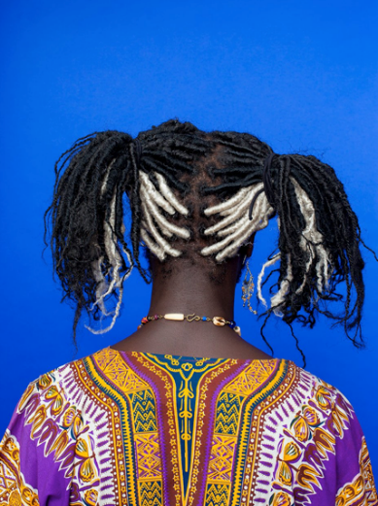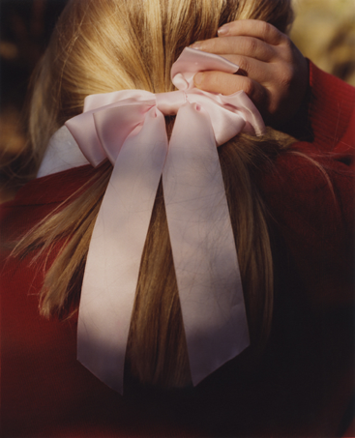

Harley Weir

* Although portraits often look at the conventions of the facial features to define someone’s appearance, I would like you to create portraits without showing the persons face. In the image, I would like you to select a defining feature/aspect and make this the focus of the image.
* Use the Digital PowerPoint sketchbook to demonstrate your favourite chosen image and your reasons why you have taken it.

1. **Present order amongst chaos**

* Do we live in an explicitly ordered world? Or do we live within chaos?
* Make your choice between order and chaos…let me see how you see the world.
* Use the Digital PowerPoint sketchbook to demonstrate your favourite chosen image and your reasons why you have taken it.

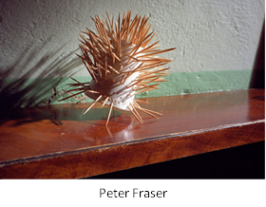

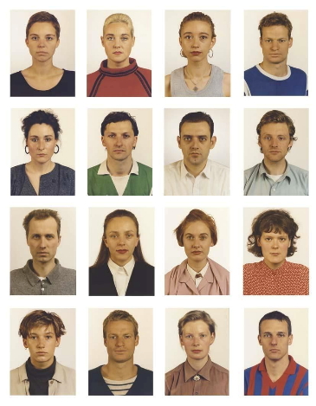

Thomas Ruff

1. **Create a photo of a thing that makes me question what it is**

* We get caught up with seeing the world through set ways, thinking about objects/people/places as they instantly appear to us. This task asks you to think about re-examining the world and looking to distort it.
* Use the Digital PowerPoint sketchbook to demonstrate your favourite chosen image and your reasons why you have taken it.

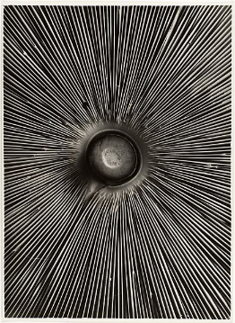

Albert Renger Patzsch

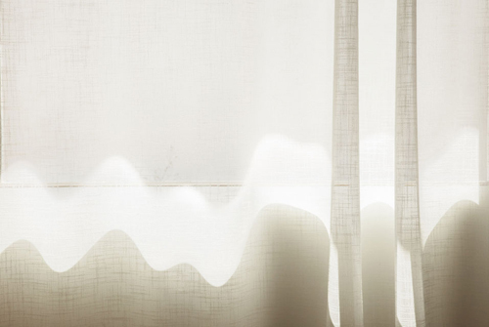

Uta Barth

Helene Binet

1. **Take me on a journey**
   * Photographers have used the camera to document a place or journey that they have taken, with photographs taken to create a narrative. These narratives paint the story of their journey.
   * This journey may simply be a walk. But try and use your photography to bring this to life.
   * Please take 5+ images to present your narrative.

* Use the Digital PowerPoint sketchbook to demonstrate your favourite chosen image and your reasons why you have taken it.

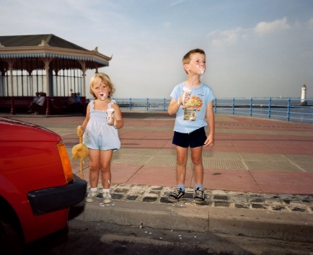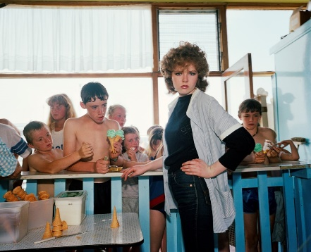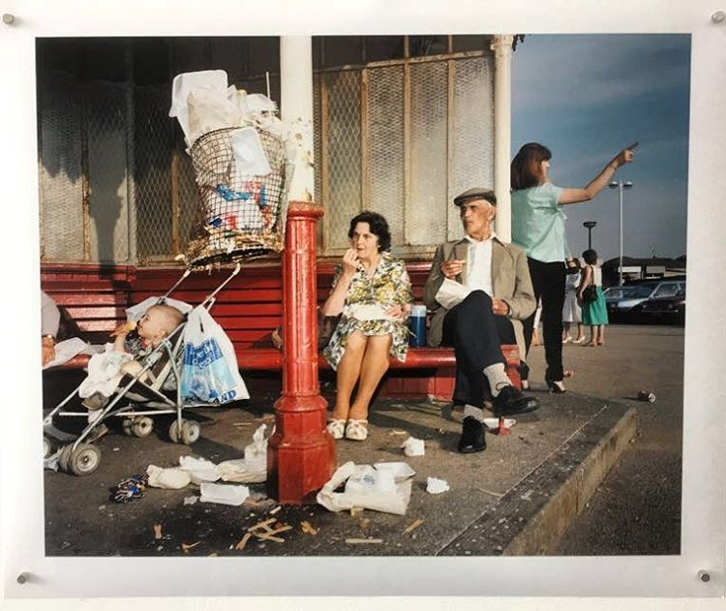

Martin Parr – *Last Resort*

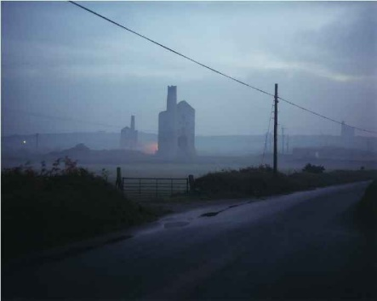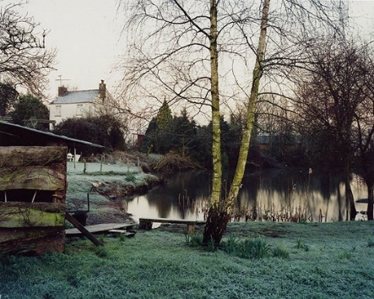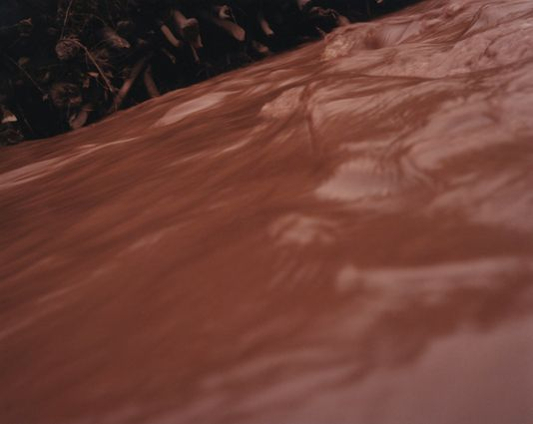

Jem Southam – *The Red River*

**Things you will need to start the A-Level:**

* General pencil case containing standard classroom equipment
  + Pens/Pencil/Ruler/Glue/Highlighters/etc
* DSLR (Digital SLR camera) / Mirrorless camera
  + Camera needs to be able to be manually controlled.
  + Preferably have an 18-55mm (or similar) lens.
  + We use Nikon DSLR’s Cameras mostly but do have some lenses available for Canon Cameras. This means that when buying a camera, we advise that you stick to these two main brands.
  + If wishing to purchase a camera good second-hand sellers include:
    - WEX
    - MPB
* SD card / Memory Card Reader / Cable to transfer images
* Access to a Cloud storage device / 16GB+ USB memory stick or portable hard drive
* *35mm film SLR camera*
  + *This will not be needed before January 2023*
  + *If you possess a 35mm SLR Camera and would like us to check it, we can look over the camera to ensure it functions correctly.*

**Other things to think about:**

* **ADOBE SOFTWARE**
  + Students can access all the Adobe Creative Cloud packages whilst on the college site, both in the classrooms and the library and open access (college computer suite).
  + If you wish to purchase your own version of Adobe CC (Photoshop/Etc), then you purchase this via Adobe, please ensure that you use the student discount. This brings the price the £16.24 per month and is a 12-month contract.
  + If able/willing to wait they do have sales during the year (*Black Friday*) where the price is further reduced.
* **PHOTOGRAPHIC KIT:**
  + We will also inform you at the start of the year of the price of the Photography Kit, this is calculated yearly but will most likely cost between £25-£40. This covers some basic art materials, Photographic 35mm Film, Photographic Darkroom Paper and Chemistry needed for the darkroom.