GCSE to A Level Business transition
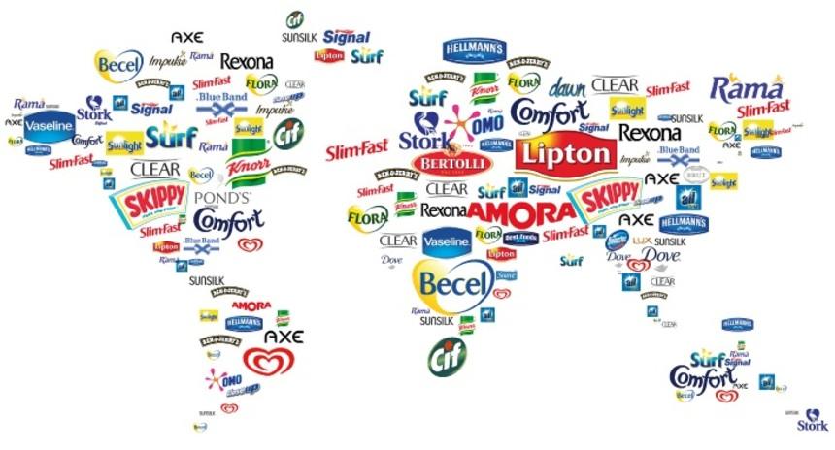
This Photo by Unknown Author is licensed under CC BY
Welcome to A-Level Business! To get you ready for your first lesson (and to start you thinking like a business analyst from day one), you will complete the following two tasks over the summer.

Task 1 – Market research project

Task 2 – Business numeracy skills check

Don’t forget to also bring your completed Task 1 with you to your first lesson! You will be using it to participate in a whole class activity.

If you have any questions, please email Jo Reeves (A level business course leader) reevesj@chichester.ac.uk

Task 1: Market Research – “What’s Trending?”

Choose a market that interests you—this could be anything from fashion, gaming, and food delivery to fitness, tech gadgets, or even pet care. You’ll investigate how that market works, who the customers are, and what trends are shaping it.
Research that market, using the following prompts to guide you.

1. Market Overview
- What is the market?
- Is it a mass or niche market?
- What types of products or services are offered?

2. Market Size and Growth
- How big is the market (in terms of revenue or number of customers)?
- Is it growing, shrinking, or stable?

3. Market Segmentation
- Who are the typical customers?
- How is the market segmented (e.g. age, income, lifestyle)?

4. Competition
- Who are the main competitors?
- What makes them successful?

5. Trends and Influences
- What current trends are affecting this market?
- How are businesses responding?

6. Your Opinion
- Why did you choose this market?
- What do you think the future holds for it?

Present your research in a clear and engaging format of your choice—this could be a poster, infographic, leaflet, or presentation. Focus on selecting the most important and interesting information to give a strong overview of your chosen market.

Task 2 – Please answer all of the following questions. Remember to show your workings.

Q1 | Balti Towers is an Indian takeaway that also offer a delivery service. Last year, the business delivered 1,400 curries. This year, the owner estimates that they will deliver 1,512 curries.  Calculate the estimated percentage increase in curry deliveries.
Your workings:

Q2 | School of Choc is a confectionary manufacturer located in County Durham. The business employs 120 staff. The ratio of male to female staff is 2:3.  Calculate how many female staff School of Choc employs.
Your workings:

Q3 | Jimmy Chews is a sweet shop located in Wetherby. This year, the owner estimates that the business, which also sells soft drinks, will sell 3,360 cans of coca cola, 5% more than last year.  Calculate how many cans of coca-cola Jimmy Chews sold last year.
Your workings:

Q4 | Bubblicious is a hot tub manufacturer located in Chester. Their hot tubs retail for £4,500. The manufacturing cost per hot tub is 2/5 of the selling price.  Calculate the cost of manufacturing one hot tub.
Your workings:

Q5 | The chart below shows the number of hot tubs Bubblicious sold between 2014 and 2017. The owner estimates that in 2018, hot tub sales will be 5% lower than in 2017.  Calculate the average annual sales of hot tubs between 2014 and 2018.
Your workings:

Q6 | Melchester Rovers Football Club can seat 42,000 spectators. Last week, when they played Harrogate Town, there were 36,960 spectators.  Calculate the percentage of empty seats.
Your workings:

Q7 | A family of four, on holiday in the UK from Spain, visited the ‘Whale of a Time’ sea life centre in London. The total entrance cost for the family was £90.  Assuming an exchange rate of £1: €1.08, calculate the total entrance cost in Euros.
Your workings:

Q8 | Loft in Space, a manufacturer of loft insulation, took 80 of its employees on a two-day team-building trip to an outdoor activity centre in the Lake District. The total cost of the trip was £9,600. The accommodation cost per employee was 3/5 of the total cost per employee.  Calculate the accommodation cost per employee.
Your workings:

Q9 | Tea-Total is a café in Cumbria. Below is a pie chart showing the percentage of drinks purchased for a group of 200 customers.  (A) Calculate how many customers purchased a coffee  (B) Calculate how many customers did not purchase a tea  (C) Calculate the fraction of customers that purchased a Latte
Your workings:

Q10 | Graham Riley is an employee of Father Treads, a business that specialises in car tyres. Graham attends a meeting at Head Office, travelling 60 kilometres each way. Graham is entitled to claim travel expenses at 45p per mile.  Based on the assumption that 10 kilometres is equivalent to 6 miles (approximately), calculate how much Graham is entitled to claim.
Your workings:

Q11 | Car-tastrophe is a car showroom based in Stanhope. The business consists of one manager and 3 salespersons, Jim, Jon and Joseph. Each month, a sum of money is paid as a bonus and is divided in the ratio of the number of cars each salesperson has sold. Jim sold 7 cars, Jon sold 8 cars and Joseph sold 9 cars. Joseph received £1,125  Calculate how much money Jim and Jon received.
Your workings:

Q12 | Barber Streisand is a hair-dressing salon located in Sunderland. The owner, Barbara, recently introduced a new system of rewarding her staff. At the end of the week, Barbara puts the following in a bag:  5 x £10 notes  4 x £20 notes  3 x £50 notes  At the end of the week, the hairdresser who has provided the best service can select a note from the bag as a reward.  Calculate the probability of not selecting a £10 note.
Your workings:

Q13 | Frame, Set and Match is a picture framing business with several shops across the North East of England. The business has 90 employees, of which 54 are female.  Calculate, in the lowest possible terms, what fraction of the total employees are male.
Your workings:

Q14 | Wooden it be Lovely is a small manufacturer of wooden children’s toys. Last week, the business produced 32,000 toys, of which 40% were checked for quality. Of the 40% checked, 1/5 had a defect.  Calculate how many wooden toys were found to not have a defect.
Your workings:

Q15 | Sparked Out is a retailer of electrical products located in County Durham. The owner, Joseph Sparks, is analysing the sales figures of two product lines, the Lavazza coffee machine and the Breville toaster.  In 2017, the total value of Lavazza coffee machine sales was £12,100 whilst the total value of Breville toaster sales was £5,292. Joseph noticed that the sales of Lavazza coffee machines have been increasing by 10% per year, whilst sales of Breville toasters have been increasing by 5% per year, over the last two years.  Calculate the total sales value of Lavazza coffee machine sales and Breville toasters in 2015.
Your workings:

