GCSE to A LEVEL
Transition Project #3
Final workbook to print and bring into college at enrolment

Name:
Subject: A Level Psychology Year 1
You will need to complete 10 hours of study on each subject every week, 4½ in class with your teacher and the rest as independent learning. Therefore, it is important that you enjoy this subject and that you start to practice your study skills as early as possible. Some subjects have significant maths content (for example business, psychology, economics); others require strong essay writing skills (for example history, English). Think about the study skills and underpinning knowledge you will require in this subject – not just the title.

If after completing this research project you think this may not be your ideal choice, you can ask to transfer to another subject at the start of term, as long as you have the entry requirements and it fits alongside your other choices on the A Level Matrix (timetable). If you do decide to change subject, you will be required to complete the transition project for your new choice too.

This is also your first taste of Flipped Learning and this material will be used within your first few weeks.

Have a good summer and we look forward to seeing you in September.

Any questions, please email: alevel_psychology@chichester.ac.uk

GCSE to A Level Transition Tasks:
You are required to complete two A Level Psychology transitions tasks over the summer. Both tasks are compulsory.
A Paper copy of Task One must be brought with you to your first lesson
A paper copy of Task Two must be handed in at enrolment before attending lessons. Please separate pages 1-4 from pages 5-9 and keep pages 5-9 for your test preparation.
Studying A Level Psychology at Chichester College
We teach the Eduqas (WJEC) specification which consists of 2 components in year 1 and a third component in year 2:
Component 1: Past to Present
This involves learning about 5 of the main approaches in Psychology: Biological, Psychodynamic, Behavioural, Cognitive and Positive. Within each approach we study;
- The main assumptions that are key to the approach
- One classic study
- One therapy
- A contemporary debate
- Evaluation of the overall approach

Component 2: Investigating Behaviour
- Research Methods
- Social and developmental psychology
- Novel Scenarios - applying knowledge to unseen research
- Conducting two personal investigations

Component 3: Applications of Behaviour
- Addiction
- Schizophrenia
- Stress
- Controversial issues in Psychology: Sexism & Cultural Bias in Psychology, the scientific nature of Psychology & the ethical costs of psychological research.
Visit www.eduqas.co.uk for further details on the Eduqas specification.
A Level Psychology requires you to be proficient (in other words skilful) in English, Maths and Science. You will need to calculate statistics in exams as well as write essays and discuss experiments and other types of research.
Your name:
Your Transition Project – Part 1 of 2 – Detailed Summary of the Biological Approach’s main assumptions

There are many different approaches in Psychology. Over the course of year 1, we will learn about the following: biological, psychodynamic, behavioural, cognitive, positive, social and developmental. Before looking at one approach, first find out what the term “approach” means. We are using the term approach as a noun (not a verb) and a different word would be “school of thought” or perspective.

One of the oldest approaches in Psychology is the biological approach. Define the biological approach:

List as many biological factors that you can think of that my influence human behaviour:

We will focus on 3 of the main assumptions within this approach. An assumption is fundamental belief held. In other words its something many of us assume is true. For examples, hormones affect our behaviour. In each of our 5 approaches, there are 3 main assumptions that you need to know and apply to human behaviour.

Assumption 1 – The role of evolutionary influences on human behaviour

This is the link to a brief youtube clip to watch. You can search youtube for relevant clips. Be prepared to watch the clips more than once so that you can process the information and make notes.

https://www.youtube.com/watch?v=vJdc9zGYVjU
the TV is in four parts, please watch each part
Define the term evolution:

This assumption claims that our traits & behaviour were shaped by the experiences of the early human species. Define natural selection

What does EEA stand for and what was it?

What’s does survival of the fittest mean?

Assumption 2 – Localisation of Brain function

Download the free app called “3D brain app” and use this app to look up various parts of the brain and what that part of responsible for.
This assumption looks at how parts of the brain are linked to specific human behaviours. Name the four lobes of the brain and what they are responsible for

Name the two other specific brain parts linked to speech and outline their function:

Assumption 3 – The role of neurotransmitters
Go to BBC bitesize and under human biology there is a 6 page section of Cells of the nervous system, neurotransmitters at synapses, Read through all 6 pages and watch the clip too. Make notes and then fill this in too.

https://www.bbc.co.uk/bitesize/guides/zrgyt39/revision/1

Define a neurotransmitter

Name as many neurotransmitters as you can and link to each one to their role in terms of human behaviour:

Please label this diagram (search online for the information)

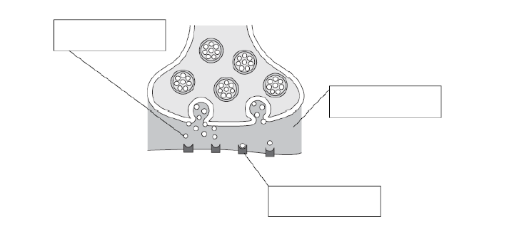

Psychology Transition Project – Part 2 of 2 – Researching a Classic Study
As an A Level Psychology student, you will need to read, understand, and learn off by heart a vast amount of information. Our current students comment that this is the most challenging aspect of studying A Level Psychology; the sheer volume of specific details that must be committed to long term memory and then retrieved under exam conditions.
Your task:
Learn off by heart one of the classic studies you will need to recall. You will be asked to write about this in the half term of lessons!
The purpose of this task is for you to understand the given study and be ready to write a summary of the study from memory, in lesson, under exam conditions. The exact lesson in which you will be asked to write your summary will be discussed at the start of the course so there will be some time to revise this in the first weeks of college to be prepared fully for the test.
How you research and revise the study is your choice, but you will need to read through the summary provided over the next few pages to gain a basic understanding. Then you may:
- Choose to borrow a relevant book from a library.
- Research the study further online.
- Discuss the study with others, maybe people who have studied Psychology already.
You should produce a self-study resource (revision aid) which has supported you in the learning of the given study. Some examples of such resources are:
- mind maps,
- posters,
- timelines,
- cue cards.
Your resource should clearly outline:
- The methodology used by Raine et.al (type of experiment, participants, etc).
- Their procedures (what did they actually do during the study? Step by step).
- Their findings/results (their data).
- The conclusions drawn from their results (what the data tells us).
Remember that you are entering A Levels which are a very different learning experience to GCSEs. There is a clear emphasis on being an independent learner who takes responsibility for pushing themselves to study thoroughly and learn in new ways. You will need to challenge yourself and actively seek out material beyond the textbook during your future A Level learning.
There is continuous assessment across the two years of A Level with significant assessments informing whether progression in the programme is appropriate. There will be four major formal progress points in each year and these will required excellent revision skills and exam technique. You must be performing well against your minimum expected grade in order to succeed in Psychology. We monitor exam performance very closely and it is vital that you are confident with exams and enhance your study skills and create strong independent learning habits now to make sure you achieve a good grade in A Level Psychology.
Brain Abnormalities in Murderers
Indicated by Positron Emission Tomography
by Adrian Raine, Monte Buchsbaum, and Lori LaCasse (1997)
Abstract:
Murderers who plead not guilty by reason of insanity (NGRI) are thought to have brain dysfunction. However, there have been no previous studies reporting direct measures of both cortical and subcortical brain functioning in this specific group. Positron emission tomography (PET) brain imaging was conducted on 41 murderers pleading NGRI and 41 control subjects. Murderers were characterised by reduced glucose metabolism in the prefrontal cortex, superior parietal gyrus, left angular gyrus, and the corpus callosum. There were also abnormal asymmetries of activity (left hemisphere lower than right) in the amygdala, thalamus and medial temporal lobe. These findings provide initial indications of a network of abnormal cortical and subcortical brain processes that may cause a predisposition to violence in murderers pleading NGRI.
Introduction:
It has long been suspected that brain dysfunction can predispose someone to violent behaviour. Whilst previous studies have shown that violent offenders have poorer brain functioning than normal control subjects, it has not yet been possible to localise which specific brain areas are dysfunctional. However, past research which looks at criminals with brain injuries does provide clues as to which areas of the brain are associated with violence and so we can expect the following areas to be dysfunctional in murderers; the prefrontal cortex, the left angular gyrus, the amygdala, the hippocampus, the hypothalamus and the corpus callosum (which is responsible for coherence between the two hemispheres, and dysfunction of which can cause hemispheric asymmetries of function. Conversely, no dysfunction is expected in other brain areas (e.g. the midbrain, the cerebellum) which have been implicated in other psychiatric condition but have not been related to violence. One particularly important group of violent offenders consists of those who commit murder and plead not guilty by reason of insanity (NGRI). Although it is thought that such individuals have localised brain impairments, there has been no previous brain imaging research on this important population.
Methodology:
The experimental group consisted of 41 subjects tried in the state of California (39 men, 2 women) with a mean age of 34.3 years who had been charged with either murder or manslaughter. Subjects were referred to the University of California to obtain evidence using PET scanning for a NGRI defence or they had been found guilty and were referred to obtain information that may reduce their sentence. Reasons for referral included history of head injury or brain damage. A control group was formed by matching each murderer with a normal subject of the same sex and age who was tested using identical PET imaging procedures in the same laboratory. The mean age of the 41 controls (39 men, 2 women) was 31.7. They had been screened for health with a physical exam, a psychiatric interview and their medical history was checked.

PET Task Procedures:
The radioactive tracer (fluorodeoxyglucose) was injected into the subject and taken up by the brain for a 32 minute period during which the subject completed a continuous performance task (CPT). The subject was then transferred to a PET scanner where the brain was scanned in 10 mm horizontal slices as shown in Figure 1.
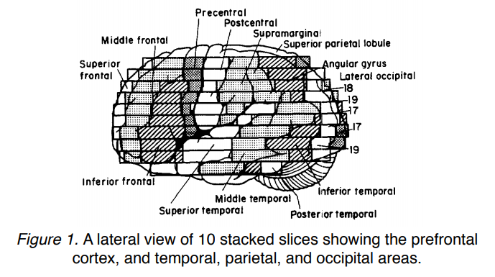
Results:
Cortical Regions:
As anticipated, the group of 41 murderers had significantly lower glucose metabolism relative to controls in both the lateral and medial prefrontal cortex in both hemispheres (see Figure 2 on next page).
Murderers had significantly lower parietal glucose metabolism than controls, especially in the left angular gyrus. As indicated in Figure 3, murderers had significantly lower glucose especially in the left and right superior parietal gyri. Murderers were identical to controls on temporal lobe glucose metabolism. Murderers were found to show significantly higher occipital lobe glucose metabolism than controls.
Subcortical Regions:
Murderers have bilaterally lower glucose metabolism in the corpus callosum than controls. Murderers showed an abnormal asymmetry of activity with reduced left and increased right amygdala activity relative to controls. Murderers showed an abnormal asymmetry of activity with reduced left and increased right activity in the hippocampus. Murderers showed an abnormal asymmetry consisting of relatively greater right thalamic activity.
As predicted, there were no significant differences for the amount of midbrain and cerebellum activity between murderers and controls.
Groups did not differ on any aspect of behavioural performance on the CPT.

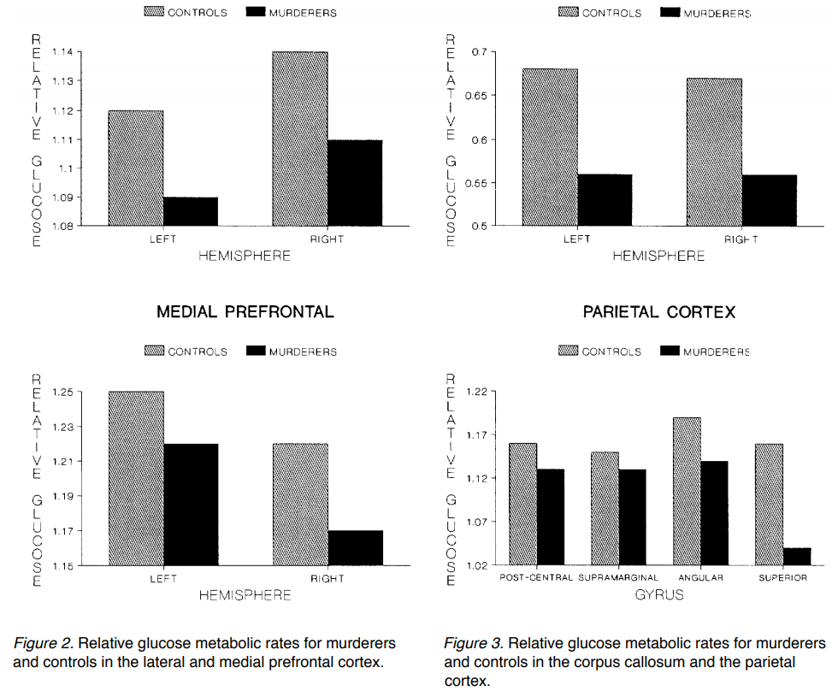
Discussion:
The key findings from this study are that murderers pleading NGRI are characterised by;
- reduced glucose metabolism in the prefrontal cortex, the parietal cortex, and the corpus callosum.
- abnormal asymmetries of activity (left hemisphere lower activity than right) in the amygdala, thalamus, and the hippocampus.

The findings of this study suggest that the neural processes underlying violence are complex and cannot be reduced to single brain mechanisms causing violence in a direct causal fashion. Instead, violent behaviour probably involves disruption of network of multiple interacting brain mechanisms that predispose to violence in the presence of other social, environmental, and psychological predispositions. Nevertheless, attempts to ‘connect’ findings from the individual brain sites in this study must proceed cautiously, because there are brain mechanisms relevant to aggression (e.g. the hypothalamus) that could not be imaged in this study. For this reason, this study cannot provide a complete account of the neurophysiology of violence in this specific and selected subgroup of violent offenders, although it is felt that it both provides evidence that murderers pleading NGRI have different brain functioning compared to controls, and also gives initial suggestions as to which specific neural processes may predispose to their violent behaviour.
Conclusions:
First, it is important to document that these findings cannot be taken to demonstrate that violence is determined by biology alone; clearly, social, psychological, cultural, and situational factors also play important roles in predisposing to violence. Second, these data do not demonstrate that murderers pleading NGRI are not responsible for their actions, nor do they demonstrate that PET can be used as a diagnostic technique. Third, these findings do not establish causal link between brain dysfunction and violence. Fourth, findings cannot be generalised at the present date from NGRI murder cases to other types of violent offenders. What these findings do document is that as a group, murderers pleading NGRI have statistically significant differences in glucose metabolism in certain brain regions compared to control subjects. They also suggest that reduced activity in the prefrontal, parietal, and callosal regions of the brain, together with abnormal asymmetries of activity in the amygdala, thalamus, and hippocampus, may be one of many predispositions toward violence in this specific group. As with all initial findings, future independent replication, refinement, and extension are greatly needed.
Possible Description Style Exam Questions

1. Describe the procedures of Raine, Buchsbaum and LaCasse’s (1997) research ‘Brain abnormalities in murderers indicated by positron emission tomography’. [10 marks]
2. Describe the findings of Raine, Buchsbaum and LaCasse’s (1997) research ‘Brain abnormalities in murderers indicated by positron emission tomography’. [10 marks]
3. Explain the conclusions of Raine, Buchsbaum and LaCasse’s (1997) research ‘Brain abnormalities in murderers indicated by positron emission tomography’. [6 marks]
4. Outline the methodology of Raine, Buchsbaum and LaCasse’s (1997) research ‘Brain abnormalities in murderers indicated by positron emission tomography’. [6 marks]

Please note that on the final exam papers, you will also be expected to be able to evaluate the study in terms of strengths and weaknesses. This content will be covered in lessons.

