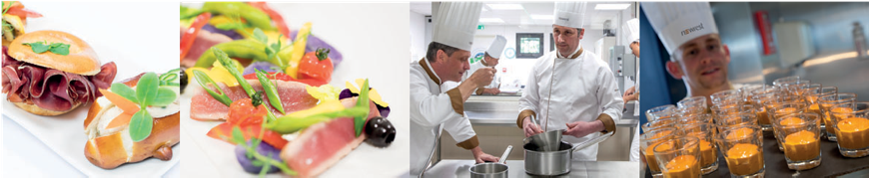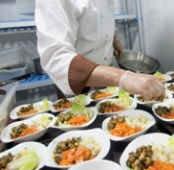

Chef Vacancies, Sterling Park, Crawley

* Average 40 hours per week, with the opportunity to work overtime
* Annual Leave of 28 days and increments bases on service
* Free meals whilst on duty & parking on site
* Full training and full protective uniform supplied
* Life Assurance of two times basic salary Income Protection Scheme
* An Employee Assistance Programme to help with everyday issues or larger problems where you may need additional support, including legal and financial advice, support with work related issues or personal issues such as bereavement.
* Unlimited access to an online platform offering mental health and wellbeing support.
* Access to a 24hr virtual GP Service
* The Newrest Discounts Scheme, offering great deals 24/7 (also open to friends and family).
* Save for your future by becoming a member of the Pension Plan

We are currently recruiting for the positions listed below as an entry level opportunity or as an apprentice. Our apprenticeship provides on the job training to support people at the beginning of their careers or anyone who might be starting a new career with us.

Through this training you will gain exposure to different departments across the business, work in different sites and rotate around sections in the kitchen. Gain a qualification, take part in professional development sessions and our leadership team will have a dedicated mentor for your journey.

**Commis Chef £12.48 per hour & Chef de Partie £16.37 per hour**

**If you are interested or would like to understand more about our opportunities, please email** [**hr**](mailto:hr.uk@newrest.eu)[**.uk@newrest.eu**](mailto:.uk@newrest.eu)