

A guide to help you get ready for

**WJE L3 Ext Cert in Medical Science**

# What is Medical Science?

This pack contains a programme of activities and resources to prepare you to start the certificate in Medical Science in September. It is aimed to be used now and throughout the remainder of the summer term and over the summer holidays to ensure you are ready to start your course in September. It does not form part of your summer project submissions and is voluntary. However the suggested activities will help you engage and enjoy the world of medical science! It’s a fantastic subject to study, particularly if you are interested in a career in health and we hope you enjoy your learning.



# Read Medical Science Based Resources

These resources are great for gaining a better understanding of biology in the modern world.

NHS choices. This site is useful to investigate how lifestyle and disease affects health. Really useful for looking up the symptoms, causes and treatments of a wide range of diseases. <http://www.nhs.uk/Pages/HomePage.aspx>

.

`We spend our whole lives in one body and yet most of us have practically no idea how it works and what goes on inside it. The idea of the book is simply to try to understand the extraordinary contraption that is us.' Bill Bryson sets off to explore the human body, how it functions and its remarkable ability to heal itself. Bill Bryson sets off to explore the human body, how it functions and its remarkable ability to heal itself. Full of extraordinary facts and astonishing stories The Body: A Guide for Occupants is a brilliant, often very funny attempt to understand the miracle of our physical and neurological make up. A wonderful successor to A Short History of Nearly Everything, this new book is an instant classic. It will have you marvelling at the form you occupy, and celebrating the genius of your existence, time and time again.

‘What I learned is that we are infinitely more complex and wondrous, and often more mysterious, than I had ever suspected. There really is no story more amazing than the story of us.’ Bill Bryson

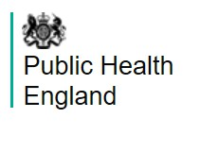

Public Health England is responsible for making the public healthier and reducing differences between the health of different groups by promoting healthier lifestyles, advising government and supporting action by local government. This website is an excellent source of up to date accurate information regarding health advice, vaccinations, and the status of the current coronavirus outbreak. htt[ps://www.gov.uk/government/organisations/public-health-](http://www.gov.uk/government/organisations/public-health-) england

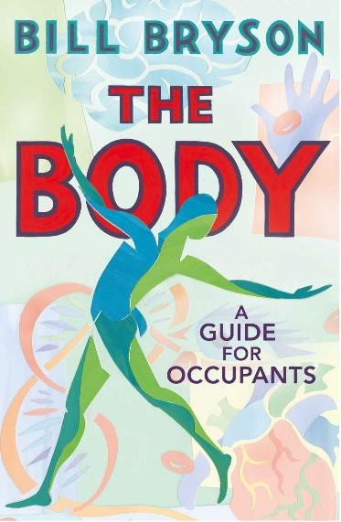

`

# TED Talks

Download the TED talk app to your device. It’s brilliant!!!

## How can we control the antibiotic resistance problem?

In this short 6-minute video Gerry Wright explains what needs to be done to overcome the ever increasing problem of bacterial resistance to current antibiotics.

htt[ps://www.ted.com/talks/gerry_wright_how_can_we_solve_the_antibiotic_resistanc](http://www.ted.com/talks/gerry_wright_how_can_we_solve_the_antibiotic_resistanc) e_crisis

## What happens during a heart attack?

Approximately seven million people around the world die from heart attacks every year. And cardiovascular disease, which causes heart attacks and other problems like strokes, is the world's leading killer. So what causes a heart attack? Krishna Sudhir examines the leading causes and treatments of this deadly disease.

htt[ps://www.ted.com/talks/krishna_sudhir_what_happens_during_a_heart_attack](http://www.ted.com/talks/krishna_sudhir_what_happens_during_a_heart_attack)

## The past, present and future of nicotine addiction

Tobacco use remains the leading cause of preventable disease and death in the United States, killing more people each year than alcohol, AIDS, car accidents, illegal drugs, murder and suicide combined. Follow health policy expert Mitch Zeller into the murky depths of the tobacco industry as he details the sordid history of nicotine addiction -- and invites us to imagine a world where policy change helps stop people from becoming addicted in the first place.

[https://www.ted.com/talks/mitch_zeller_the_past_present_and_future_of_nicotine_a](https://www.ted.com/talks/mitch_zeller_the_past_present_and_future_of_nicotine_addiction) [ddiction](https://www.ted.com/talks/mitch_zeller_the_past_present_and_future_of_nicotine_addiction)

## Animations of unseeable biology

We have no ways to directly observe molecules and what they do -- but Drew Berry wants to change that. He demos his scientifically accurate (and entertaining!) animations that help researchers see unseeable processes within our own cells.

htt[ps://www.ted.com/talks/drew_berry_animations_of_unseeable_biology](http://www.ted.com/talks/drew_berry_animations_of_unseeable_biology)

## Why our bodies age

Human bodies aren't built for extreme aging: our capacity is set at about 90 years. But what does aging really mean, and how does it counteract the body's efforts to stay alive? Monica Menesini details the nine physiological traits that play a central role in aging.

<https://www.ted.com/talks/monica_menesini_why_do_our_bodies_age>

# Use of Key Terms and Scientific Language

It is important in Medical Science to use the correct scientific words when describing structures, diseases and physiological tests.

Have a practice with some key names, terms and words that you will use in one important topic in Medical Science-coronary heart disease. Complete this crossword (answers are over the page but don’t peek!) When you have finished why not get ahead of the game and start making a glossary.

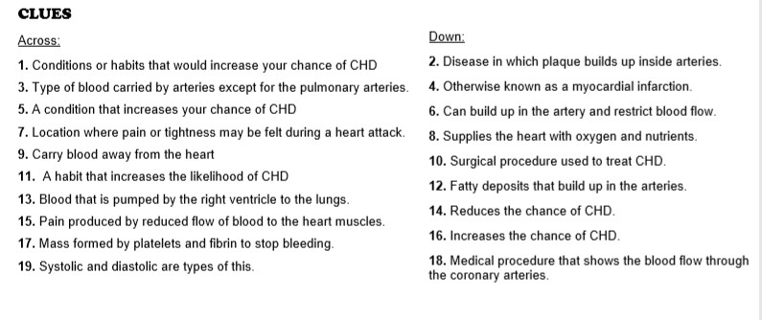

# Topics to Research

## What is the ideal blood pressure and pulse rate?

This is an important component of Unit 2: Physiological measurements. A machine called a sphygmomanometer measures the pressure created by your heart when it is contracting (systolic pressure) and when it is relaxing (diastolic pressure). These measurements can give a really good indication of the health of a person’s cardiovascular system. Ideal readings to vary by age, sex and ethnicity. See if you can find what the ideal blood pressure should be for the members of your family.

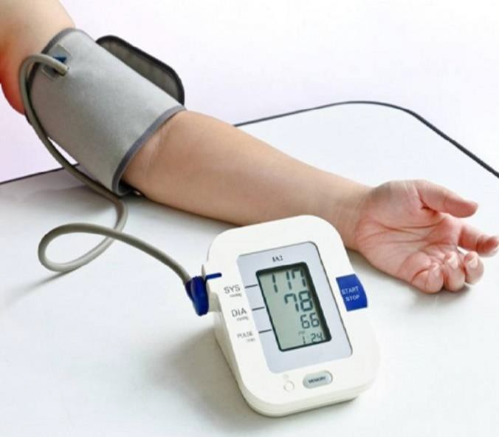

Pulse rate is a measure of how many times in one minute your heart beats, pushing that important oxygen rich blood to your body tissues for cell respiration. Have a go at taking your pulse rate and compare this to the ideal. Try moving about a bit and see what effect this has on your pulse rate.

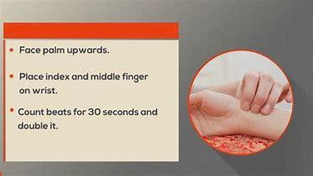

Good resources to use to research the importance of maintaining ideal blood pressure and pulse rate are:

The British Heart Foundation: <https://www.bhf.org.uk/> The NHS: <https://www.nhs.uk/>



**Cross word Answers**

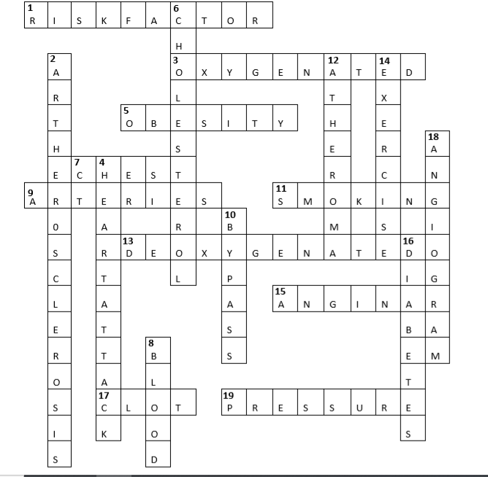

# Online Learning Courses

A Massive Open Online Course (MOOC) is an interactive step-by-step course aimed at reaching an unlimited number of participants worldwide to create a community of lifelong learners. There are many different MOOC providers that cover a huge variety of different subject and topic interests.

Typically a MOOC will involve 2-3 hours study per week for 6 weeks or so. MOOCs are free of charge. All required course materials will be provided for you online, which is also 100% free! Each course is open to anyone with internet access across the world and all you need is your wonderful brain!

Here are a few that you may wish to try: **Human Anatomy** <https://www.edx.org/course/human-anatomy>

## Vaccines: From Smallpox to technologies of the future

htt[ps://www.edx.org/course/vaccines-from-smallpox-to-technologies-of-future](http://www.edx.org/course/vaccines-from-smallpox-to-technologies-of-future)

Follow the course learning instructions & complete all tasks, keep a record of what you do and save all work as evidence of your learning.

**Good Luck!**